April 13, 2022  Join us for our Monthly Zoom Meeting with  Jay Young, Executive Director, Common Cause Illinois  Our topic is…  Voter Suppression | Voter Suppression  Have you ever been told to answer an impossible question in order to vote? For example:  - Guess the right number of gumballs in a jar.  2. How many bubbles in a bar of soap?  3. Can you recite the United States constitution?
Voter suppression is a strategy used to influence the outcome of an election by discouraging or preventing specific groups of people from voting. It is distinguished from political campaigning in that campaigning attempts to change likely voting behavior by changing the opinions of potential voters through persuasion and organization, activating otherwise inactive voters, or registering new supporters. Voter suppression, instead, attempts to reduce the number of voters who might vote against a candidate or proposition.

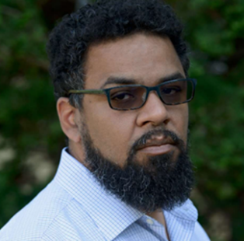
Join us at our next meeting as Jay Young the Executive Director for Common Cause Illinois. Talks about the history of voter suppression and how common day voter suppression is still prevalent in today’s elections.

Jay joined Common Cause in October 2017 and is an expert in Gerrymandering & Representation, Money & Influence, Voting & Elections.
 | 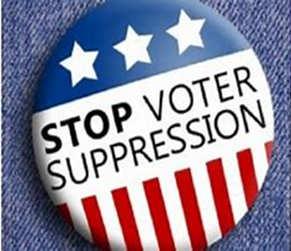
Are you a member?
For more information about joining the league email
Tiffani Graham tiffanig@versatilecsi.com

LEAGUE OF
WOMEN VOTERS
OF THE PARK
FOREST AREA
PO BOX 782
PARK FOREST, IL 60466

WWW. LWVPFA.ORG


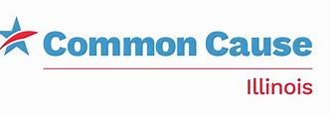

The meeting is 7 pm – 8 pm via Zoom. https://www.zoom.us/

Click on “Join a Meeting”

ZOOM MEETING ID: 890 2968 0196
Passcode: LWVAPR2022

