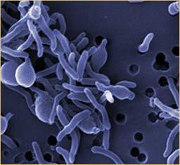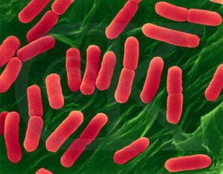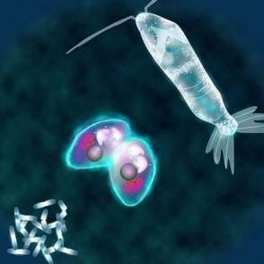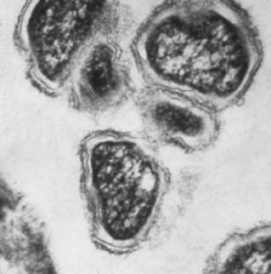
LIFE-ATOMS & THE CAUSE & CURE OF DISEASE
by
Marguerite dar Boggia

Science teaches us that the living as well as the dead organism of both a human being and animal are swarming with bacteria of a hundred various kinds, that from without we are threatened with the invasion of microbes with every breath we draw, and from within by aerobes, anaerobes, and what not. But science never yet went so far as to assert with the occult doctrine that our bodies, as well as those of animals, plants and stones are themselves altogether built up of such beings, which beings, except larger species, no microscope can detect. Each particle, whether you call it organic or inorganic, is a LIFE. Every atom and molecule in the universe is both life-giving and death giving to that form, inasmuch as it builds by aggregation universes and the ephemeral vehicles ready to receive the transmigrating soul, and as eternally destroys and changes the forms and expels those souls from their temporary abodes. It is that mysterious LIFE, represented collectively by countless myriads of lives, that follows in its own sporadic way, the hitherto incomprehensible law of Atavism; that copies family resemblances as well as those it finds impressed in the aura of the generators of every future human being. We are taught that every physiological change, in addition to pathological phenomena, diseases, nay, life itself, or rather the objective phenomena of life, produced by certain conditions and changes in the tissues of the body, all are due to those unseen CREATORS and DESTROYERS that are called in such a loose and general way, MICROBES. Such experimenters as Pasteur are the best friends and helpers of the Destroyers and the worst enemies of the Creators--if the latter were not at the same time destroyers too.¹ Years ago we were able to purchase unpasteurized milk, but not today; everything is pasteurized.
To understand the nature of a Life-Atom, we have to understand that the BOUNDLESS ALL is the Source of the ONE Life. It is the one Boundless, Immutable Principle, one Absolute Reality which antecedes all manifested conditioned Being. It is beyond the range and reach of any human thought or expression. It is without form, beginning or end.²
The Ancient Wisdom teaches that "Space is an Entity." It is with the life of this entity and with the LIVINGNESS of the forces and energies, the impulses and the rhythms, the cycles and the times and seasons that the esoteric studies deal.³
Esotericism teaches that underlying the dense physical body of a human being and its comprehensive and intricate system of nerves is a vital or etheric body which is the counterpart and the true form of the outer and tangible phenomenal aspect. It is likewise the medium for the transmission of force to all parts of the human frame and the agent of the indwelling life and consciousness. It determines and CONDITIONS the physical body, for it is itself the repository and the transmitter of energy from the various subjective aspects of man and also from the environment in which man (both inner and outer man) finds himself.⁴
Just as the forces of the planet and of the inner spiritual man, (to mention only one factor among many), pour through the etheric body of the individual human being upon the physical plane, and condition his outer expression, activities and qualities, so do the varying forces of the universe pour through every part of the etheric body of that entity we call SPACE and condition and determine the outer expression, the activities and qualities of every form found within the cosmic periphery.⁵
Another point should be added here: The individual etheric body is not an isolated and separated human vehicle but is, in a peculiar sense, an integral part of the etheric body of that entity which we have called the 'human family'. This kingdom in nature, through its etheric body, is an integral part of the planetary etheric body. The planetary etheric body is not separated off from the etheric bodies of other planets but all of them in their totality, along with the etheric body of the Sun constitute the etheric body of the solar system. This is related to the etheric bodies of six solar systems which, with ours, form a Cosmic Unity and into these pour energies and forces from certain great constellations. The field of space is etheric in nature and its vital body is composed of the TOTALITY of etheric bodies of all constellations, solar system, and planets which are found therein. Throughout this cosmic golden web there is a constant circulation of energies and forces and this constitutes the scientific basis of the astrological theories.⁶
The Esoteric Teachings state that Spirit is the first differentiation of (and in) SPACE.^{6A} 'Spirit' is applied solely to that which belongs directly to Universal Consciousness. The Ancient Greek Philosophers, called Spirit a "Monad". It is a learning, evolving Entity. Its Essence is DEITY! It is indivisible and its essential characteristic is homogeneous.⁷ In Occultism it often means the unified Triad. This threefold Monad, emanates from itself seven lesser Monads, to wit: its seven Lives and vehicles, one, for each of the seven planes of the solar system. Science now calls these planes, 'implicate dimensions'. The lowest plane is the etheric plane. It is the counterpart to the dense physical plane. It is invisible except to those who are clairvoyant.
A Life-Atom is a RAY from the Spiritual Monad extending down to the etheric plane. It then creates a VORTEX in the etheric matter and thus creates its etheric Monad. This is called the Life-Atom. The Life-Atom, then creates in the same way, the atom of the chemist. The Life-Atom, you might say, is the soul of an atom. An atom is infinitely divisible; while the Life-Atom is NOT. It is an UNCONSCIOUS GOD SPARK. It is a CONSCIOUSNESS CENTER, a LEARNING, evolving entity. All substance and matter is composed of life-atoms and nothing else.⁸
The doctrine of the life-atoms is intimately related to the causes and manifestation of disease. Both health and disease are karmically the consequences of the characters and tendencies which we ourselves have impressed upon the life-atoms, which life-atoms, compose our various bodies or sheaths. It is impressed upon them by our thoughts, our feelings, our desires and our habits. Disease, shape of body and physiognomy or shape of face, are all matters of change, of karmic change, of evolution. Everything is composed of Life-Atoms.⁹
The Tibetan Master wrote through His amanuensis, Alice A. Bailey, dictating to her through mental telepathy. In the book Esoteric Healing, the Tibetan Master says that in His opinion it is the belief and feeling of SEPARATIVENESS, which produces the major difficulties arising in the etheric body, plus the inability of the outer tangible form to respond adequately to the inner and subtler impulses.¹⁰ One does not realize that one's Inner Self is part of the One Life and the One Soul. That it is not your soul and my soul. There is nothing SEPARATE in boundless infinitude. This is the basis of brotherhood. Everything is linked, interlinked, bound, interbound, woven, interwoven with everything else. All souls are part of the ONE Oversoul.¹¹
Besides the soul being frustrated, and the lack of development of the major force centers, (known as chakras) in the etheric body, there are many other reasons for discord in the body and also in the planet. Throughout the long ages, evolving humanity has expressed greed, selfishness and hatred. These potent energies, together with wars, have created a miasma on the inner planes. This affects the immune system. Eventually It will be humanity itself that must dissolve that unholy miasmic fog.
In "Light on the Path", by Mabel Collins¹², the Master Hilarion says: "Kill out all sense of separateness. Do not fancy you can stand aside from the 'bad' man. He is yourself, though in a less degree than your friend or your Master. But if you allow the idea of separateness from any evil thing or person to grow up within you, by doing so you create karma which will bind you to that thing or person till your soul recognizes that it cannot be isolated. Remember that the sin and shame of the world are your sin and shame, for you are part of it".
We are urged to practice HARMLESSNESS. It is the scientific method of cleaning house and purifying the force centers, known as chakras. Its practice clears the clogged channels in the subtle bodies and permits the entrance of the higher energies.¹³
∆∆∆
Marguerite dar Boggia presently serves as Secretary and Membership Chairperson of ISAR (the International Society for Astrological Research). She formerly served as publisher of Kosmos, the ISAR Journal and as Secretary and Director of ISAR and UAC, (the United Astrology Congress). She was a co-founder of UAC. Her articles are published in the ISAR journal and in other publications. At this time she offers FREE of charge three pages weekly online of the Ancient Wisdom Teachings as was known by Pythagoras. She can be contacted through her website: www.FreePythagorasTeachings.com which website she created at the age of 90.

References:

¹Blavatsky, H.P. The Secret Doctrine I, Theosophical University Press, Pasadena, CA. 1963, Verbatim with the original edition, 1888, pp. 260-261
²Bailey, Alice A., A Treatise on Cosmic Fire, Lucis Publishing Co. 1925, p. 3
³Bailey, Alice A., Esoteric Astrology, Lucis Publishing Co. 1951, p. 8.
⁴Ibid, p. 10
⁵Ibid, p. 11
⁶Ibid, pp. 10, 11
^{6a}Blavatsky, H.P. An Abridgement of the Secret Doctrine, The Theosophical Publishing House, London, Ltd.,1966, p. 113.
⁷de Purucker, G. Occult Glossary, Theosophical University Press, 1972, p. 108-109
⁸de Purucker, G. Gods, Monads, Life-Atoms, Point Loma Publications Inc. 1987, pp. 19-20
⁹Ibid p. 42
¹⁰Bailey, Alice A., Esoteric Healing, Lucis Publishing Co. 1953. p. 82
¹¹Bailey, Alice A., A Treatise on Cosmic Fire. Lucis Publishing Co. 1925, p. 7.
¹²Collins, Mabel, Light on the Path, p. 1. These rules are written for disciples. It was dictated by the Master Hilarion through the mediumship of M.C. It is a palm-leaf manuscript translated from Sanskrit by the Venetian Master into Greek. Master Hilarion translated the aphorisms into English and added to them certain explanations. P.S. If anyone wishes to receive these rules, (4 pages) I can send it to them online.
¹³Bailey, Ibid Esoteric Healing p. 40.

