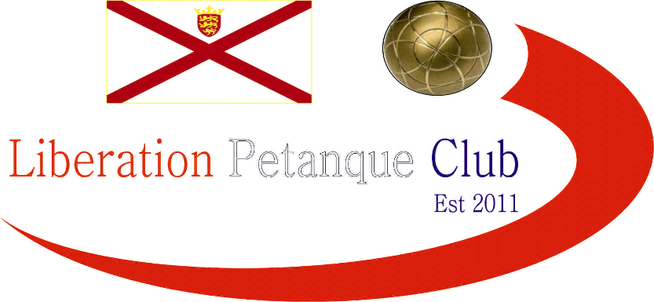

LIBERATION PETANQUE CLUB

CHARITY TRIPLES OPEN

7th October 2017

In Aid of Jersey Childrens Charity

10 teams entered this year resulting (along with donations) raising £175 for Jersey Childrens Charity. Well Done and thank you to everyone who contributed.

Matt Pinel, Andrew Bellamy-Burt and James Rondel joined forces to try and win this year’s competition and started off well moving to a 10 – 5 lead against Andy & Lorna Limbrick and Alan Huelin, but ended up losing 13 – 10!. Big win for three times winner Toby who was playing with Matt Buesnel and Geoffroy Buffetrille, they played last years winner Colin Myers who was also playing with new partners Jake Romeril & Richard Williams, final result 13 – 2.

Alex, Jean and Cassie Stewart fought back to win a very close match 13 – 12 against Ross Payne, Brian Harris and James Gennoe.

David, Brigitte & Alice also lost 13 – 12 to Bob and Michel Morel and Dawn Buckley.

Round 2 saw Matt Pinel, Andrew and James regain some form to beat Colin, Richard & Jake 13 – 4, Ross, Brian and James won their first match against Toby, Matt B and Geoffroy.

Michel, Bob and Dawn were the only team after two rounds to have won both matches. Round 3 though did see them lose to Neil, Chris and Matt.

Alex, Jean and Cassie thrashed Toby, Matt B and Geoffroy 13 – 2 with some great placing and a few lucky fires! Last years winner Colin Myers with Richard and Jake finally won a game against David, Brigitte and Alice 13 – 7.

Wendy, Mike and Judy took a big step towards the semi finals with a 13 – 3 win over Andrew, Lorna and Alan.

So after 3 rounds:
Matt, Andrew and James 2 wins +14
Wendy, Mike, Judy 2 wins +9
Alex, Jean, Cassie 2 wins +7
Bob, Michel, Dawn 2 wins +4
Neil, Chris, Matt 2 wins +3
David, Brigitte, Alice 1 win -1
Toby, Matt, Geoffroy 1 win -4
Ross, Brian, James 1 win -5
Lorna, Andrew, Alan 1 win -13
Colin, Richard, Jake 1 win -14

Well what a turn around in round 4 as Colin, Richard and Jake won big 13 – 4 against Wendy, Mike and Judy, Matt P, Andrew and James won 13 – 2 against Alex, Jean and Cassie.

Neil, Chris and Matt were 10 – 0 down against Toby, Matt and Geoffroy, before coming back to 10-7, before the latter finished the game off 13 – 7.

David, Brigitte and Alice beat Ross, Brian and James 13 – 9 and Bob, Michel and Dawn won their 3rd match against Lorna, Andrew and Alan.

So the final rankings were:
Matt, Andrew and James 3 wins +14
Bob, Michel, Dawn 3 wins +8
David, Brigitte, Alice 2 wins +3
Toby, Matt, Geoffroy 2 wins +2
Wendy, Mike, Judy 2 wins 0
Neil, Chris, Matt 2 wins -3
Alex, Jean, Cassie 2 wins -5
Colin, Richard, Jake 2 wins -5
Ross, Brian, James 1 win -9
Lorna, Andrew, Alan 1 win -17
Semi-Final 1
Ranked 1st Ranked 4th
Matt, Andrew and James v Toby, Matt, Geoffroy
Semi-Final 2
Ranked 2nd Ranked 3rd
Bob, Michel, Dawn v David, Brigitte, Alice

David, Brigitte and Alice would have been looking for revenge over Bob, Michel and Dawn after losing by the narrowest of margins 13 – 12 against them in round 1. It was to be as the Ibitsons started off really well and never looked back winning 13 – 6 to make the final.

Toby, Matt, Geoffroy, after squeezing through to the semi-finals started off really well, quickly moving into a 6 – 2 lead and could have made the margin much wider had it not been for a complete miss fire by James Rondel shooting a boule at least a meter away from the target boule and not even on the same line, the bouole he it, some how took the coche out saving the team losing 4-5 points.

In the end Matt Pinel made his second successive Charity Triples final as himself, Andrew and James ran out 13 – 7 winners.

With the rain coming down heavy Bob, Michel and Dawn took full advantage beating Toby, Matt and Geoffroy 13 – 8 to take the bronze medal.

David, Brigitte and Alice couldn’t have had a better start to the final taking a 9 – 0 lead, however Matt, Andrew and James came back to lead 12 – 11, before the Ibitsons made it 12 – 12.

The final end saw another coche move go Alice’s way as the Ibitsons took the title 13 - 12. Congratulations. Pictured below with Chairman Ross Payne.
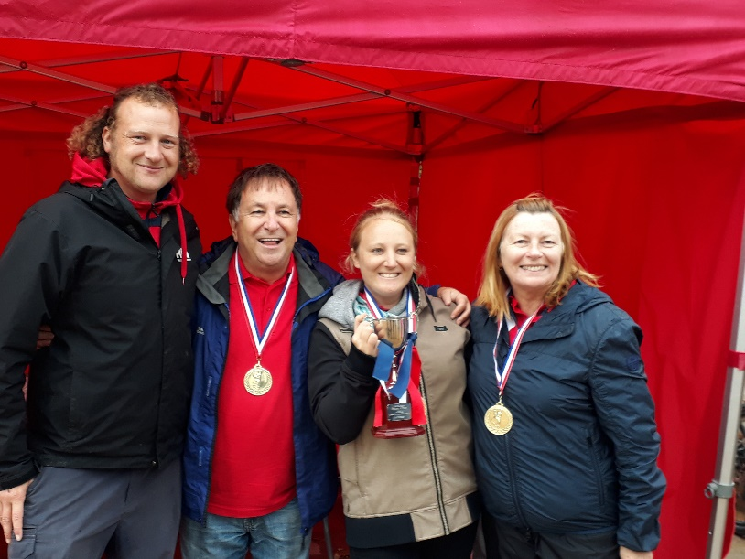

A wonderful days play and a great amount raised for a very worthwhile charity – Special thanks to everyone for their kind support.

Kind Regards
Toby Northern
Liberation Petanque Club

2016 Rankings (after 4 rounds)

Toby Northern, Ross Payne, Brian Harris 4 Wins +39
Matt Pinel, Matt Buesnel, Richard Nevitt 4 Wins +37
Michel Morel, Chris Pinel, Bob Morel 4 Wins +22
Colin Myers, Steve Simpkin, Matt Ryan 3 Wins +15
Ellis Turmel, James Gennoe, Geoffroy Buffetrille 2 Wins +10
Wendy Ritzema, Mike Ritzema, Richard Sowerby 2 Wins -1
Andy Limbrick, Lorna Limbrick, Matt Scholefield 2 Wins -3
Martin Koradi, Teresa Koradi, Michael 1 Win -20
Pat Cooper, Gary Cowburn, Haden 1 Win -21
Zoe, Alison, Liz 1 Win -23
Helene Retrosi, Neil Selby, Christian Selby 0 Win -26

