

**BRAND AMBASSADOR**

**2019-2020**

**Did you see a lot of Addison in our social media feeds this year?**

**Want to know why?**

**She was our Brand Ambassador 2018-2019**

**Check email blasts for more information about how your dancer can be the next brand ambassador for**

**Next Step Dance!**

**PICTURE WEEK 2019**

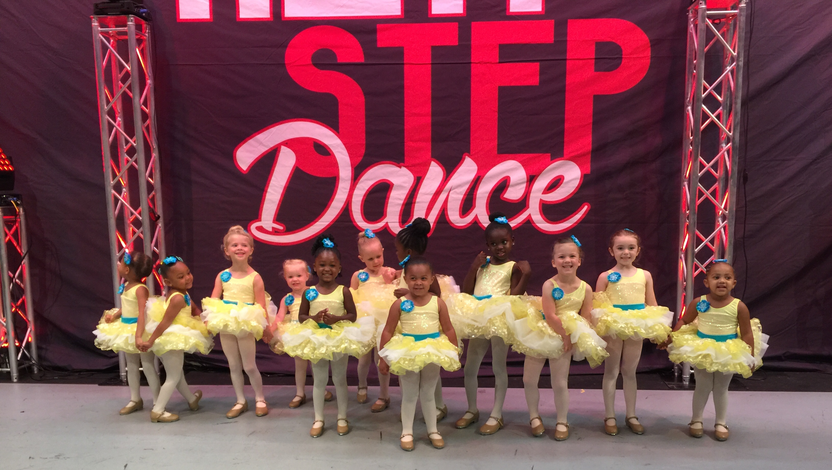

Get ready for group and individual portraits of your dancer! April 8th-11th we will shoot pictures during your child’s regular class time. Come dressed with your recital costume and the biggest smile ever! Check emails for more information.

**#class of the month**

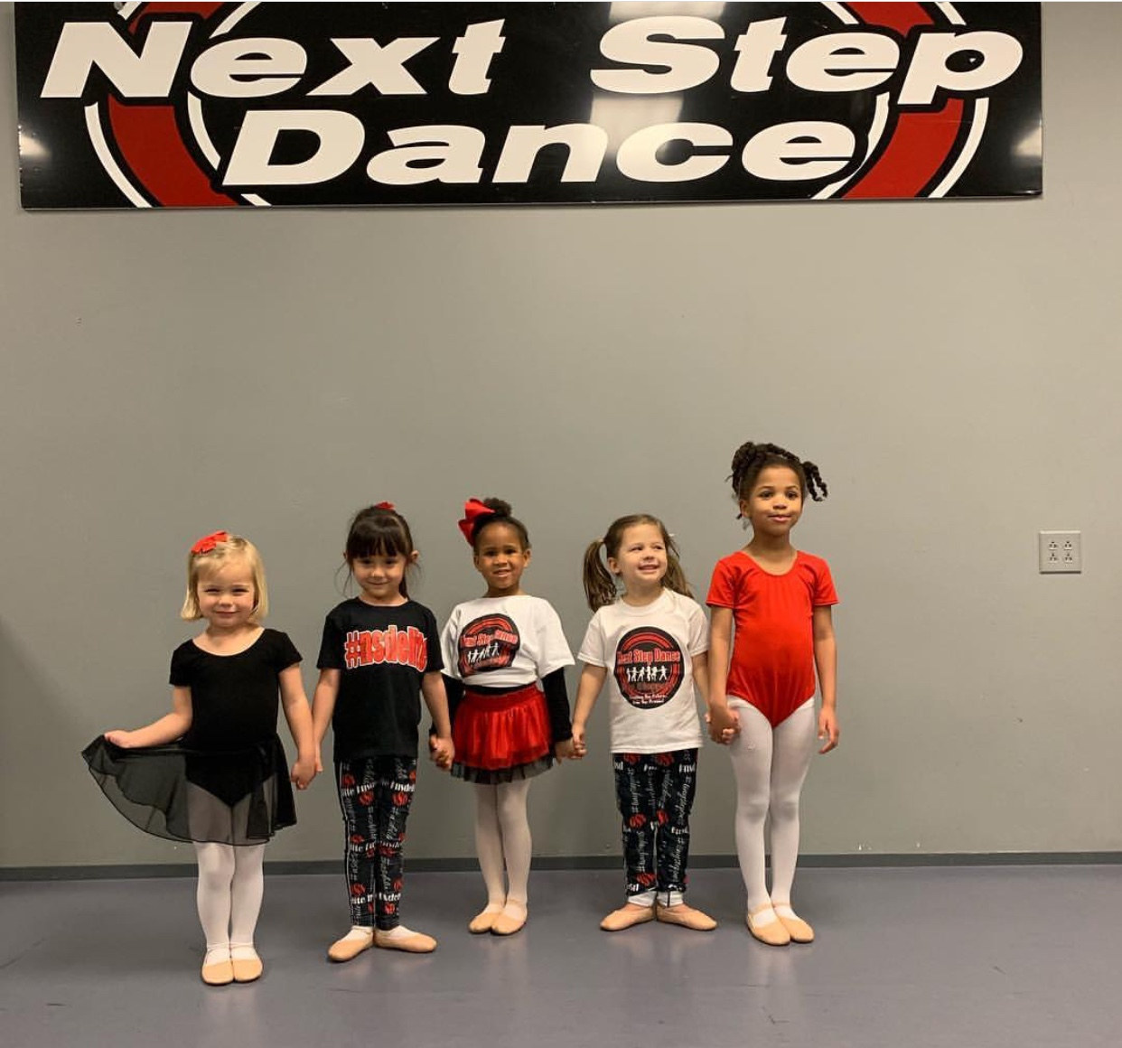

***OUR YOUNGEST DANCERS***

During the month of March our youngest dancers will get a sneak peek into **summer** **class** **fun!** This will help you know what to sign up for during our pre-registration week.

**2019 SUMMER CLASSES**

 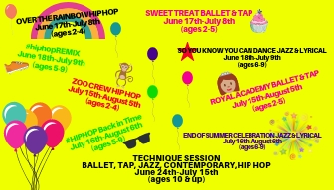

Our summer class schedule will launch this month! March 4th-7th our summer registration station will be in the lobby for early sign-ups and discounts. Register during this week and you will receive a discount on your 2019-2020 registration fee AND if you sign-up for 2 sessions there will be a discount on tuition. Come check out all the adventures we have planned for our Tiny Steppers and the action packed fun in our 5-10 year old classes. There is also an opportunity to work with our industry professionals in technique classes. Don’t miss a minute with your friends and teachers as we make **DANCE** **FUN** **ALL SUMMER** **LONG!**

Steppin’ into **MARCH 2019** with Next Step Dance

[**www.thenextstepnc.com**](http://www.thenextstepnc.com)

**7712 Sossamon Lane, NW Concord, NC 28027 (704) 786-7837 nsdcalendar@gmail.com**

**OPEN HOUSE**

Thinking ahead to summer activities or even Fall 2019? Have a friend or relative interested in dance? Have a younger sibling that will be old enough for our Tiny Steppers program? Find out schedules and all the important stuff at our Open House on Saturday, May 18th, 2019 from 10:00am-1:00pm

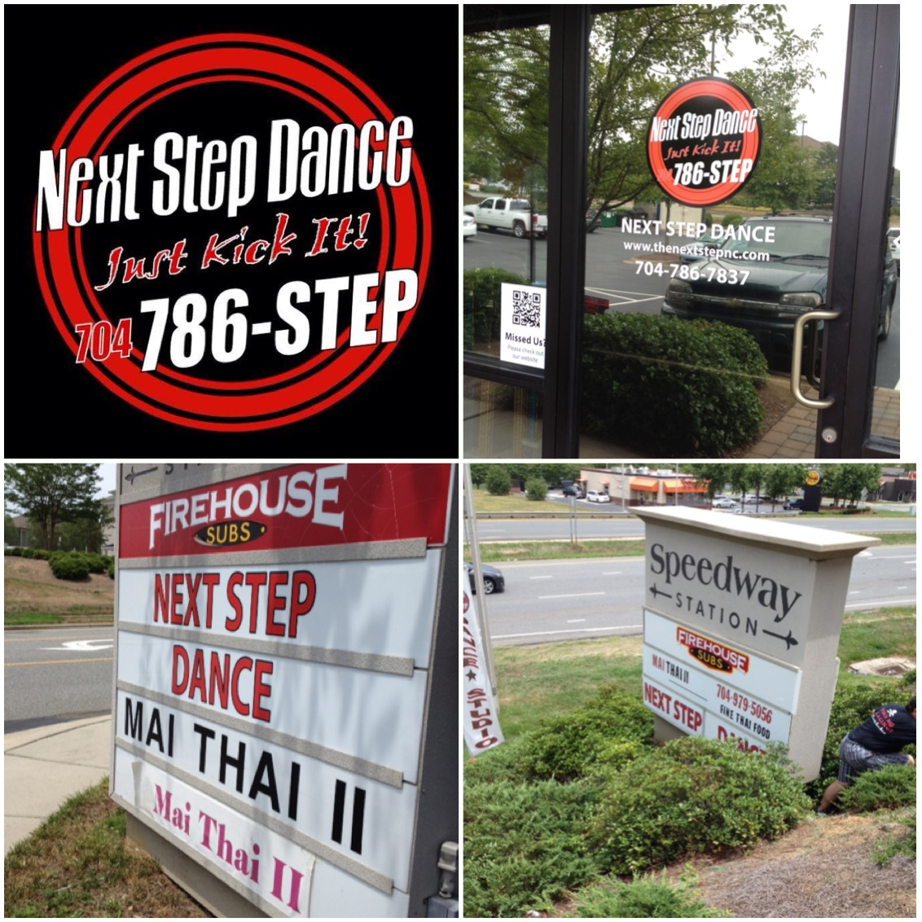

**SAVE THE DATE**

March 10- Daylight Savings Time begins

**March 17- Wear GREEN**



Shoe orders take approximately 1-week for delivery and some we have in stock!

REMEMBER TO JOIN US ON

Facebook, Twitter, & Instagram!