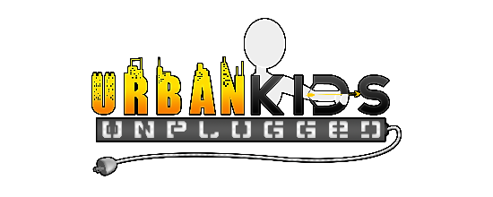

Camper Guide

We are happy to welcome you to Urban Kids Unplugged Adventure Day Camp 2025 and are looking forward to an exciting session! To ensure your child’s enjoyment and comfort, we have come up with simple rules and recommendations.

**Daily Personal Items Check List:**

sunscreen mosquito spray

athletic shoes hat (full brim if possible)

extra pair of socks extra underwear

swimsuit (everyday) towel (everyday)

sunglasses personal hygiene items

backpack 20oz. or larger water bottle

breathable athletic shorts or pants camp shirts

personal medication (check in)

*Most campers choose to bring their own personal bikes, but we do have loaners. Please request to use a bike prior to our riding day(s).

*Please leave cell phones at home! They are not needed. Parents are welcome to call me direct or other coaches, if needed. Remember, we are unplugged. Even teens!

**Lunch and Snacks**

Please pack a hearty lunch and ample snacks for a busy day. We give an advance notice when dining out is an option. Gatorade and water will be provided, so beverages are not necessarily needed.

**Camp Rules**

Urban Kids Unplugged rules are simple and easy to follow. Please do your best to honor and abide by them so your camp experience will be awesome!

1. I will be safe
2. I will try my best
3. I will be respectful
4. I will be responsible

Thank you,

Coach Rodriquez

**Important Message Before Registering:**

Over the past few years, Urban Kids Unpluggedhas achieved great success by priding itself in moral respect, wholesome values, and a love for unplugged physical activities and the outdoors. Our high client return rate and many friend referrals fuel us to offer our valued clients this unique service each year.

We do understand that kids will be kids and we do not expect them to be perfect. They will make mistakes and have disagreements. Through patience and respect, we will do our best to guide them through their learning process. 

**​**Please note that our camp is a privilege for your child, **not a punishmen**t from video games and electronics. For the enjoyment and safety of all campers, we will not tolerate:

-Vulgar or explicit language and heated conversations

-Threats or intentional physical harm to others

-Lack of respect to coaches and campers

-a poor attitude (Simply put, if your child does not desire to participate in our unplugged camp, then we are not the best option for them)

Failure to comply will result to a possible dismissal from camp without refund or transfer (based on reoccurrence or severity). We will give campers ample redirection/warnings and communicate concerns with parents before any action is taken.

Thank you for your time and we look forward to working with your child.

Sincerely,

Coach Rodriquez

Fair time and we look forward to working with your

**Urban Kids Unplugged Oath**

I am an Urban Kid Unplugged. Today, I will use my mind and body in ways that enhance my health and wellbeing. I will attentively listen to instructions given and make safe choices. I will strive to perform to my fullest potential and be an encouragement to my peers. Today, I will do all these things because I am an Urban Kid Unplugged!