Summer 2018
End of Season
Report
What a record breaking season it has been, not only was there a record number of Fanny certificates given out (22) including only the third ever Double Fanny certificate but a number players achieved their first title successes.
Premier League Double Champions
Jake Romeril and Mark Nicol
Jake and Mark made it back to back Summer Premier League titles, beating Toby Northern & Matt Pinel who finished second. Third place was a close finish, but just on points difference by two points it went to Ross Payne & Neil Selby.
Commiseration to those relegated from the Premier League, Joey Le Clech & Jonny Hill and Alan Oliveira & Craig Kelly
Division 1 Double Champions
Alice & Brigitte Ibitson
Division 1 Doubles was won by Alice & Brigitte who started out as favourites and never looked anything but all season, also joining them in promotion was Eamonn & Karen Bougeard who finished second, followed by David Le Gresley & Paul Bell in third. All three teams playing in the Premier League next Summer.
Commiseration to those relegated Mo De Gruchy & Stephen Stoneman and Jean Stewart & Chris Le Gallais.

Singles Division 1 Champion
Alex Stewart
Alex won in impressive style, scoring a massive 28 points beating Richard Williams to the title by 3 points, this is Alex second successive promotion to the Premier League having done so also in the Winter 17-18 season.
Pre-Season favourite Joey Le Clech had far too many draws as he finished 8 points off top spot and missed out by 1 league point to Laurent Pellaton to that coveted promotion place despite having a much better points difference. Laurent could have been rueing a bad start to the season picking up just two league points from his first four matches but played exceptionally well in the second half of the season to snatch third place from Joey.
Commiseration to those relegated Mo De Gruchy, Stephen Stoneman and Jean Stewart.

Premier League Singles Champion
Matt Pinel
Well Done to Matt Pinel who handed out a record number of fanny certificates on his way to the title and at one point after winning his first 9 matches was looking good for a 100% record before his doubles partner Toby Northern ruined it. Matt though finished 10 points clear of second placed Andrew Bellamy-Burt who was on the end of one of Matt’s 13 – 0 wins.
Third place was tight, but Ross Payne pipped Matt Buesnel for a medal position, clearly he had a much better Summer than he did the previous Winter season when he finished bottom of the Premier League.
Commiseration to those relegated Jonny Hill, Paul Le Moine and Callum Stewart.
Well Done also to Andrew Bellamy-Burt for winning the Club Singles Cup, Toby Northern & Matt Pinel for winning the Liberation Doubles Cup.

Player of the Season
Richard Williams
Richard had a great season in the Singles league gaining promotion unbeaten with a points difference of +116 and is one of the rising stars.

Last but certainly not least –
Liberation Petanque Club and the InterClub Champions
Team Photo below. (a few missing players though)
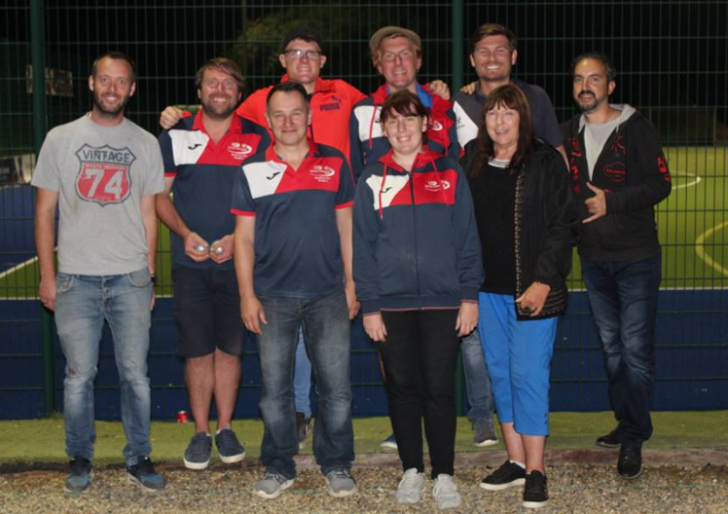
Don’t forget the end of Season Presentation & Meal Saturday 20th October 2018 at Chambers
I hope you all enjoyed the season and are looking forward to another great winter of petanque.

All end of summer season tables, winter fixtures and calendar on the website.

Club email address - liberationpc@gmail.com

Club Website - www.liberationpetanque.co.uk

Kind Regards

Toby Northern

Chairman

Liberation Petanque Club

SPONSORED BY

