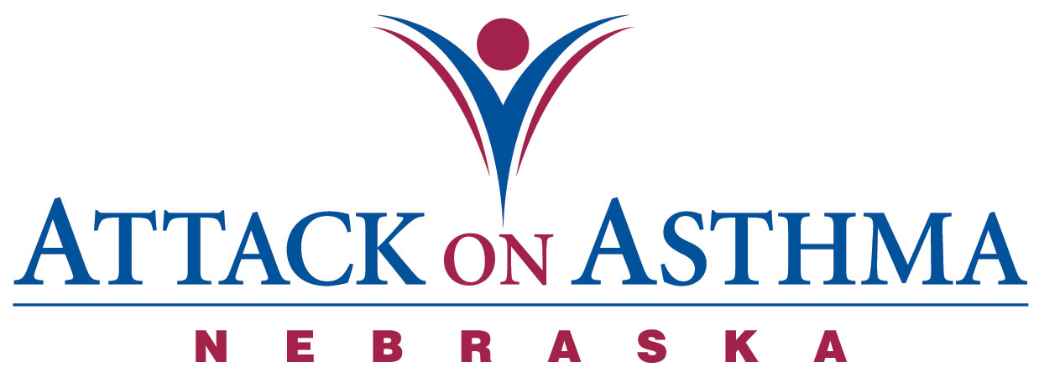

Characteristics of Individuals and Protocol Use in Nebraska Schools
2007-08

Data was voluntarily reported to Attack On Asthma Nebraska (AOAN) during and following the 2007-2008 school year. During this period of time there were 48 reported incidents of the Emergency Response to Life-Threatening Asthma or Systemic Allergic Reaction (Anaphylaxis) protocol being implemented. Schools submit data using a standardized form.

- While most schools reported only one incident of protocol administration with a student, there were 2 schools that reported two incidents with the same student.

- Half the incidents occurred during the months of August, September, October, November (50%).

- Protocol administration was split evenly between male and females (50%).

- More Elementary school students (46%) were administered the protocol than Middle School (10%) and High School (20%) students. There was also one staff incident reported.

- The greatest percentage of incidents was reported in conjunction with activity; PE class and recess (40%). Classroom (40%) incidents as a location followed.

- The majority of the incidents were with an individual with a history of asthma (75%). Ten reported no history of either asthma or anaphylaxis (21%) and only two reporting a history of anaphylaxis (4%).

- Slightly over two-thirds (69%) received epinephrine as a correct usage of the protocol.

- Five individuals (10%) with no history of asthma returned to school with an action plan.

- Eighteen individuals (38%) with a history of asthma and no action plan on file returned to school with an action plan after protocol administration.

- Of those individuals with a history of asthma, one quarter (27%) had an action plan on file.

- Both individuals with a history of anaphylaxis did not have an action plan on file at school. One individual returned to school with an action plan and one did not.

- No one required the administration of CPR.

- There were thirteen (27%) incidents in which albuterol only was administered.

- Emergency Medical Services (EMS) was summoned 96% of the time. Of the two times that EMS was not summoned, both incidents were treated with albuterol only.

- Thirty-six individuals (75%) were transported to a medical facility via the Emergency Medical System. Ten individuals (21%) were transported to a physician’s office or medical facility by a parent or were signed off by a parent.

- Twelve school districts reported the 48 incidents.

Assumption made: Action plans on file at school include prescribed medication(s).

Notes: The numbers and percentages above include all incidents, not to exclude the students of repeat protocol administration.

