In This Issue
ISSUE
May
2022

CCUMC NEWSLETTER
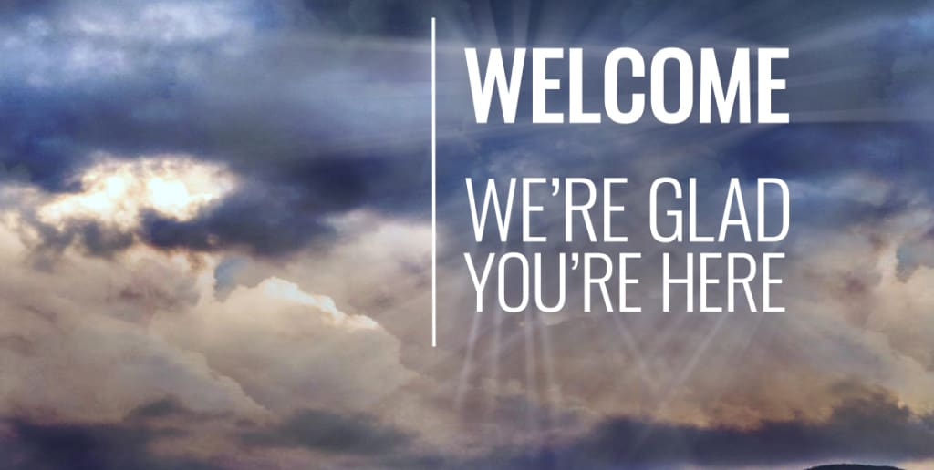
Pg. 1, 2, 3, 4 Pastor’s Corner
Pg. 5 Coming Up Nest
Pg. 6 Save the Date
Pg. 7 Bible Studies & Small Groups
Pg. 8 Vacation Bible School for 2022
Pg. 9 Youth VBS T-Shirt Order Form
Pg. 10 VBS Decorating Work Bee
Pg. 11 Calendar for April 2022
Pg. 12 Church Information

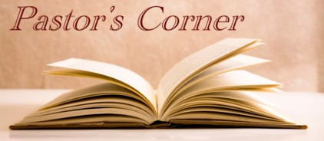
This months’ Pastor’s Corner is an article I want to share from Good News Magazine’s Perspective by Thomas Lambrecht, that explains where we are currently as a denomination and how we got to this point.
With the postponement of General Conference until 2024 and the announced launch of the Global Methodist Church on May 1, 2022, many people across The United Methodist Church are waking up to the reality of separation in our denomination. Hundreds of churches are applying for disaffiliation from the UM Church. Hundreds more are discerning whether their future lies in the GM Church. In the process, thousands of laypersons who have been in the dark about all the conflicts leading up to this point are asking, “What’s it all about?” Why are many churches leaving the UM Church? Why would our congregation consider leaving for the GM Church?
This article aims to give a succinct, but not exhaustive, summary of what is at stake.
Theological Crisis
Baked into the DNA of United Methodism since 1972 is the idea of theological pluralism – that there are many different understandings of the faith and nearly all understandings are welcome within United Methodism. From the time our denomination was founded, we have not had a coherent, unified understanding of our faith. Is Jesus without sin and error, or was he a flawed human being like the rest of us who somehow became a revered moral teacher? Was Jesus’ death on the cross necessary for our salvation, or was it an act of so-called “divine child abuse?” Did Jesus really rise bodily from the grave, or was his “resurrection” only a greater spiritual awareness on the part of his disciples?

Pastor’s Corner cont’d

From the beginning of our church in the 1960’s, many boards of ordained ministry have approved candidates for ordination who believed and taught very diverse understandings of the faith. Beneath headline-grabbing issues such as marriage and sexuality, root theological issues have divided United Methodists for decades revolving around evangelism, church planting, the Great Commission, Sunday school curriculum, and even the most fundamental beliefs of the Christian faith. Those moving into the GM Church believe clergy (and indeed all Christians) should be able to recite the Apostles’ Creed without holding crossed fingers behind our back or reinterpreting the words to mean something other than what they say.
One way this doctrinal pluralism manifests itself is through disagreements over the understanding and interpretation of Scripture. Is the Bible “the true rule and guide for faith and practice” we say it is in our doctrinal standards (Confession of Faith, Article IV)? The United Methodist Church affirms, “Whatever is not revealed in or established by the Holy Scriptures is not to be made an article of faith nor is it to be taught as essential to salvation" (Ibid). Yet, many bishops, clergy, and UM leaders, for example, want to rewrite the biblical understanding of marriage taught in Scripture (e.g., Matthew 19:2-9) and ignore or countermand the explicit teaching of Scripture that same-sex relationships are not in keeping with God’s design for human relationships (e.g., Romans 1:21-27; I Corinthians 6:9-11). Some high-profile United Methodist leaders would go so far as to relegate whole chunks of the Bible to the category of “they never reflected God’s timeless will.”
This disregard for the clear teaching of Scripture undermines its authority. If the Bible can be wrong about one important aspect of Christian theology, can it be wrong about other aspects of faith? The Bible should be our authority for what to believe, not what aspects of Scripture we accept as God’s self-revelation and what aspects we ignore. In the latter case, we become the authority for our own faith. But that approach contradicts what we say we believe as United Methodists. We would no longer be true to our Wesleyan understanding.
The theological crisis manifests itself most clearly right now in attempts to officially contradict Scripture by affirming same-sex relationships. We don’t vote at General Conference on the deity of Jesus or whether God performs miracles. But that crisis also manifests itself every time a pastor preaches an Easter sermon without reference to the resurrection or communicates that the way to salvation is “doing all the good you can” apart from Jesus’ atoning death on the cross. For decades, our denomination has been able to muddle through despite all these theological differences. What has cast the church into an existential turning point now is the second crisis, an ecclesiastical crisis.

Pastor’s Corner cont’d

Ecclesiastical Crisis
The short description of our ecclesiastical crisis is that The United Methodist Church has now become unable to function by the processes and rules set by our church constitution. Over the years, bishops and other leaders who disagreed with the church’s teachings have increasingly turned a blind eye to violations of that teaching. The unwillingness to hold one another accountable to the teachings and practices of the church is the acid that has eaten away the foundation of our denomination.
In 2002, then-Bishop Joseph Sprague published a book, Affirmations of a Dissenter, that reinterpreted or denied many of the main tenets of Christianity. A complaint was filed against him for “dissemination of doctrines contrary to the established standards of doctrine of The United Methodist Church.” Those in charge of adjudicating that complaint took no disciplinary action against Sprague. Apparently, his beliefs were within the pluralistic realm of United Methodist faith.
Over the last 20 years, the accountability processes for clergy and bishops have broken down. Bishops have decided to circumvent the process by “resolving” complaints with little or no discipline for clergy who violate our church’s requirements. By the same token, complaints against bishops are “resolved” with no accountability by those bishops and church leaders entrusted with upholding the church’s Discipline. Bishops and leaders are only willing to enforce those provisions they agree with.
In 2016, the denomination appeared ready to unravel at General Conference. As a last-ditch effort to preserve unity, General Conference authorized a Commission on the Way Forward to figure out a solution and bring it to a special 3-day General Conference to be held in 2019. Contrary to the wishes and lobbying of many U.S. bishops, the 2019 General Conference reaffirmed once again the church’s historic stance on the definition of marriage and the ordination of non-celibate gays and lesbians. It further added accountability provisions to ensure that the church’s clergy and bishops would abide by the church’s teachings.
In response, many U.S. bishops and annual conferences publicly apologized for the conference’s decision and sought to distance themselves from it. More than half the U.S. annual conferences passed resolutions repudiating the decision of General Conference, with at least 11 saying they would not abide by it. Several annual conferences in spring 2019 ordained persons as clergy who did not meet the denomination’s qualifications. One European central conference removed the church’s teachings from its Social Principles. Another European annual conference and the whole U.S. Western Jurisdiction began looking into the possibility of separating from the UM Church because they disagreed with the General Conference stance.

Pastor’s Corner cont’d

Faced with this widespread rebellion against church teaching in parts of the U.S. and Western Europe, a group of bishops and church leaders representing traditionalist, centrist, and progressive theological perspectives agreed to a proposal for amicable separation. Called the Protocol for Reconciliation and Grace through Separation, this proposal provided a clear and amicable way for traditionalist congregations and clergy to leave the UM Church, allowing the church to then change its teaching to accommodate a progressive understanding. (For more analysis on why traditionalists are willing to be the ones to move to a new church, despite the current Discipline upholding a traditionalist position, see this article.)
The Protocol was poised to pass at the May 2020 General Conference. With the pandemic causing the postponement of General Conference, finally now until 2024, progressives became increasingly impatient to move the church in a progressive direction. Several annual conferences adopted vision statements that stated they would now start “living into” the future they envisioned, despite the fact that the provisions in the Discipline remain unchanged.
Some individual bishops began taking punitive actions against traditionalist clergy, removing them from their appointments and in some cases even expelling them from the denomination without due process or trial. None of these bishops has been held accountable for their actions. There are bishops now who are openly stating that the General Conference (the only body empowered by our church constitution to make decisions for the whole denomination) can no longer adequately govern the church.
We have evolved to the point in our denomination that the actions and decisions of General Conference can be ignored with impunity by bishops and annual conferences that disagree. Bishops have become a law unto themselves within their own annual conferences, not subject to accountability to other bishops or the broader church. Decisions of the Judicial Council can be ignored. The third postponement of General Conference indicates that the power of institutional preservation of the status quo is greater than the inclination to move into a healthier future. Many progressives and centrists seem increasingly uninterested in an amicable way to allow separation to occur. Instead, many seem to want to punish traditionalists for holding the beliefs that we have and at the same time doing whatever they can to delay or prevent traditionalist clergy and churches from separating from the UM Church in order to join a GM Church that more faithfully represents our faith perspective.

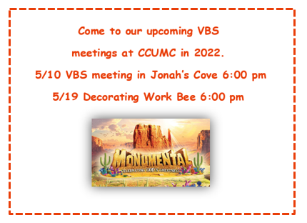
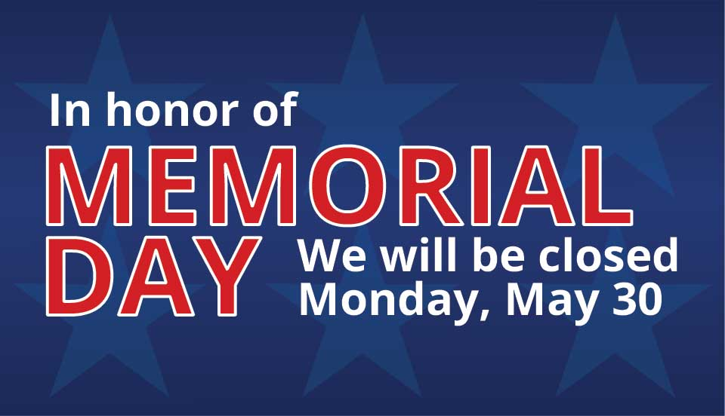

Commission On Aging Meals
Every Tuesday & Thursday @ Noon
In the CCUMC Fellowship Hall
Contact COA @ 989-831-7476
For reservations & cost
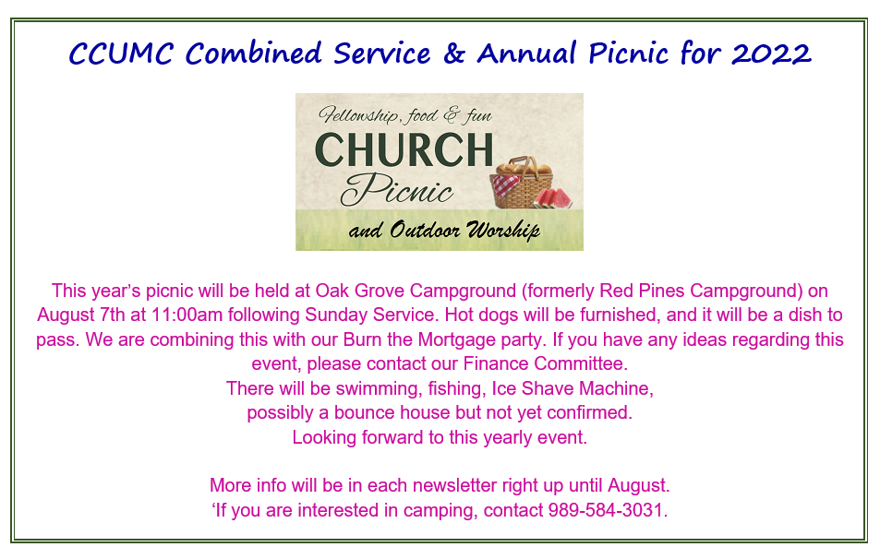
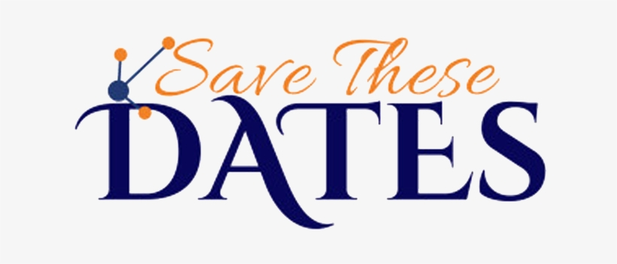
National Day of Prayer: Is Thursday, May 5th. There is a Prayer gathering being held at the old city hall at 7:00 pm. Everyone is welcome to attend.
The theme for the 2022 National Day of Prayer is a call to praise in prayer, ‘EXALT THE LORD, WHO HAS ESTABLISHED US’ based on Colossians 2:6-7 NIV
⁶ Therefore, as you have received Christ Jesus the Lord, so walk in Him, ⁷ having been firmly rooted and now being built up in Him and established in your faith, just as you were instructed, and overflowing with gratitude.
For more information, or to donate, go to https://www.nationaldayofprayer.org/

Page
UWF Frontier Days Picnic Lunch
Sat, 6/4/22 @ 11:00 am to 1:00 pm
in the CCUMC Fellowship Hall

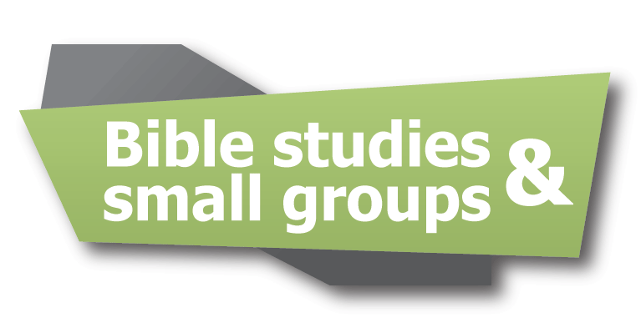

Cool Hour & Children’s Church:
Last day for these two is Sun, May 15th,
which will also be Celebration Sunday.

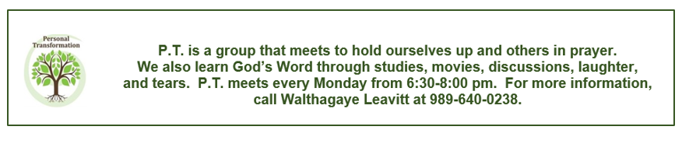
Last meeting dates for the summer on some groups are specified below.
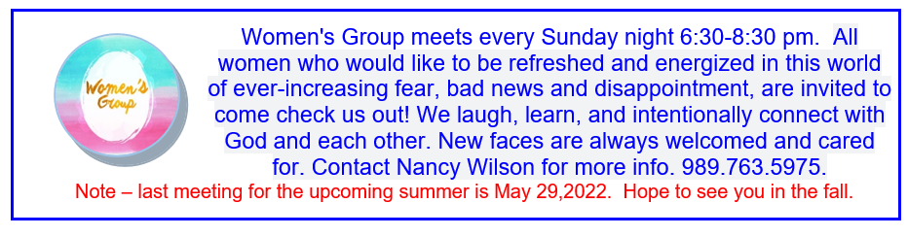

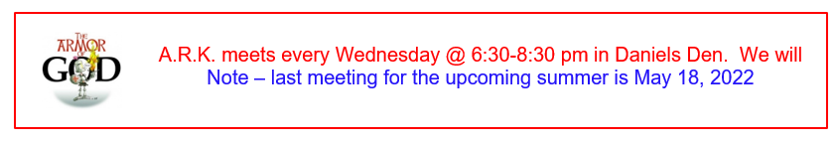

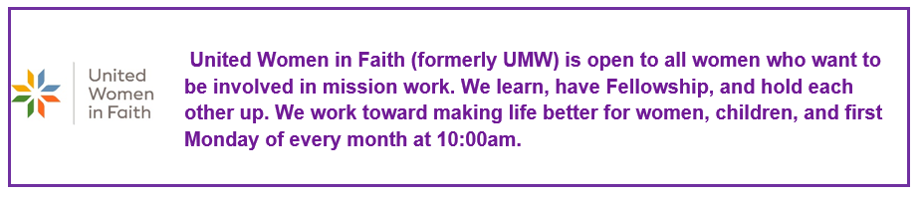

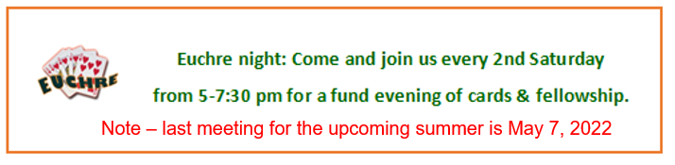

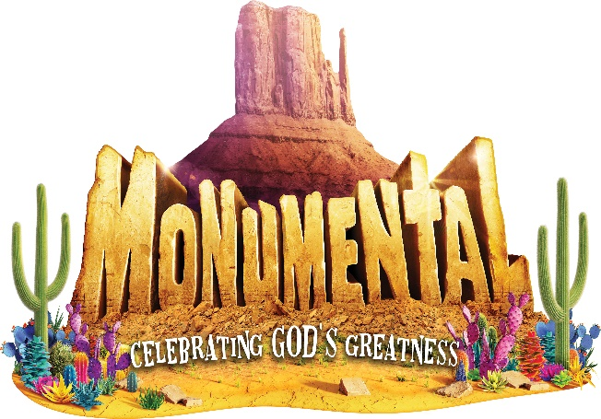

Vacation Bible School - 2022
Monumental
Celebrating GOD’s GREATNESS

“Celebrating God’s Greatness,” the theme for this summer’s VBS is scheduled for Sunday through Thursday evenings, July 17 – 21, 2022, from 6:00-8:30 p.m. Those who attended the March 8th meeting chose Psalm 8:1 as the umbrella scripture for the week’s activities.
“O Lord, our Lord, how majestic is your name in all earth.”
All kids, from 3 years through those entering 6th grade, whether your kids, grandkids, friends, and neighbors, are encouraged to attend this amazing week of experiencing God’s greatness through scripture, Bible Adventures, games, Imagination Station, Kid-Vid- Cinema and snacks. In serving others, we will be providing money to purchase school supplies for Native American children in North America.
You can help through prayer as we spread God’s love throughout this area. If you have any of the following supplies to donate, any will be very much appreciated. Possibilities include small pup tents, cylindrical oatmeal boxes, pool noodles, brown butcher paper or packing paper, white flat sheets, and colorful tissue paper.

Pre-Order VBS
Youth Theme T-Shirts

Kids T-shirts are available for you to pre-order by using the following form, or a form can be picked up from the V.B.S. display in the church lobby. Kids’ sizes are $5.00 each. Forms are due no later than May 15th and may be turned into the church office.

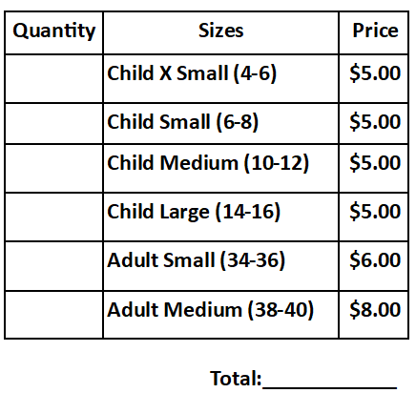

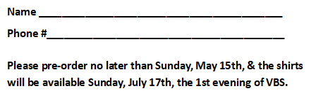

VBS Decorating Work Bee pictures from April 26, 2022.
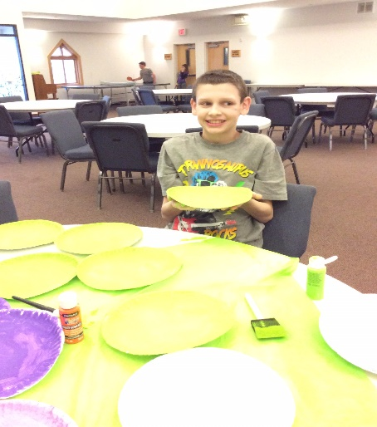
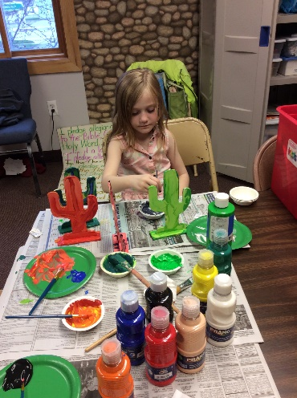
Fifteen people gathered in the evening of Tuesday, April 26th for our decorating bee in preparation for July’s V.B.S. Adults and kids enjoyed a creative time together painting cactus, cutting out giant Buddy posters and assembling decorative items. Our next bee is Thursday, May 19th in the Fellowship Hall at 6:00 pm. Join us if you can!
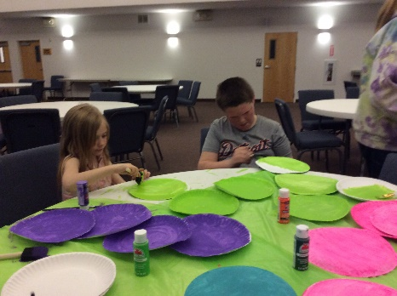
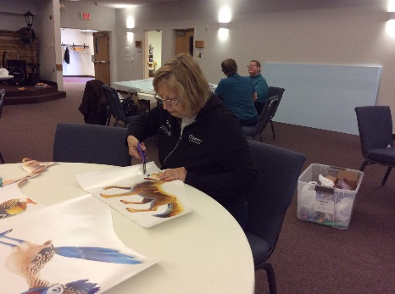
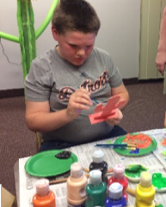
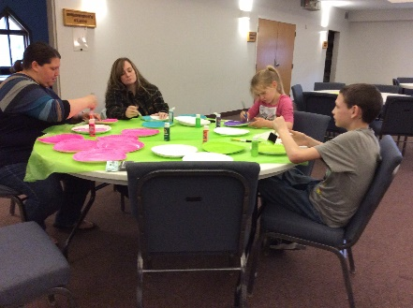
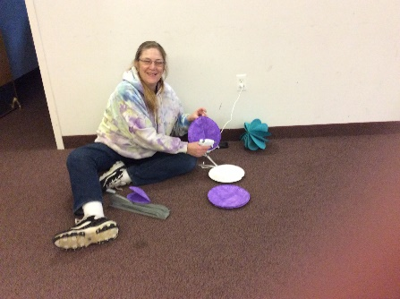
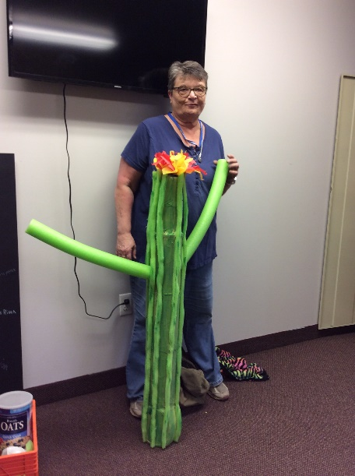
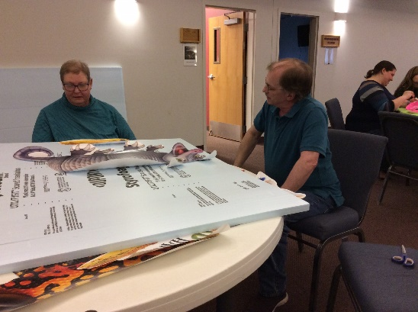

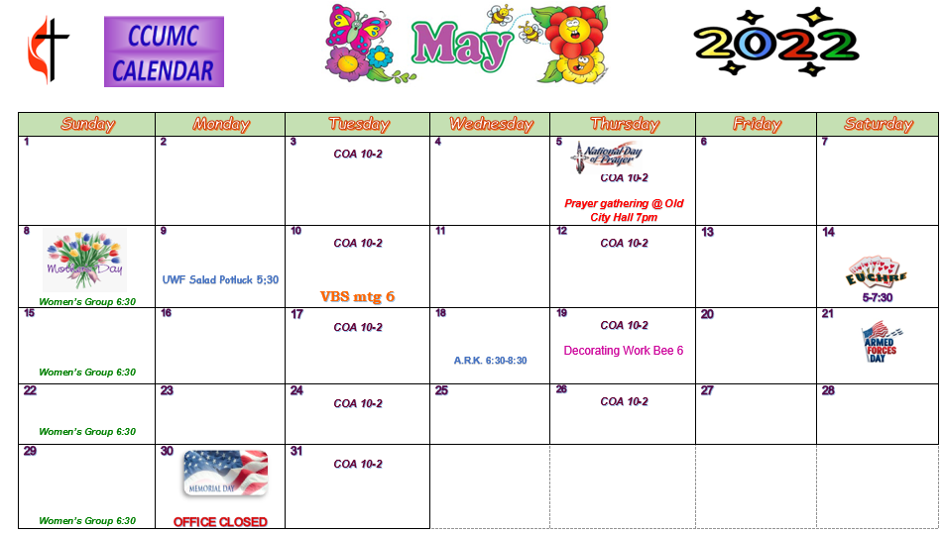

Schedule’s subject to change – contact office for more information”

Stay connected! Follow us on:

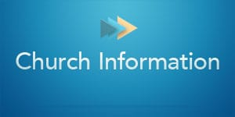

Join Us Each Sunday

Worship Services 10:30 am

(masks are optional)
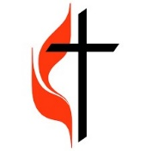

Carson City United Methodist Church
Phone: 989-584-3797
Email: carsoncityumc@gmail.com
Website: carsoncityumc.com
Office Hours: Monday to Thursday, 9:00 am-Noon
After hours by appointment
Pastor: Ian McDonald (906) 322-5318
Secretary: Bonnie Seaman (989) 763-1674

Weekly Sunday Bulletin now available on our website
at www.carsoncityumc.com

Online giving available: Website: http://www.carsoncityumc.com/donate.html

