

SUMMER – 2020 SEASON
CLUB SINGLES CUP - 2020

Our 9th Club Singles Cup was held for the first time on a Saturday and we had great weather all day.

Round 1 saw current Champion Andrew concede the first point against Lorna but that’s was all as he scored 13 straight points for a great start to his defence.

Two other top players amongst the favourites though suffered shock defeats as current Singles Premier League leader Neil Selby lost 13 – 8 to Matt Hutchings and to top that Branden De La Haye beat Geoffroy Buffetrille 13 – 9.

There were two 13 – 12 results as Laurent Pellaton beat Paul Bell and Andrew Limbrick beat James Villalard.

Round 2 saw Andrew match his result against Matt Hutchings and Laurent only conceded 3 points against Ross.

Toby Northern playing his first matches since February followed his 13 – 4 win over Tim Jackson in round 1 by beating Matt Buesnel 13 – 10.

Callum and Jean Stewart played each other and it was the closest match of the round finishing 13 – 12 in Callum’s favour.

In a match that would have been worthy of any final some exceptional play by both Andrew and Toby saw a fantastic game with Toby hitting a 9 metre boule to boule fire moving the coche towards his boule, Andrew just failing to place in meant Toby won 13 – 11 for three wins from three.

Laurent and Callum also won their third straight matches against Brian and Andrew Limbrick respectively.

Ross survived a real scare against Daniel Villalard just taking the win 13 – 12 to stay in contention.

Round four saw the top two play each other but it was Laurent playing exceptionally well who m,ade it four from 4 against Toby.

Daniel Villalard lost his second successive 13 – 12 game, this time against Cassie who moved into contention for a top 8 place. Ross Payne also moved into contention with a good win over Paul Bell.

Brian Harris narrowly beat Jean Stewart 13 -11 to look on course for a top 8 place and Callum Stewart made in 4 straight wins with a 13-3 win over Alex Stewart.

Matt Buesnel chances took a big hit against Doubles League partner Geoffroy who won 13-4.

So the final round with many places and final places up for grabs.

Toby took another big scalp having already beat Matt Buesnel; and Andrew Bellamy-Burt also beat Geoffroy from 5 – 1 down to a 13 – 5 win as Toby finished 2nd in the rankings. Geoffroy dropping out of the top 8 finishing 10th.

Laurent made it 5 from 5 to top the rankings undefeated with a 13 – 7 win over Callum who finished 4th.

Andrew Bellamy secured third place with the first 13 – 0 of the day against James Villalard. Matt Buesnel beat Jean Stewart 13 – 12 but results didn’t go his way and he finished 9th just missing out on 8th place by 1 BHN. This was down to Andrew Limbrick who took 8th with a win over Matt Hutchings.

Paul Bell and Cassie could have both gone through but playing each other it was a win or bust match which Paul won to finish 7th with Ross Payne finishing 6th despite losing his final match to Brian who finished 5th.

FINAL RANKING

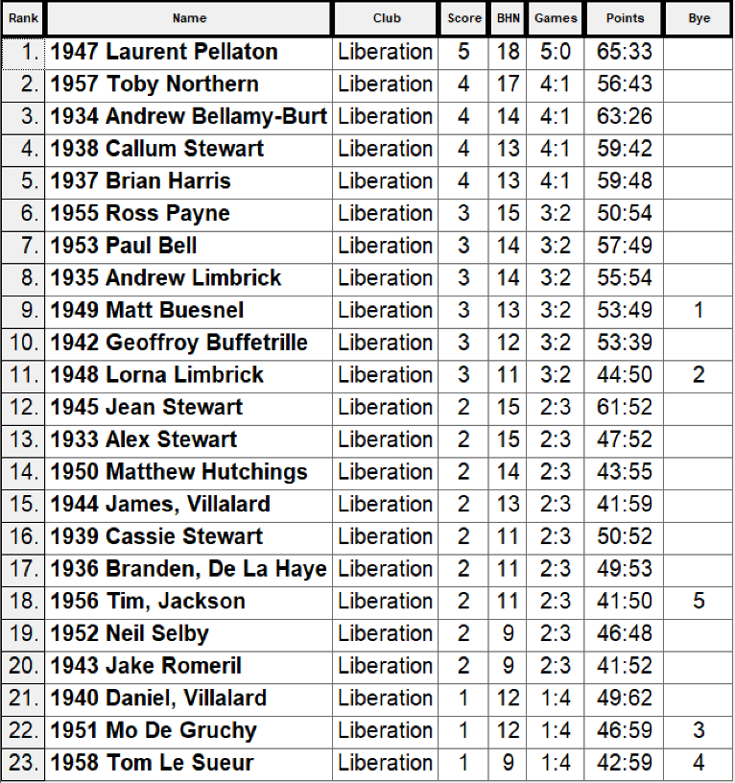

Quarter Finals

Ranking |  |  |  |  |  | Ranking
1 | Laurent Pellaton |  | v |  | Andrew Limbrick | 8
2 | Toby Northern |  | v |  | Paul Bell | 7
3 | Andrew Bellamy Burt |  | v |  | Ross Payne | 6
4 | Callum Stewart |  | v |  | Brian Harris | 5

Laurent was looking odds on for the title with a 13 – 6 win over Andrew Limbrick with Toby matching that score against Paul and Brian turn the rankings around also matching the 13 – 6 by beating Callum.

The closest match though was Andrew B and Ross who played out a 13 – 12 match with Ross missing a good chance to win it and then two miss fires on the last end after Andrews great point meant Andrew stayed on course for a historic third title in a row.

Semi Finals

1 | Laurent Pellaton |  | v |  | Brian Harris | 5
2 | Toby Northern |  | v |  | Andrew Bellamy-Burt | 3

Brian started off really well against Laurent leading 7 – 1 early on but Laurent fought back well but unfortunately it wasn’t to be as Brian saw out the game for a 13 – 10 win.

Andrew also built up an early lead 8 – 2 against Toby who then got back to 8 – 7 before Andrew excellent placing saw him make his third successive final winning 13 – 7.

Despite leading 11 – 5 Laurent couldn’t take advantage against Toby who score 8 straight points to win 13 – 11 to take third place.

It was a close final between Brian and Andrew. Brian was leading 11 – 7 before Andrew scored three points and looked to have the advantage but threw an invalid coche allowing Brian to place it where he wanted and this proved this difference as Brian picked up the two points he needed for his first major Liberation title having lost in three previous finals (2 Liberation Doubles Cups 2018 & 2019 and 2019 Super Sevens Cup)

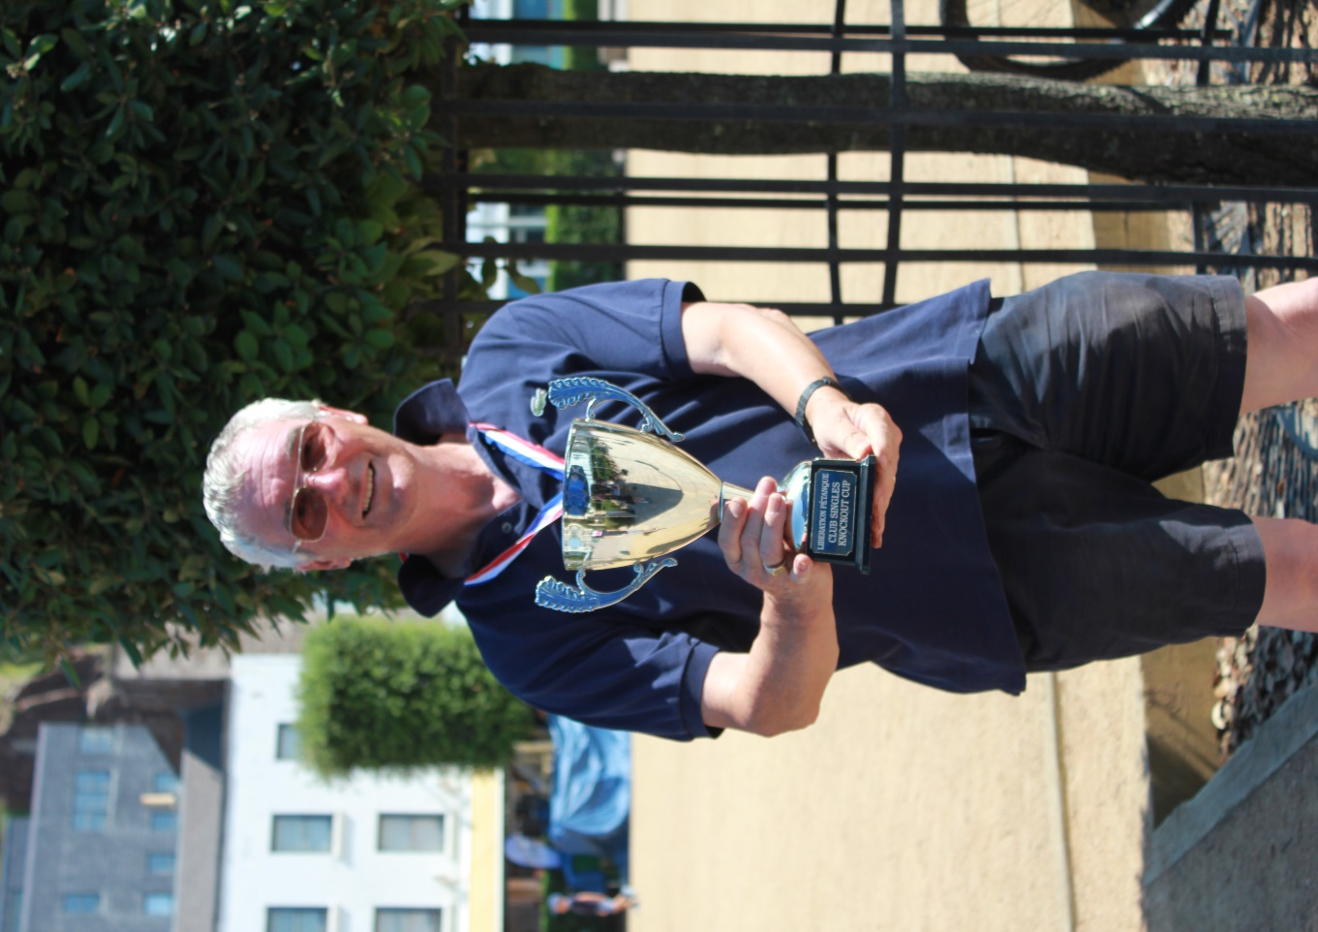

NEXT WEEK - 12th August - DOUBLES LEAGUE

Club email address - liberationpc@gmail.com

Club Website - www.liberationpetanque.co.uk

Kind Regards

Toby Northern

Chairman

Liberation Petanque Club


SPONSORED BY

