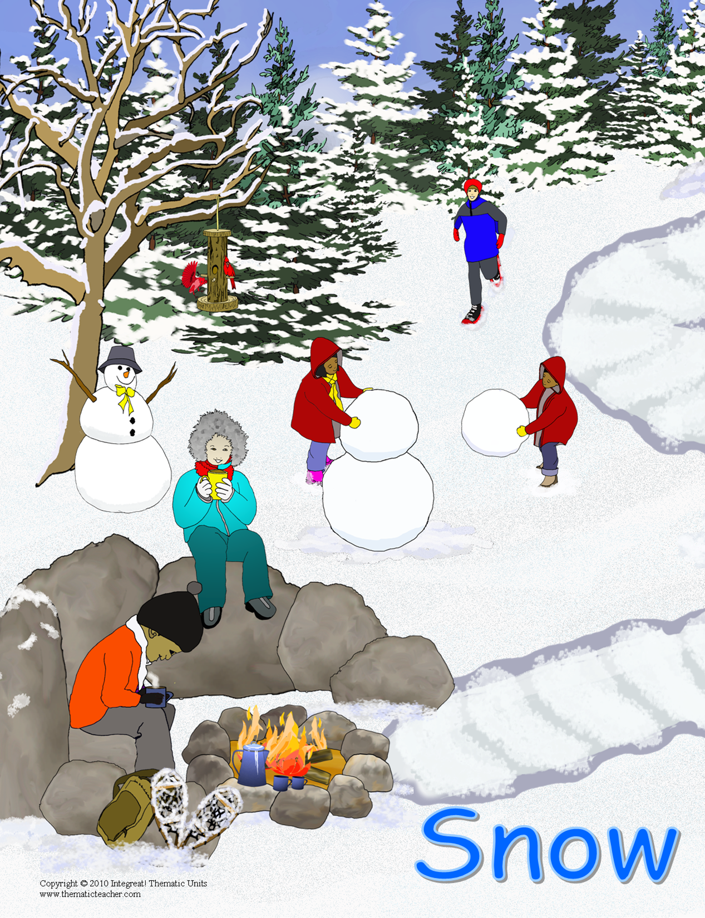
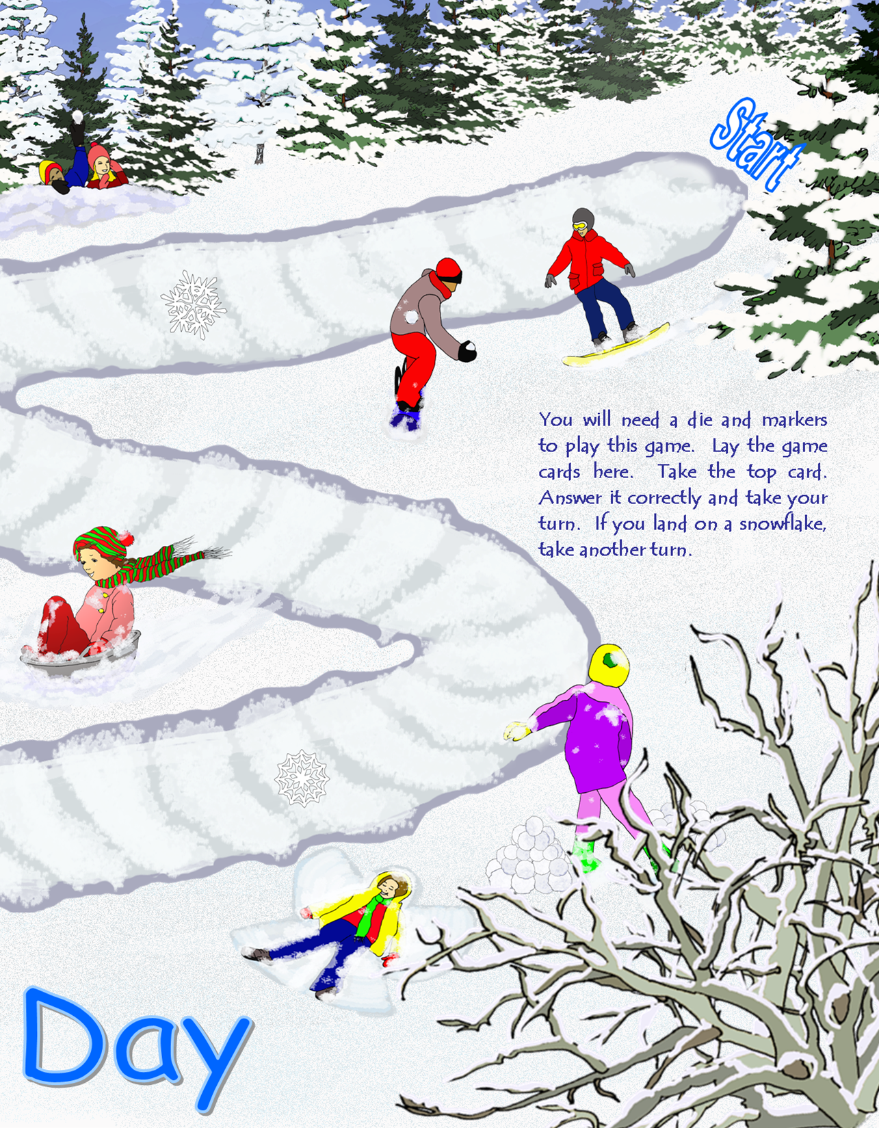

Type your words or questions here.
Type your words or questions here.

Type your words or questions here.

Type your words or questions here.

Type your words or questions here.

Type your words or questions here.

Type your words or questions here.

Type your words or questions here.

Type your words or questions here.

Type your words or questions here.

Type your words or questions here.

Type your words or questions here.

Type your words or questions here.

Type your words or questions here.

Type your words or questions here.

Type your words or questions here.

Type your words or questions here.
Type your words or questions here.
Type your words or questions here.
Type your words or questions here.

Type your words or questions here.

Type your words or questions here.

Type your words or questions here.

Type your words or questions here.

Type your words or questions here.

Type your words or questions here.

Type your words or questions here.

Type your words or questions here.

Type your words or questions here.

Type your words or questions here.

Type your words or questions here.

Type your words or questions here.

Type your words or questions here.

Type your words or questions here.

Type your words or questions here.

Type your words or questions here.

Snow Day
Game Board
Tips and Suggestions

You can use this game board with any set of flashcards, or lists of questions and answers that you want the children to practice. With emergent and beginning readers you may give them a book you want them to practice, and after reading a page they may then take their turn. With older students you may have them read a passage from the science or social studies text and state the main idea. You may also use the mini game cards to produce your own set of cards to practice, or you could let the students make their own flashcards. If you have access to Microsoft ™ Word, all you have to do is type in your own sight words, spelling words, vocabulary words, math facts, formulas, science, or social studies facts into the space. It is easy to change the font size to fit more or less in the small space.
Run off the game materials on 8.5x11 white construction paper or cover stock. Trim the inside margin on the game board sections, tape them together on the back, and laminate. You will need to supply one die and a couple of small manipulatives (counters, colored beans, chips, etc.) to use as markers. Store these with the flashcards in a zipper baggie and you’ll have a fun activity to add to your classroom centers.
If you have a large format printer, or you take the file to a copy center, you can run the entire game board on a piece of ledger (11x17) paper. Most printers will allow you to make a borderless print, which extends the image to the edges of the paper. Just make sure your printer is set to borderless printing.

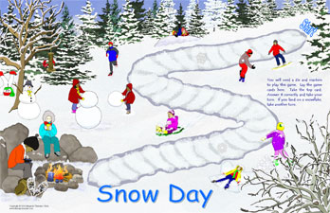

Copyright © 2010 by Integreat! Thematic Units All rights reserved.
Permission to reproduce these classroom materials is given to the individual who downloaded this publication, for use with their own students or clients in their classroom. They may change the publication to make it more suitable for their own personal use. It may not be redistributed to other people for any reason using any method.

Credits: Some clip art was supplied by Sallie Ehrlich, Watercolor Artist.

