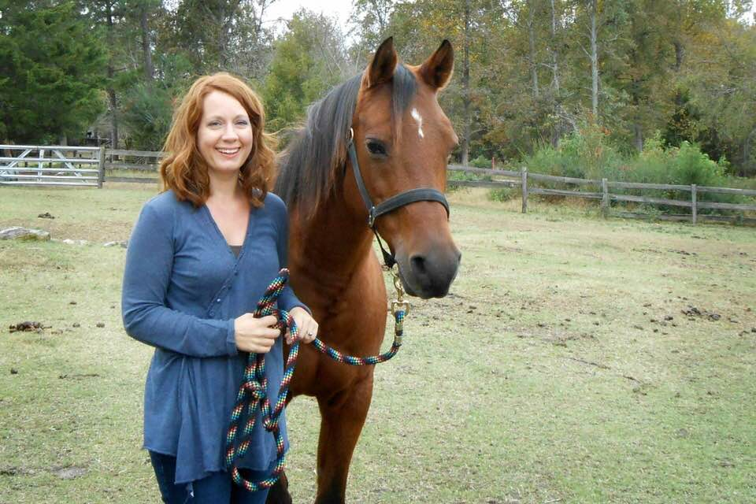
Saradina "Sara"
​DOB: April 24, 1997
​SIRE: SAFIRE
DAM: DALZEYNA
HEIGHT: 14.2 HANDS
BREED: ARABIAN
​DICIPLINE: TRAIL/ DRESSAGE

Patty started leasing Sara January 2012 and loved her so much, she finalized the purchase of this awesome little mare, October 2012. Sara is a sweet yet spunky gal! She is by far one of the easiest horse boarded with JRF. Sara causes no drama out in the pasture and gets along with almost everyone! She enjoys her stall when one of her BFF's are around while she eats. Sara suffers from Cushing's, but has shown great improvement with meds. Sara has suffered from a facial injury which caused a permanent dent in her face next to her eye and a hamstring injury which causes her to short step on that leg. Through all these hard times, Sara has persevered and has been working on her cantering and getting ready for some dressage. Sara enjoys going on trail rides with her boys, Tango and Secret and watching the sunset with her mom. Congratulations Sara!

