API Q2 Combined Essentials and Auditing Course

Presented by Wollam Petroleum Advisory Group in partnership with SG Petroleum
2016 Registration Form

Attendee Information
Please type or print clearly, using a separate form for each attendee.
Name:Click here to enter text.

Job Title:Click here to enter text.
Company:Click here to enter text.
Department/Division:Click here to enter text.
Street Address:Click here to enter text.
City:Click here to enter text.
State:Click here to enter text. Zip Code:Zip Code
Phone:Click here to enter text.Fax:Click here to enter text.
Email:Click here to enter text.
If you require any special assistance, please make a note of your needs here:
Click here to enter text.

Registration (per attendee)
Fee for 5-day course – API Q2 Technical Application for Lead Auditor
RegistrationAmount7,485.14 SAR ($1995 USD)

Course Dates

☐Saudi Arabia (Sept. 25-29)

*Dates and location is subject to change based on enrollment numbers.

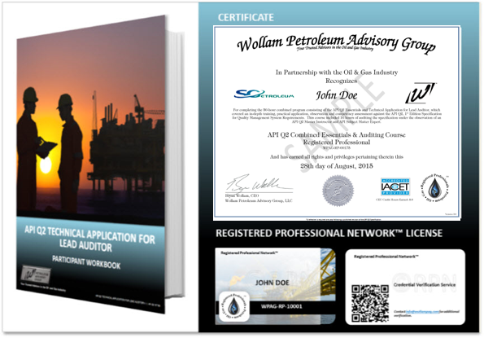

Upon successful completion of this course, 5.0 CEUs will be awarded.

Payment
All registration fees are in SAR

Payment by Bank Transfer

SG Petroleum Service Co.

Bank Name: Samba Bank

Account No: 2100601121

IBAN No: SA3540000000002100601121

Swift Code: sambsari

Make check payable to and mail along with completed registration form to:

SG Petroleum
Al-Waha down town
2nd Floor office No. 7
Al-Dammam, KSA

Cancellations
Refunds, will be given for written cancellation, minus a processing fee
Received by SG Petroleum as follows:
- 10% within 14 calendar days prior to course
- 25% within7 Calendar days prior to course
- No refund for cancellations within 6 calendar days of course.
Class substitutions are permitted.

Training venue
SG Petroleum Training Center
Al-Waha down town
2nd Floor office No. 12
Al-Dammam, KSA

E- Mail: bookings@sgpetroleum.com

Office Tel +966 13 8270780 (Head Office)
Office Tel +966 13 8060108 (Training Center)
