www.deltacentre.co.uk

Annual International Society of Reproductive Surgery Conference
with workshop session

Advances in Reproductive Surgery for Fertility enhancement

15- 16th November 2018

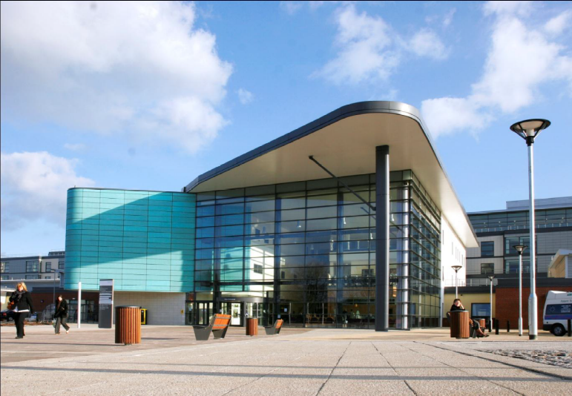
Venue: Education Centre, Royal Derby Hospital, Derby, UK

Organisers: Mr Kanna Jayaprakasan, Mr. Saad Amer, Mr Kamal Ojha

Centre Director: Mr Summi Abdul

For: Consultants, Registrars, Nurses and students in Gynaecology and Fertility

Programme
Day 1 15th Nov
09.30-12.30 | Registration and viewing of abstracts
10.00 -12.20 | Workshops  Hysteroscopic:  Surgical techniques, Truclear, Myosure, Hands on simulation (Faculty: S. Kolhe, J. Dasgupta, M Cust, J Hiscock, O. Tamizian, D Casayuran)  Laparoscopic and Robotic:  Surgical techniques, Suturing, Use of advanced energy sources, Hands on simulation (Faculty: S. Umranikar, S. Amer, S. Abdul, A. Bali, V. Asher, A. Phillips, S. Tarsha)  Ultrasound & HSG:  Techniques for 3D ultrasound, HyCoSy, Saline Infusion Sonography (Faculty: K. Ojha, K Jayaprakasan, L Polanski, A Richardson, T Elshamy)
12.20-13.00 | Lunch
13.00 – 13.15  Session 1 13.10 – 15.00  Chair person: Ovrang Djahanbakhch  Gedis Grudzinskas | Presidential Address: Role of International Society of Reproductive Surgery – Ertan Saridogan  Keynote lecture: Principles of Reproductive Surgery (20 min) - Stephan Gordts  Debate: Tubal factor subfertility: How best to assess in low risk women? For HSG (20 min) – Gedis Grudzinskas For HyCoSy (20 min) – Kamal Ojha Response and discussion (5 min x 2 = 10 min total)  Tubal surgery: Is it worthwhile in the era of ART? (20 min) - Mostafa Metwally  Discussion (20 min)
15.00-15.30 | Coffee
Session 2 15.30 – 17.10  Chair person:  Antoine Watrelot  Ertan Saridogan | Diagnosis of Congenital uterine anomalies: Is ESHRE/ ESGE classification appropriate? (20 min) – Kanna Jayaprakasan  Which Uterine anomalies to treat to enhance fertility? (20 min) – Luciano Nardo  Intra-uterine adhesions – management strategies (20 min) – Justin Clark  Tips and Tricks in operative hysteroscopy (20 min) –Ertan Saridogan  Discussion (20 min)
19.00 | Course Meal

Day 2 16th Nov
Session 3 9.00 - 11.00  Chair person: Ertan Saridogan/ Samir Umranikar | Debate: Adenomyosis should be treated surgically to enhance fertility (9.00-9.40) For (15 min) - Stephan Gordts Against (15 min) - Enda McVeigh Responses and discussion (10 min)  Endometriosis surgery for infertility: tips and tricks (9.40-10.00)- Antoine Watrelot  Endometriomas and ART: to operate or not to operate? (10.00-10.20) - Saad Amer  The role of Robot in Reproductive surgery (10.20-10.40) – Gourab Misra  Discussion (10.40-11.00)
11.00 - 11.30 | Coffee
Session 4 11.30 – 13.00  Chair person: Stephan Gordts/ Anish Bali | Uterine transplantation – an update (11.30-12.00) - Mats Brannstrom  Fertility preserving surgery in cancer patients (12.00-12.20) - Summi Abdul  Addressing fertility issues in disorders of sexual development (12.20-12.40) – Ephia Yasmin  Discussion (12.40-13.00)
13.00 – 13.40 | Lunch/ viewing of abstracts
13.40-14.00  14.00-15.30  Chair person: Sheila Lane/ Kamal Ojha/ Antoine Torre  15-40-16.30  Chair person: Gedis Grudzinskas/Saad Amer | Best 3 abstracts Oral presentation (5 min each)  Use of Ovarian tissue cryopreservation in clinical practice and referral pathway: UK perspective (14.00-14.20) – Christian Becker  Ovarian tissue cryopreservation for cancer to benign reasons, social reasons and as hormone replacement treatment (14.20-14.40) – Erik Ernst  Counselling for women undergoing cryopreservation case presentation (14.40-14.55) - Pip Reilly  Discussion – (14.55-15.30)  Debate: Intramural fibroids of ≥5 cm should be removed for enhancing fertility For (15.40-15.55) - Yacoub Khalaf Against (15.55-16.10) - Abha Maheshwari  Response and Discussion (10 min)  Closing remarks (16.20-16.30) – Kamal Ojha/ Ertan Saridogan

Advances in Reproductive Surgery for Fertility enhancement
Application Form
Title
First Name
Surname
Home Address
Postcode
Mobile Telephone Number
Home Telephone Number
E-mail address
Current Grade
Specialty
Current Hospital/Trust
Current Hospital/Trust Address
GMC/NMC No
Any Special Dietary Requirements?

Fees | Consultant | Trainee | Nurse and other health care professionals
15-16th November 2018 | £400 | £300 | £200

Please enclose: | Cheque made payable The DELTA centre  On line Bank transfer facility available on request
Please return completed form, enclosing cheque to:
Sahdia Ansar, Medical Staffing Coordinator / DELTA Centre administrator
Level 2, Maternity & Gynaecology Block, Royal Derby Hospital, Uttoxeter Road, Derby, UK DE22 3NE

Telephone: 01332 785 386, E-mail: sahdia.ansar@nhs.net

Last date for Abstract Submission is October 26th 2018
Organising Committee members:
Alison Richardson, Tarek El-shamy, Uchechukwu Ijeneme

