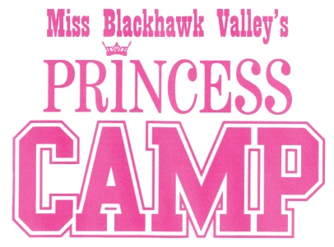

Princess Program Enrollment Form, 2022
Princess Name: __________________________ Age: _______ Birth date ______
Sponsor(s): __________________________________________________________
(Grandparents, Parents, Business, etc.)
Parent/Guardian Information:
Names: _____________________________________________________________________
Relationship: ________________________________________________________________
Mailing Address: _____________________________________________________________
City: ___________________________________________ State: _____ Zip: _____________
Cell Phone: ______________________ Email: _____________________________________
T-Shirt Size: (Please check one.)
[ ] Youth Small [ ] Youth Medium [ ] Youth Large
[ ] Adult Small [ ] Adult Medium [ ] Adult Large
Send this enrollment for as well as the items listed below to:

Jaryn Dennehey
6726 Brookview Lane
Davenport, IA 52806

- $100 enrollment fee with the name of the sponsor
- Digital photograph in .jpg format, head shot
- Copy of birth certificate

I hereby give the Miss Blackhawk Valley Scholarship Program permission to use my daughter’s picture and name for publicity in newspapers, website, TV, radio and/or social media.
_____________________ ___________________________ _______________
Princess name Parent/Guardian name Date
Revised 8/25/2021

