Rock City Church Unoffendables
Curriculum

Contents

Introduction………………………………………………………………………..........Page 4

Table of Contents

Lesson 1: “A Clean Heart”……………………………………..………………….....Page
Lesson 2: “It’s Not Fair”...........…………………………………………………….. Page
Lesson 3: “Mad at Dad: When Fathers upset us.…………………………..Page
Lesson 4: “Because I say so”………...……………………………………….........Page
Lesson 5: “Stronger than the Giants”…………………………………………..Page
Lesson 6: “A Precious Stone”…………..…………….………………………........Page
Lesson 7: “Building others up”..………………………………..…………..........Page
Lesson 8: “Forgiving others” ………………………...........................................Page
Lesson 9: “He is My Defender”………….………………………………………...Page
Lesson 10: “Don’t Judge Others”……………………………………………........Page
Lesson 11: “Getting It Right”.........………………………………………………..Page
Lesson 12: “Will you Forgive Me?”……………………….................................Page
Lesson 13: “Walking in Forgiveness”…………………………………………...Page

Mad at
Dad: When Fathers Upset Us.
1 Samuel 24:11

How do you stay respectful to father figures when you are upset with them. Leaders don’t always get it right, instead of being offended, pray for that person.

KINGDOM KADETS: FALL LESSON 3
AGE: NURSERY (INFANTS & TODDDLERS 0-2)
Adopted from Bait of Satan by John Bevere

Lesson Topic: Mad at Dad: When Fathers Upset Us.

LESSON | WHAT CHILDREN DO | SUPPLIES | PREPARATION
1  Getting Started | Introduction/Ice Breaker:  Freeze!! | No Supplies needed | Choose a good song and turn up the volume. Ask them to dance until the music stops. When it does, they have to freeze in whatever position they find themselves in.
2  Bible Exploration.  Key Verse Activity | Key Verse: 1 Samuel 24:11  Bible Story: King Saul and David.
 | Bible Activity for Infants and toddlers: Sensory bags | -Ziploc Bags  -Cheap Hair Gel  -Duck or packing tape  -Glitter | For this lesson we will use gems to tell the kids the story of King Saul and David. King’s crowns, garments, and thrones often displayed elegant gems and jewels.
LESSON | WHAT CHILDREN DO | SUPPLIES | PREPARATION
3  Weaving Faith  Into Life | Craft/Make and Take for Toddlers:  Crown | -Poster board.  -Crayons, sprinkle glitter, foam stickers or whatever you want to use to decorate the crowns.  -Pencil  -Scissors  -Stapler  -Small mirror | The kids will decorate their own crown.  You can pre-cut the crowns ahead of time to save time.
Prayer Points:
Asking God to work in the lives of leaders and to enable you to
pray for them and forgive their faults.

4  Lasting Impressions | Faith at Home:  Talk about how to share what they learned with their families. |  | What parents can do at home:  Make a card with your kid(s) to honor a leader (school teacher, church teacher, pastor…)

Lesson Topic: Mad at Dad: When Fathers Upset Us

Lesson Background/Foundation for Teachers:
How do you stay respectful to father figures when you are upset with them. Leaders don’t always get it right, instead of being offended, pray for that person.

Introduction Activity: Freeze !!
Choose a good song and turn up the volume. Ask them to dance until the music stops. When it does, they have to freeze in whatever position they find themselves in.

Praise & Worship:
- Song 1: Nothing My God Can not Do.
- Song 2: Forgive One Another (Integrity Kids)
- Song 3: You Forgive Me (Lifetree Kids)

Key Verse: 1 Samuel 24:11 New International Version (NIV)
See, my father, look at this piece of your robe in my hand! I cut off the corner of your robe but did not kill you. See that there is nothing in my hand to indicate that I am guilty of wrongdoing or rebellion. I have not wronged you, but you are hunting me down to take my life.

Bible Story: King Saul and David
- Scripture Reference: 1 Samuel 24:11
- Narrative of Story:
When Saul came back after dealing with the Philistines, he was told, “David is now in the wilderness of En Gedi.” Saul took three companies—the best he could find in all Israel—and set out in search of David and his men in the region of Wild Goat Rocks. He came to some sheep pens along the road. There was a cave there and Saul went in to relieve himself. David and his men were huddled far back in the same cave. David’s men whispered to him, “Can you believe it? This is the day God was talking about when he said, ‘I’ll put your enemy in your hands. You can do whatever you want with him.’” Quiet as a cat, David crept up and cut off a piece of Saul’s royal robe.
5-7 Immediately, he felt guilty. He said to his men, “God forbid that I should have done this to my master, God’s anointed, that I should so much as raise a finger against him. He’s God’s anointed!” David held his men in check with these words and wouldn’t let them pounce on Saul. Saul got up, left the cave, and went on down the road.
8-13 Then David stood at the mouth of the cave and called to Saul, “My master! My king!” Saul looked back. David fell to his knees and bowed in reverence. He called out, “Why do you listen to those who say ‘David is out to get you’? This very day with your very own eyes you have seen that just now in the cave God put you in my hands. My men wanted me to kill you, but I wouldn’t do it. I told them that I won’t lift a finger against my master—he’s God’s anointed. Oh, my father, look at this, look at this piece that I cut from your robe. I could have cut you—killed you!—but I didn’t. Look at the evidence! I’m not against you. I’m no rebel. I haven’t sinned against you, and yet you’re hunting me down to kill me. Let’s decide which of us is in the right. God may avenge me, but it is in his hands, not mine. An old proverb says, ‘Evil deeds come from evil people.’ So be assured that my hand won’t touch you.
14-15 “What does the king of Israel think he’s doing? Who do you think you’re chasing? A dead dog? A flea? God is our judge. He’ll decide who is right. Oh, that he would look down right now, decide right now—and set me free of you!”
16-21 When David had finished saying all this, Saul said, “Can this be the voice of my son David?” and he wept in loud sobs. “You’re the one in the right, not me,” he continued. “You’ve heaped good on me; I’ve dumped evil on you. And now you’ve done it again—treated me generously. God put me in your hands and you didn’t kill me. Why? When a man meets his enemy, does he send him down the road with a blessing? May God give you a bonus of blessings for what you’ve done for me today! I know now beyond doubt that you will rule as king. The kingdom of Israel is already in your grasp! Now promise me under God that you will not kill off my family or wipe my name off the books.”
22 David promised Saul. Then Saul went home and David and his men went up to their wilderness refuge.

Bible Activity for Infants and Toddlers:
Sensory bags are a great way to use up small items that you normally couldn’t let toddlers or babies play with; in a sensory bag the small pieces aren’t a choking hazard (though obviously, do keep an eye on the little ones while they’re playing, just in case!)
You can fill these bags with whatever you want, as long as it doesn’t have sharp edges that will puncture the bag.

For this lesson we will use gems to tell the kids the story of King Saul and David. King’s crowns, garments, and thrones often displayed elegant gems and jewels. Using these sensory items, explain the life of a king; Servants, a crown, a throne, etc.. Tell the kids that David always showed love and respect towards king Saul even when the king wasn’t nice to David.

Materials:
-Ziploc Bags
-Cheap Hair Gel
-Duck or packing tape
-Glitter

Instructions
Ask the kids to help you filling the bag with hair gel. For a quart sized bag I use about 1 cup of hair gel. You don’t want to use too much or the bag will be overfilled and not as easy to squish around.
Ask the kids to add the gems and glitter to the bag. Again, don’t overfill the bag or it will be sensory overload! Once your bag is full, carefully squeeze all of the air out of the bag, then close the bag. Using duct tape or packing tape, seal the opening so the bag doesn’t accidentally open while the kids are playing with it! Duck tape makes fun, colorful duct tape you can use, or Scotch has a line of decorative packing tape that works great as well.
Cover all four edges in tape, folding the tape over the edge to help reinforce the bag.
And you’re done making sensory bags!

If the kids are more interested in trying to eat the sensory bag than playing with it, you can always tape the bag up onto a wall or window. Tape all four edges so they can’t pull the bag off the window; they can still play with it and move stuff around, but they won’t be able to eat it.

For the younger babies, tape the sensory bags to the floor in front of them and let them have some tummy time while they play.

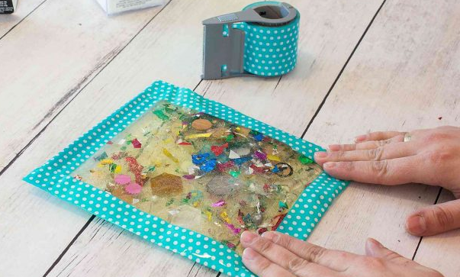
Activity taken from practicallyfunctional.com

Craft/Make & Take for Toddlers:
- Title: Crown
- Supplies Needed:
-Poster board.
-Crayons, sprinkle glitter, foam stickers or whatever you want to use to decorate the crowns.
-Pencil
-Scissors
-Stapler
-Small mirror

- Directions
1. Draw and cut crown from poster board (one crown per kid)
2. Decorate the crown.
3. Cut a long strip from poster board. Fit around the child’s head and form a circle that fits on top their head.
4. Staple crown to front of strip.

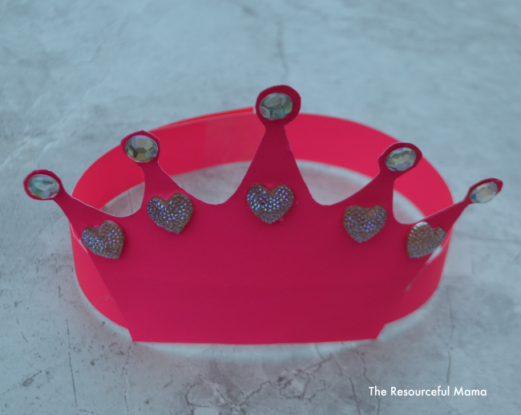
Activity taken from theresourcefulmama.com

Closing Prayer:
Asking God to work in the lives of leaders and to enable you to
pray for them and forgive their faults.

Faith At Home:
- Description: Make a card with your kid(s) to honor a leader (school teacher, church teacher, pastor…)

