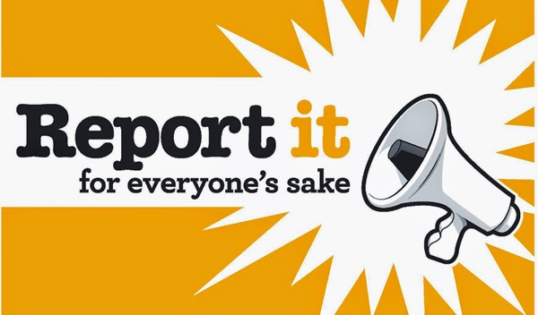

Feedback from members:-
96% of members would like to see line trainers re-instated!
To make a change we need to start reporting this!

…we are not trained on delivering the appropriate feedback …
…A stressful time for CMs….A lot of pressure to get a supernumery crew member trained…
…Cm's already have enough to do without having to be in charge of a checklist for a new entrant to complete
Are you feeling pressured to support and check new entrants! The training department don't think you are!!
This is because they say crew have not reported any problems to them via a CSR

“…They are putting more responsibility on CM for no more money or recognition. If the new entrant isn't up to standard I will not sign paper work and get crewing to issue more flights…”

96% of members would like to see line trainers re-instated!
To make a change we need to start reporting this!

This year we ALL need to step up and start reporting.
What we have to report on a CSR:
- That we feel pressured by the time and responsibility for training new entrants

- That we feel under pressure to complete training on short sectors when there is no time

- That we do not feel we are correctly trained to deliver appropriate feedback

When are we reporting this – on EVERY flight with supernumeries where we feel under pressure

You say you want to see line checks returned – we all need to start reporting this in order to make EasyJet realise they are putting profit before safety!

