

# Summer 2018 Season

# Pre – Season Report

# 

Welcome to the Summer 2018 Season and also welcome to new club member Stephen Stoneman and welcome back Martin & Teresa Koradi.

Geoffroy will be looking to retain his Premier League Summer Singles title but will have work to do with newly crowned Winter Premier League Champion Matt Buesnel looking to add the Summer title to his Winter one. Only two players have managed to hold both Summer & Winter titles at the same time, Toby Northern and Andrew Bellamy-Burt, no easy task.

With expanded leagues and more games to play, will we see a record point’s total. Will some players be able justify their place in the top flight. Will it be as close as ever!

How will promoted Callum, Jonny and Paul fair in the top flight, which one of these three players will finish highest.

Jonny has the longest current unbeaten record in the singles league, 13 matches unbeaten closely followed Andrew Bellamy-Burt on 10.

Joey Le Clech should be favourite to win Division 1 but who will challenge him, who will be this year’s surprise performer.

Premier League Doubles, can Jake Romeril & Mark Nicol win again! It will be another tough season with Matt Pinel being joined by Toby Northern, Geoffroy Buffetrille joining up with Matt Buesnel and Alan Oliveira & Craig Kelly and Callum Stewart & Andrew Bellamy-Burt to name a few trying to beat them to the title.

Division 1 favourites should be Brigitte & Alice but with many new teams could someone spring a surprise, it should be close.

**If you have not put your name down for the Triples league, give it try, please let us know before the 5th April.**

**First Open of the year is the Singles Open on Saturday 7th April – start time 8.45**

After a successful trial in the Winter Season (with Chairman Toby Northern winning the league), the Super 6 is back and bigger than ever. Well not quite, it is still six matches and a Tiebreaker but it is free, it is fun and who knows you may win a prize at the end of the season!

**Click on the link to play Week 1.** <https://www.surveymonkey.com/r/BKKGQB9>

**Remember if you cannot play on the scheduled fixture date; please try to play in advance.**

Best of Luck to everyone

***NEXT WEEK***

**4th April - Singles League – Week 2**

**WEBSITE** [**www.liberationpetanque.co.uk**](http://www.liberationpetanque.co.uk)

**EMAIL** [**liberationpc@gmail.com**](mailto:liberationpc@gmail.com)

**Kind Regards**

**Toby Northern**

**Chairman**

**Liberation Petanque Club**

# SPONSORED BY

# http://nebula.wsimg.com/135a1bd6338e1b589a50cdec98bd84d1?AccessKeyId=C6E923731F1A482DD910&disposition=0&alloworigin=1

# Summer 2018 Season

# Week 1 – 28.03.18

# Singles League Report

# 

**Remember if you cannot play on the scheduled fixture date; please try to play in advance.**

Well Jonny Hill’s unbeaten record was in serious threat losing the first game in the Premier League as Toby Northern returned to form to start the season winning 13 – 2, also handing Jonny a certificate. Jonny though changed terrain and his fortune taking a 12 – 0 lead before finally gaining a draw with a 13 - 4 win.

Matt Buesnel hoping to prove he’s not a one hit wonder took on Keith Pinel, but it wasn’t the ideal start as a draw was all he could manage dropping points early on.

Draws are becoming a bad habit for Andrew Bellamy-Burt as another one means he has 9 out of his last 11 matches!! This time to Brian Harris.

Matt Pinel did get a win as he beat Neil Selby to start the season off in the best possible way and an improvement as he also played Neil in the first match of the season in the winter season but could only draw that time.

Matches not played

Ross Payne v Callum Stewart

David Ibitson v Paul Le Moine

Alice Ibitson v Geoffroy Buffetrille

Division 1 saw title favourite Joey only manage to draw with the ever improving Cassie Stewart. Laurent Pellaton started his push for the Premier League with a draw against experience player John McGaw.

New comer Stephen Stoneman started off well in his first ever match against Richard Williams taking a 5 – 0 lead, but experienced showed as Richard triumphed in the end.

Alex Stewart is hoping to make it back to back promotions to the Premier League and started off well taking a very close match against Paul Bell, who is getting better with every game.

Harrison Marie also won, against Jean Stewart, so no draws in Division 1. Looks like it’s going to be a big scoring season.

Matches not played

David Le Gresley v Matt Hutchings

Brigitte Ibitson v Mo De Gruchy

**Super 6 Results**

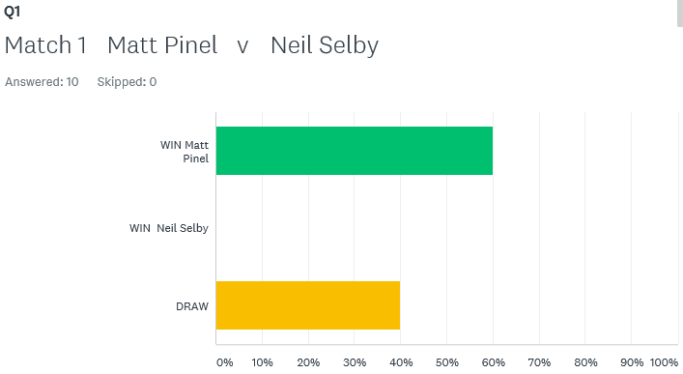

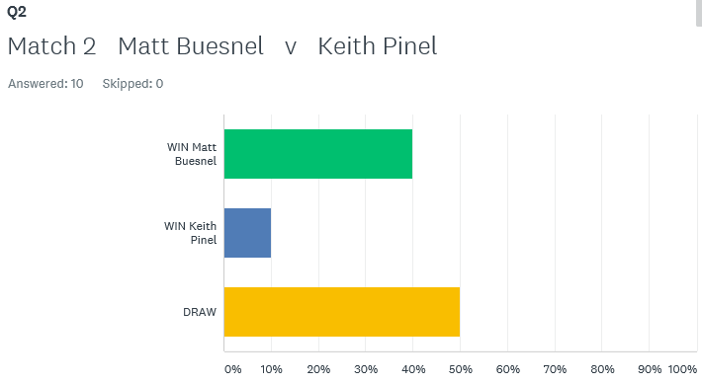

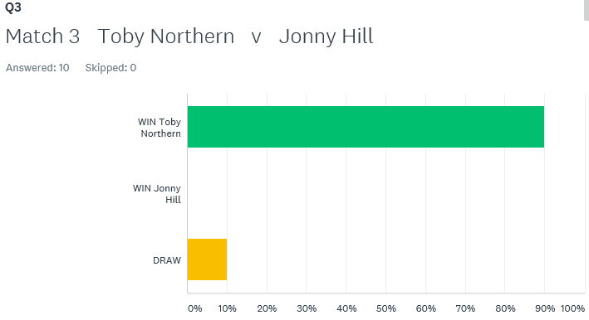

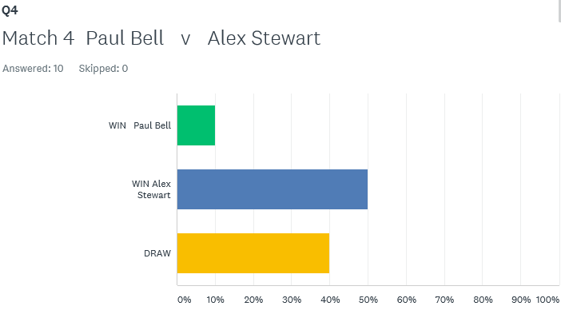

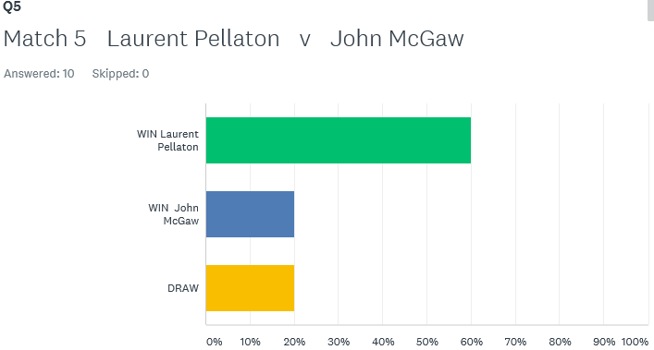

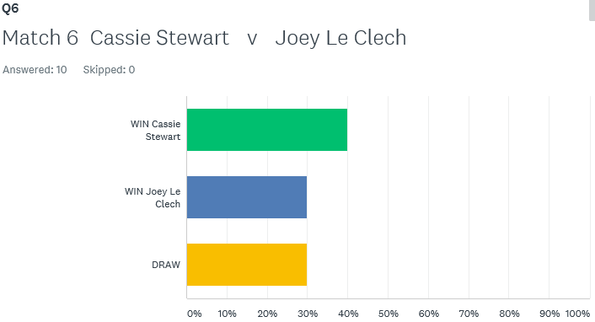

How would you have done on the **Super 6**? – next weeks out on Monday – have a go, see how good you are.

**First Open of the year is the Singles Open on Saturday 7th April – start time 8.45**

Best of Luck to everyone

***NEXT WEEK***

**4th April - Singles League – Week 2**

**WEBSITE** [**www.liberationpetanque.co.uk**](http://www.liberationpetanque.co.uk)

**EMAIL** [**liberationpc@gmail.com**](mailto:liberationpc@gmail.com)

**Kind Regards**

**Toby Northern**

**Chairman**

**Liberation Petanque Club**

# Summer 2018 Season

# Week 2 – 04.04.18

# Singles League Report

# 

**Remember if you cannot play on the scheduled fixture date; please try to play in advance.**

**If you have not played on the scheduled fixture date please take into account section 4 of the rules to avoid penalty point deductions.**

Well Jonny Hill’s unbeaten record went as he lost to Matt Buesnel but only just losing game one 13 – 12.

Geoffroy Buffetrille as official got a bogie player in David Ibitson who beats him two seasons running.

In the Winter season just past Ross Payne only win was against Matt Pinel, could he repeat that feat. Not this time, but should have drawn the match losing one game 13 – 12. Matt Pinel sitting top with 6 points from his first two matches.

Alice Ibitson played her first match, against Brian Harris and picked up three well earned points. Brian Harris doubles partner Paul Le Moine did win, against Toby whose form is going from bad to worse as he again struggles.

Keith Pinel and Neil Selby drew as did Callum Stewart and Ross in a catch up match to finish off the Premier fixtures this week.

**Matches not played**

Andrew Bellamy-Burt v Callum Stewart

Division 1 saw title favourite Joey only manages to draw again. He needed to win the second game to get a valuable point as the pressure of being title favourite takes its toll.

Well done to Mo De Gruchy who won her first game in the league, unfortunately not the match but a very positive step taking a league point against experience John McGaw.

Matt Hutchings late show saw him also just miss out on a win despite leading comfortably lost 13 – 12 in the first game but recovered to get a point against Brigitte Ibitson.

Alex Stewart is on 100% record with two wins in two, this time against newcomer Stephen Stoneman as Alex looks for back to back promotions to the Premier League.

Paul Bell got off the mark with a close win 13-10, 13-8 over Jean Stewart after losing to Alex Stewart last week gets him back on the promotion trail.

Cassie Stewart ensured Laurent Pellaton remained without a league win so far this season, in stark contrast to the winter season. A draw was the case as both players without a win.

**Matches not played**

David Le Gresley v Harrison Marie

**Super 6 Results**

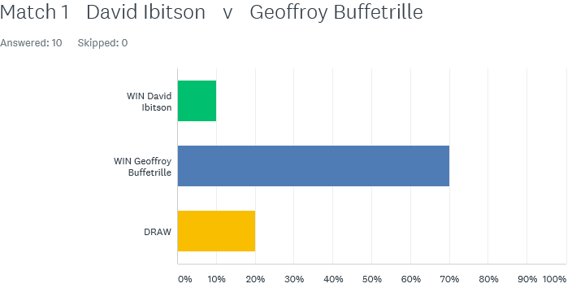

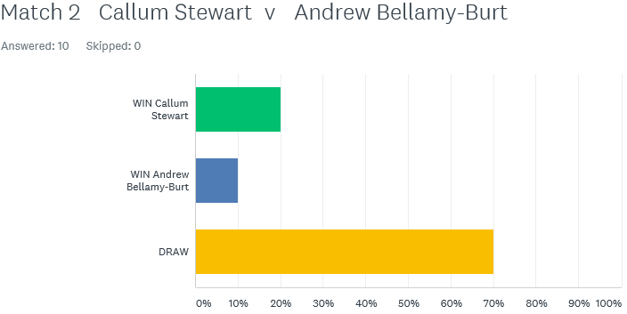

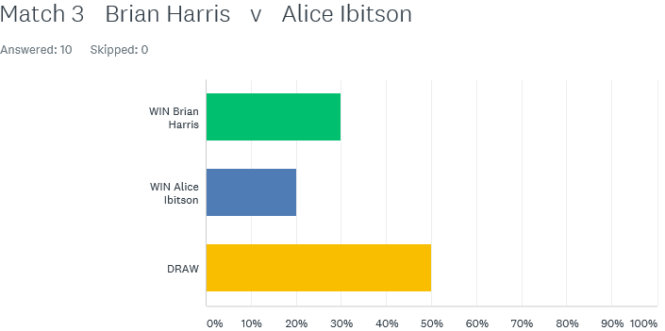

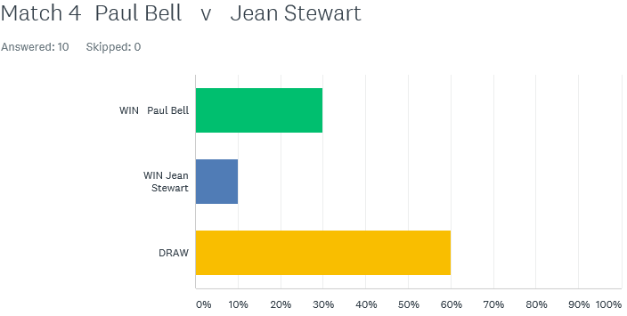

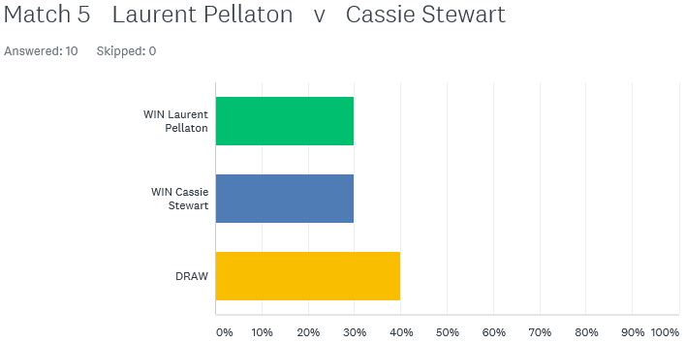

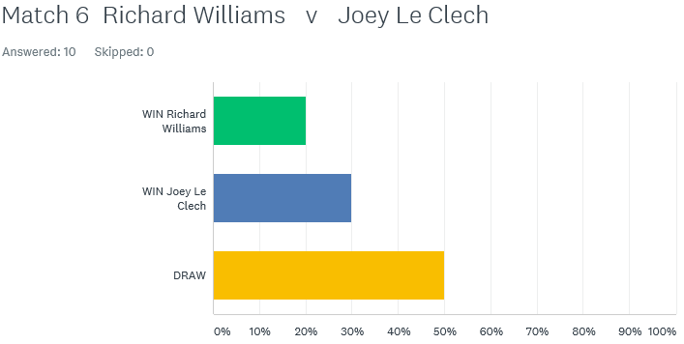

How would you have done on the **Super 6**? – next weeks out on Monday – have a go, see how good you are.

**First Open of the year is the Singles Open on Saturday 7th April 2018**

Best of Luck to everyone

***NEXT WEEK***

**11th April - Doubles League – Week 1**

**WEBSITE** [**www.liberationpetanque.co.uk**](http://www.liberationpetanque.co.uk)

**EMAIL** [**liberationpc@gmail.com**](mailto:liberationpc@gmail.com)

**Kind Regards**

**Toby Northern**

**Chairman**

**Liberation Petanque Club**

# Summer 2018 Season

# Week 3 – 11.04.18

# Doubles League Report

# End of Season Meal – Sat 28th April 2018

# Jersey Bowl - £17.50

# Please email club if you wish to attend

# Jersey Petanque Association

# Island (Mens & Womens) Triples Championship

# Sat 21st April 2018

# See club website for entry form.

# 

**Remember if you cannot play on the scheduled fixture date; please try to play in advance. You must email club confirming date match will be played.**

The doubles league was finally underway in surprisingly dry weather. The Premier league saw Ross Payne & Neil Selby team up again and faced Matt Pinel & Toby Northern who were playing together for the first time in the Summer Leagues hoping their cup successes would translate to league success.

Unfortunately for Ross & Neil, Toby’s placing and Matt’s firing were both consistently spot on and were fortunate in both games to score points losing 13 – 3, 13 – 7. Toby & Matt will be pushing hard for the title.

Alan Oliveira & Craig Kelly were very close to winning the Winter Premier League title and with great pedigree were hoping to go one better this season after winning the Division 1 title last Summer. They started off against Brian Harris & Paul Le Moine, both Singles Premier League players so was going to be a tough match.

Brian & Paul pulled out some great shots as they won comfortably (at least that’s what the score line suggests) 13 – 6, 13 – 4.

Both David Ibitson and Joey Le Clech made the knockout rounds in the Singles Open at the weekend, but were on opposite sides with David partnering Matt Ryan, the only partnership going since the very first season and won the title in Summer 2012. Joey again partnered with Jonny Hill so no easy games.

I said no easy games but Joey & Jonny became the seasons first Certificate casualties losing 13 – 0. They recovered though to take the second game 13 – 10 for a valuable draw.

**Matches Not Played**

James Rondel & Tom McMinigal v Matt Buesnel & Geoffroy Buffetrille

Alex & Cassie Stewart v Jake Romeril & Mark Nicol

**Division 1**

Brigitte & Alice Ibitson, relegated last Summer started off their quest to return to the Premier League against up and coming Laurent Pellaton & Matt Hutchings. It turned out a mismatch as the highly experience team of Brigitte & Alice won comfortably 13 – 5, 13 – 4.

Playing their first doubles match together was Mo De Gruchy & Stephen Stoneman, they had a tough match against Richard Williams & Harrison Marie.

They gave a good account of themselves but it wasn’t quite enough as Richard & Harrison won the match 13 – 6, 13 – 8.

Matches Not Played

Colin Myers & Steve Simpkin v Christophe & Iwona Ait-Elhadj

Martin & Teresa Koradi v Colin & Karen Hidrio

Paul Bell & David Le Gresley v Alan Mitchell & Mike Robinson

Eamonn & Karen Bougeard v Jean Stewart & Chris Le Gallais

**Triples Mini League starts 25th April 2018, last chance to get your name down before teams selected.**

Best of Luck to everyone

***NEXT WEEK***

**18th April - Singles League – Week 3**

**WEBSITE** [**www.liberationpetanque.co.uk**](http://www.liberationpetanque.co.uk)

**EMAIL** [**liberationpc@gmail.com**](mailto:liberationpc@gmail.com)

**Kind Regards**

**Toby Northern**

**Chairman**

**Liberation Petanque Club**

# SUPER 6

# 

# 

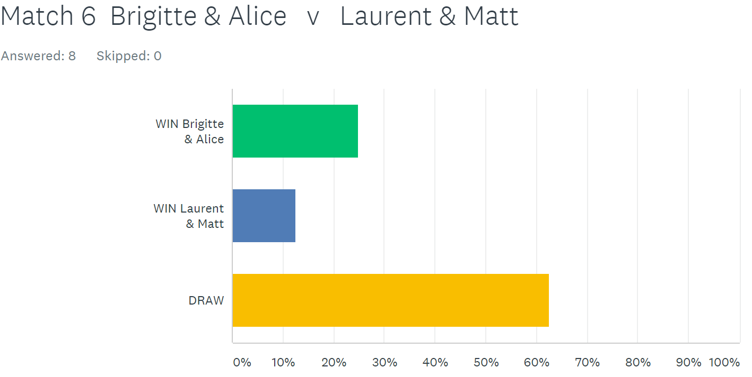

# Summer 2018 Season

# Week 4 – 18.04.18

# Singles League Report

# 

# End of Season Meal – Sat 28th April 2018

# Jersey Bowl - £17.50

# Please email club if you wish to attend

**Remember if you cannot play on the scheduled fixture date; please try to play in advance. You must email club confirming date match will be played.**

Well the early season front runners after three weeks are Matt Pinel and Matt Buesnel in the Premier League

Matt Pinel was hoping for three wins in a row but was up against Andrew Bellamy-Burt, a tough match that could go either way. Well that is what you would have thought, especially given Andrew’s excellent record against Matt. However, a dip in form saw Andrew beaten and one game resulting in a certificate, yes a 13 – 0 for Andrew. Matt with 100% record.

Geoffroy Buffetrille was hoping to recover from his defeat against David Ibitson was up against Brian Harris who lost his first match to Alice. Despite winning the first game, Geoffroy was heavily beaten in the second 13 – 4 for a draw. Geoffroy then drew a catch up match with Alice but was lucky in the first game as Alice blew a big lead 13 – 11 and a valuable 3 points.

Alice Ibitson was looking for back-to-back wins though in her scheduled match, this time against Callum Stewart. Another draw for both. Alice sits in third place now.

Ross Payne was up against Keith Pinel, with both players hoping for their first win of the season. Ross played really well catching Keith off guard to record a much-needed win.

David Ibitson came up against Toby Northern who was looking for his first win and David looking to build on his win over Geoffroy. A very close first game with David leading all the way and 12-10 up fired his own boule out of the way and drop his third shot short to gift Toby three points to take the first game 13 – 12. Despite this, David changed terrain but this only resulted in a heavier defeat 13 – 2 for Toby’s first win of the season.

David then drew a catch up match with Paul Le Moine.

Neil Selby was hoping his cup form translated into league form against Jonny Hill but Neil is fast becoming the draw master with Jonny proving hard to beat.

Matt Buesnel played Paul Le Moine and was looking at a draw losing 9 – 0 in the second game Matt came back to win 13 – 11 and take 3 valuable league points sitting in second place in the league.

Division 1

Harrison Marie played Paul Bell and a close second game 13 – 11 gave Harrison a point in a good draw.

David Le Gresley played Brigitte Ibitson after his Easter holidays, playing his first match. Another very close match saw Brigitte take three points winning 13- 12, 13 – 11.

Jean Stewart played Stephen Stoneman and Stephen almost won his first match, just losing the first game 13 – 12 before winning the second game for a draw. Playing his first ever season is already improving.

Matt Hutchings played John McGaw with both players hard to beat, there was only ever going to be one result. A draw.

Alex Stewart played Joey Le Clech with Alex on two wins from two, would have been confident, especially as Joey had failed to win either of his first two matches. Joey though performed well taking the first game 13 – 1 before going onto win his first match of the season.

Mo De Gruchy played Cassie Stewart and Brigitte Ibitson and although improving all the time two defeats on the day. Brigitte in second place on seven points from three matches.

Richard Williams played Laurent Pellaton; these two battled it out for the Winter Division 2 title, before Laurent won the league. The Summer season isn’t going as well as Laurent lost heavily 13 -4, 13-4 to Richard and now as only two points from three matches, whilst Richard sits on 7 points and top spot.

Best of Luck to everyone who is playing in the Island Triples Championship at Quennavais this weekend.

Super 6 - Statistics

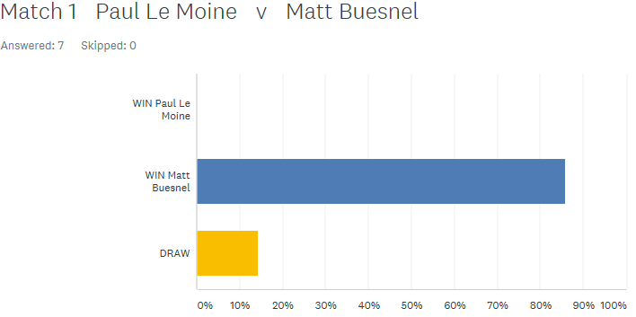

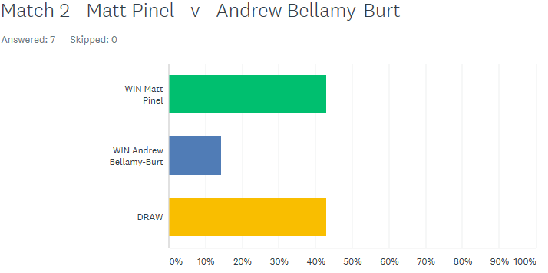

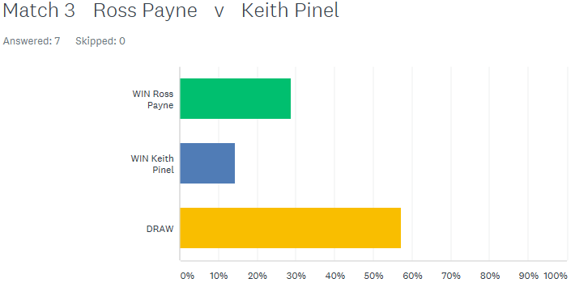

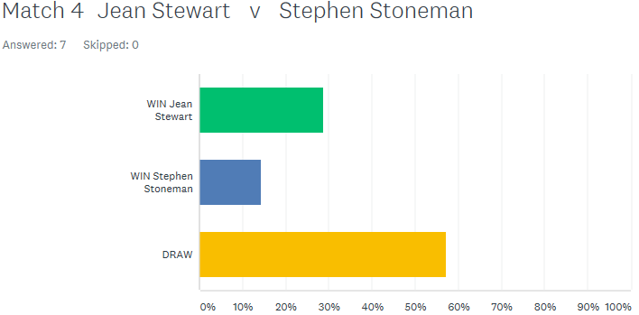

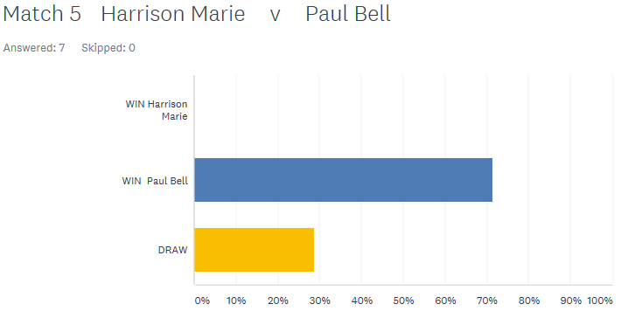

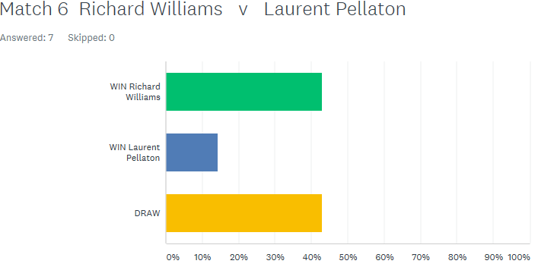

***NEXT WEEK***

**25th April – Triples Mini League – Week 1**

**(If you not playing a change to catch up on outstanding matches)**

**WEBSITE** [**www.liberationpetanque.co.uk**](http://www.liberationpetanque.co.uk)

**EMAIL** [**liberationpc@gmail.com**](mailto:liberationpc@gmail.com)

**Kind Regards**

**Toby Northern**

**Chairman**

**Liberation Petanque Club**

# Summer 2018 Season

# Week 5 – 25.04.18

# Triples Mini League Report

# 

**Remember if you cannot play on the scheduled fixture date; please try to play in advance.**

A new trial this season with the Triples Mini League format replacing the Melee’s had its first run.

The four captains were: Matt Pinel

Andrew Bellamy-Burt

Neil Selby

Geoffroy Buffetrille

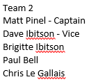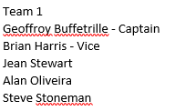

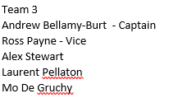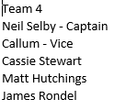

Week 1 fixtures were:

**Captain - Neil Selby v Captain - Geoffroy Buffetrille**

**Captain - Andrew Bellamy-Burt v Captain - Matt Pinel**

**Captain - Neil Selby v Captain - Matt Pinel**

**Captain - Andrew Bellamy-Burt v Captain - Geoffroy Buffetrille**

**Round 1**

**Team Neil’s** players for the first match were Neil, Matt Hutchings and James Rondel who faced **Team Geoffroy,** who were Brian Harris, Alan Oliveira and Jean Stewart.

Brilliant start from Jean with boule bang on the coche, Neil’s team couldn’t displace this and Brian and team made full use of the good start in gaining 5 points. Brian team continued fine start and we ahead 9 nil.

Neil and team fought back to gain 6 points but couldn’t gain anymore, so was a very good victory for Geoffroy’s team without their star player.   13 – 6 To Team Geoffroy.

**Team Andrew** players were Ross Payne, Laurent and Alex who took on **Team Matt** who were Matt Pinel, Chris Le Gallais and Paul Bell.

Matts team started off well by taking the lead 10-3, but once Andrew’s team won their first end and control of the coche they changed direction on the open terrain and adjusted quicker to the different surface picking up one point at a time till it was 10-10.

Andrew’s team then took the lead for the first time in the game scoring two points, going into the final end only needing one point. Matt’s team were out of boules holding the point, Andrew’s team with four boules in hand with Laurent and Alex both having a go at shooting the boule out but missed only for their teammate Ross, captain on the day to show them how it’s done 13 - 10. A great game and a reminder never to give up no matter how far behind you are in a game (even 12-0) as you can always come back to win.

**Round 2**

**Team Neil**, this time Neil played with Callum and Cassie Stewart and took on **Team Matt** who were Matt Pinel, David and Brigitte Ibitson.

After both teams lost their opening match, this was a tight affair. Neil’s team took slight early lead, from a good shoot from Cassie, before Matt’s team came back.

With the game level at 10 – 10 Neil’s team managed to gain full advantage to gain 3 points and gain first win of season.

**Team Andrew,** this time was Ross, Mo De Gruchy and Alex Stewart taking on **Team Geoffroy** of Brian, Alan Oliveira and Stephen Stoneman.

The game started off with Team Geoffroy taking the lead with four points on the first end, on the second end Mo placed a cracking boule in front of the coche with Team Geoffroy unable to move the her boule with six shots resulting in Team Andrew picking up three points.

Team Andrew took the lead to 11-5 with the win in sight things were looking good until Alan starting going first it all changed as they crawled back to 12 all, going in to the final end, with luck on their side Team Andrew were holding one and out of boules. Stephen threw his boule that rickoshade off an outside boule to move the jack on to one of their boules to win the game in style.

Just a thought for next time when your 11-5 up and struggling to get a point you can make a sub at any time could make all the difference.

Best of Luck to everyone

***NEXT WEEK***

**2nd May – Singles League – Week 4 & 5 (Double Fixture Week)**

**WEBSITE** [**www.liberationpetanque.co.uk**](http://www.liberationpetanque.co.uk)

**EMAIL** [**liberationpc@gmail.com**](mailto:liberationpc@gmail.com)

**Kind Regards**

**Toby Northern**

**Chairman**

**Liberation Petanque Club**

# Summer 2018 Season

# Week 6 – 02.05.18

# Singles League Report

# 

**Remember if you cannot play on the scheduled fixture date; please try to play in advance.**

**Please remember New Rules regarding rearranging fixtures.**

Well the first Singles League double fixture week went with a bang as some players made big strides forward whilst some went the other way.

Geoffroy was one of six players on two points with tough matches against Toby and Callum. Toby probably had the toughest week also playing Matt Buesnel.

Geoffroy faught back well in the first game against Toby after being 11 – 4 down won the first game 13 – 12 and went on to win the match. Geoffroy could then only draw with Callum, but four vital points.

Matt Pinel was the only one on a 100% record, he took on Alice and Brian as he looked to extend his lead. He did just that with 5 straight wins to his name and handed out another certificate this time to Brian Harris. Brian pushed Matt close in the second game 13 – 11. But it wasn’t a complete loss for Brian as he beat Callum in his first match.

Matt Buesnel was hoping to keep up the pace with Matt Pinel and started off well handing David Ibitson a heavy defeat but could not match that against Toby as he lost the first game to Toby, but recovered to get a draw.

Neil Selby also without a win had a chance to pick up points against Paul Le Moine and David Ibitson. Neil won convincingly against Paul but was frustrated in his defeat against David Ibitson as David seemed to get all the luck.

Ross Payne made it back to back wins for the first time in a number of seasons by beating Jonny Hill who is struggling in the top flight, but Ross then lost heavily to Paul Le Moine.

**Outstanding Premier League Matches**

**Andrew Bellamy-Burt** - Callum Stewart

**Andrew Bellamy-Burt** - Keith Pinel

**Andrew Bellamy-Burt** - Jonny Hill

Division 1 saw Richard Williams take 4 points from 6 drawing a very close match against Matt Hutchings and a win over Mo. Richard remains top of Division 1 as a result.

Brigitte was sitting in second place prior to the days play, but had tough players to overcome if she wanted to keep the pace with Richard. Playing Harrison Marie, could only manage a draw but remains in third place.

Alex Stewart moved up to second place with a win over Laurent but could have gone top but lost the second game to Mo De Gruchy 13 – 12 for a draw.

Joey Le Clech needed a big week as the pre-season title favourite was playing catch up with the top three. He faced Jean Stewart and Paul Bell. Joey is struggling to get wins in Division 1 as he drew both matches to make that four draws out of five matches played.

Newcomer Stephen Stoneman is proving a hard man to beat as he as drew both his matches, against Harrison and Paul Bell.

Matt Hutchings got his first win of the season over Cassie Stewart before drawing with Richard Williams. David Le Gresley also had two draws against Harrison and Cassie.

Division 1 has three players with one win and four draws in a very close league with 58% of matches drawn so far.

**Outstanding Premier League Matches**

**John McGaw** - Brigitte Ibitson

**John McGaw**  - David Le Gresley

Good luck to those playing in the JPC doubles on Saturday and Sunday and the Carrefour Triples on Monday.

***NEXT WEEK***

**9th May – FREE WEEK – Liberation Day**

**If the Terrains are available a good chance to catch up on outstanding matches or play in advance.**

**WEBSITE** [**www.liberationpetanque.co.uk**](http://www.liberationpetanque.co.uk)

**EMAIL** [**liberationpc@gmail.com**](mailto:liberationpc@gmail.com)

**Kind Regards**

**Toby Northern**

**Chairman**

**Liberation Petanque Club**

# Summer 2018 Season

# Week 7 – 09.05.18

# FREE WEEK

# 

**Remember if you cannot play on the scheduled fixture date; please try to play in advance.**

Best of Luck to everyone

***NEXT WEEK***

**16th May – Doubles League – Week 2**

**WEBSITE** [**www.liberationpetanque.co.uk**](http://www.liberationpetanque.co.uk)

**EMAIL** [**liberationpc@gmail.com**](mailto:liberationpc@gmail.com)

**Kind Regards**

**Toby Northern**

**Chairman**

**Liberation Petanque Club**

# Summer 2018 Season

# Week 8 – 16.05.18

# Doubles League Report

# 

**Remember if you cannot play on the scheduled fixture date; please try to play in advance.**

**And**

**If you are not playing then you must email club with the date the match is rearranged for within 28 days.**

Did you know that there have now been 102 different doubles teams taking part in Liberations League’s since the clubs inception in March 2011 with 81 13 – 0 certificates being handed out.

Only 5 of the 102 teams have made it into the **100 CLUB** Hall of Fame and just 3 of those are still with their original playing partners.

To find out who – check out the 100 Club page on the clubs website and see how they fared in their first 100 matches.

The current champions Mark Nicol & Jake Romeril, already playing catch up took on Ross Payne & Neil Selby who lost to Matt Pinel & Toby Northern in the first week. It didn’t start of very well losing 6 points on the first end, but only lost another two as they won the first game 13 – 8 and went on to win the match taking the second game 13 – 9. Mark & Jake also won a catch up match against Alex & Cassie to sit on maximum points from their first two matches.

Matt Buesnel & Geoffroy Bufetrille also playing catch up took on Keith & Sue Pinel and as expected a big win for a team expected to be title challenges.

Another experienced team and probable title challenges Callum Stewart & Andrew Bellamy-Burt dropped points against Alex & Cassie Stewart with a draw.

Brian Harris & Paul Le Moine were looking for back to back wins to start of their season but were taking on experienced pair David Ibitson & Matt Ryan who handed Joey & Jonny a 13 – 0 certificate in week 1 before losing the second game. There was no slip up this time though from David & Matt as they won a close match to keep up the pace at the top.

Matt Pinel & Toby Northern looking to make back to back wins in their bid for the Premier League title took on Alan Oliveira & Craig Kelly who lost to Brian & Paul in week 1.

With a late start Alan & Craig were playing catch up in game one, but despite several chances, including one end where they were holding 3 but a coche move with the last boule gave the point away, the end result a 13 – 0 defeat. It didn’t get that much better in game two as Matt & Toby ran out 13 – 3 winners to top the table on points difference.

**Outstanding Matches**

James Rondel & Tom McMinigal v Geoffroy Buffetrille & Matt Buesnel

James Rondel & Tom McMinigal v Joey Le Clech & Jonny Hill

**Division 1**

Alice & Brigitte Ibitson were looking for another win to keep up the pace and head towards the Premier League against Christophe & Iwona, it would have been an upset if it was anything other than a win for Alice & Brigitte who duly obliged.

Alan Mitchell & Mike Robinson took on returning pair Martin & Teresa Koradi who were beaten 13 – 0 in their first match against Karen & Colin Hidrio. They faired a better though this time getting their first point of the season.

Harrison Marie & Richard Williams took on Jean Stewart & Chris Le Gallais and a close affair resulting in a draw.

**Outstanding Matches**

Paul Bell & David Le Gresley v Eamonn & Karen Bougeard

Jean Stewart & Chris Le Gallais v Eamonn & Karen Bougeard

Colin & Karen Hidrio v Laurent Pellaton & Matt Hutchings

Colin Myers & Steve Simpkin v Mo De Gruchy & Stephen Stoneman

Super 6 matches played – would you have got it right? Have a go next week and test your knowledge.

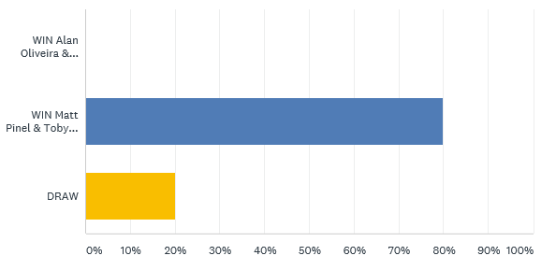

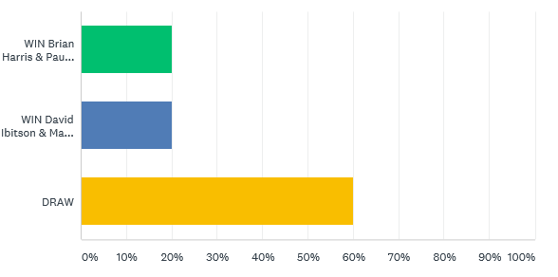

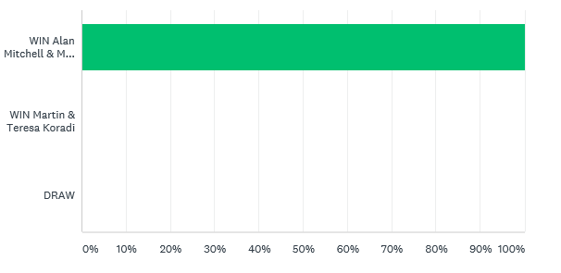

Best of Luck to everyone

***NEXT WEEK***

**23rd May – Singles League – Week 6 & 7 (Doubles Fixture Week)**

**WEBSITE** [**www.liberationpetanque.co.uk**](http://www.liberationpetanque.co.uk)

**EMAIL** [**liberationpc@gmail.com**](mailto:liberationpc@gmail.com)

**Kind Regards**

**Toby Northern**

**Chairman**

**Liberation Petanque Club**

# Summer 2018 Season

# Week 9 – 23.05.18

# Singles League Report

# 

**Remember if you cannot play on the scheduled fixture date; please try to play in advance. You must email club with new date within 4 weeks!!!**

Well Matt Pinel is a man on a mission this season, now on seven straight wins after dispatching both Callum Stewart and Geoffroy Buffetrille with ease. Matt has now opened up a 9 point lead over second placed Matt Buesnel who didn’t have a good night, losing to Geoffroy before gaining a draw with Neil Selby.

Neil Selby made it two draws as despite winning the first game 13 – 8 against Toby, lost the second one 13 – 3. Toby blew a 9 – 4 lead in the second game against Ross Payne to also draw two matches on the day. Ross Payne followed suit drawing with David Ibitson.

Bottom placed Jonny Hill got a draw against Alice Ibitson before losing a close match against Brian Harris. Brian though lost his first match to Keith Pinel who sits in third in the league just 12 points!! off top spot.

**Outstanding Matches**

Andrew Bellamy-Burt v Keith Pinel (2nd May)

Andrew Bellamy-Burt v David Ibitson

Andrew Bellamy-Burt v Paul Le Moine

Alice Ibitson v Paul Le Moine

Division 1 saw Joey Le Clech take the top spot in the league with wins over Stephen Stoneman and Harrison Marie, the latter being a much closure affair as Harrison lost his first match of the season.

Joey though is only top by two points and has played two matches more than Richard Williams who is in second place.

The Winter player of the season Laurent Pellaton is on the charge moving up to third in the league following a miserable start to the season. Laurent only picked up two points in his first four matches but has now won three matches in a row. His recent wins over Paul Bell and Stephen Stoneman.

He moved above Alex Stewart who has only played five of the seven matches and Brigitte Ibitson who drew with Cassie Stewart, Brigitte one of just five players unbeaten in Division 1.

Jean Stewart won her first match of the season against Mo De Gruchy before losing to Matt Hutchings who is also unbeaten and a title contender.

**SUPER 6**

**HOW DID YOU DO?**

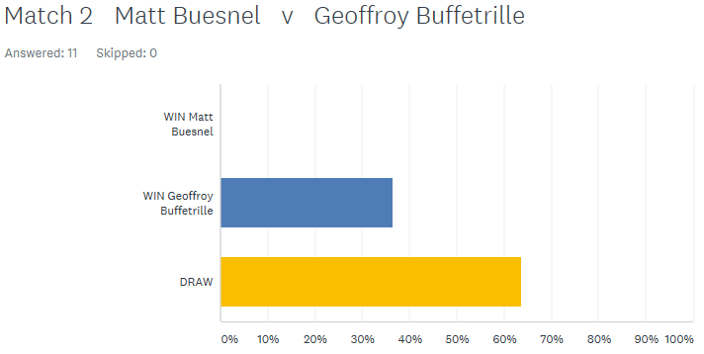

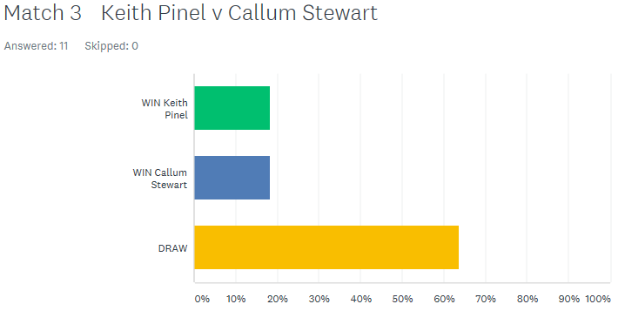

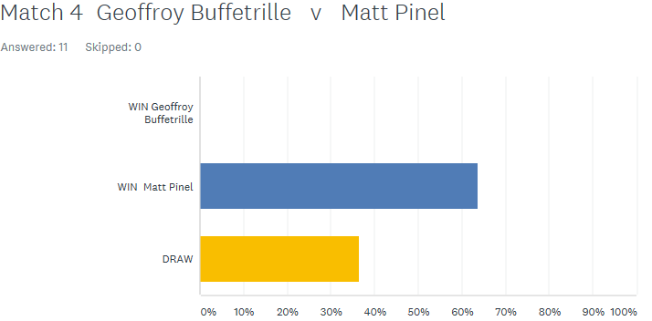

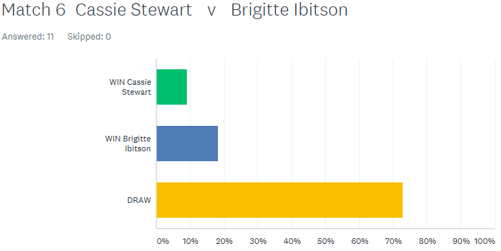

**GOOD LUCK IN THE ISLAND SINGLES CHAMPIONSHIP THIS WEEKEND (26TH MAY) AT THE WEIGHBRIDGE**

Best of Luck to everyone

***NEXT WEEK***

**30th May – Doubles League – Week 3**

**WEBSITE** [**www.liberationpetanque.co.uk**](http://www.liberationpetanque.co.uk)

**EMAIL** [**liberationpc@gmail.com**](mailto:liberationpc@gmail.com)

**Kind Regards**

**Toby Northern**

**Chairman**

**Liberation Petanque Club**

# Summer 2018 Season

# Week 10 – 30.05.18

# Doubles League Report

# 

**Remember if you cannot play on the scheduled fixture date; please try to play in advance.**

Joey & Jonny had just one point, but that was one more than their opponents in Keith & Sue. A win here would see a big jump up the league. But as always with struggling teams wins are hard to come by as was in this case with a draw.

Top of the table Matt Pinel & Toby, who have won their last 6 matches in the league (Winter & Summer) took on tough opponents in David & Matt Ryan who were on four points from two matches, which included handing Joey & Jonny a fanny certificate.

Well Toby & Matt were nearly handed a certificate in game one at 12 nil down gained four points, but that was it. Game two saw Matt & Toby take a 9 – 0 lead before two fours brought Matt & David back into the game and with both playing extremely well took the game 13 – 11 and the match.

Ross & Neil without a win, but had played the top two already. So the hope of a better result against Alex & Cassie who were on just one point from their first two matches, but this match was cancelled to brought forward their match against Matt & David and in stark contrast Matt & David could not get into the match and lost 13 – 2, 13 – 7, just when their title hopes were looking good.

**Outstanding Matches**

James Rondel & Tom McMinigal v Brian Harris & Paul Le Moine

Jake Romeril & Mark Nicol v Alan Oliveira & Craig Kelly

Callum Stewart & Andrew BB v Geoffroy Buffterille & Matt Buesnel

Alex & Cassie Stewart v Ross Payne & Neil Selby

Division 1 saw top of the table Alice & Brigitte take on Colin & Karen Hidrio and three wins in a row as the Ibitson’s look for a title win.

Two of the top teams (potentially!) played each other as David & Paul took on Harrison & Richard. An easy win in game one for David & Paul, but had to fight back in game two, which they did to make it two wins from two as they look to challenge the Ibitson’s for the title.

Laurent & Matt, who are both doing well in the Singles League Division 1, took on the experienced partnership of Alan & Mike who have played in the Premier League. It was a very close match, with the young guns taking the first game 13 – 10, before the experience showed and Alan & Mike took the second game by the same score for a good draw.

Alan & Mike won a match in advance against Karen & Colin Hidrio to move into third place.

Colin Myers & Steve Simpkin took on Jean & Chris, with both teams on just one point a win would be valuable, but as shown above another draw is all they could manage.

**Outstanding Matches**

Mo De Gruchy & Stephen Stoneman v Christophe & Iwona Ait-Elhadj

Mo De Gruchy & Stephen Stoneman v Colin Myers & Steve Simpkin

Eamonn & Karen Bougeard v Paul Bell & David Le Gresley

Eamonn & Karen Bougeard v Martin & Teresa Koradi

**Good Luck to our Ladies playing in the Inaugural Liberation Ladies Singles Open this Saturday at the Weighbridge.**

***NEXT WEEK -* 6th June – Singles League – Week 8**

**WEBSITE** [**www.liberationpetanque.co.uk**](http://www.liberationpetanque.co.uk)

**EMAIL** [**liberationpc@gmail.com**](mailto:liberationpc@gmail.com)

**Kind Regards**

**Toby Northern**

**Chairman**

**Liberation Petanque Club**

# Summer 2018 Season

# Week 11 – 06.06.18

# Singles League Report

# 

**Remember if you cannot play on the scheduled fixture date; please try to play in advance.**

**You MUST inform the club if you are not playing on the scheduled date and the New Date the match has been rearranged for when this has been agreed.**

**Liberation Doubles Cup (Members Only – Free)**

**Wednesday 20th June 2018**

**Still Time to Enter**

**Super 6 Results**

**Coming Up in July – New Monthly Prize?**

**Limited Edition Liberation Merchandise?**

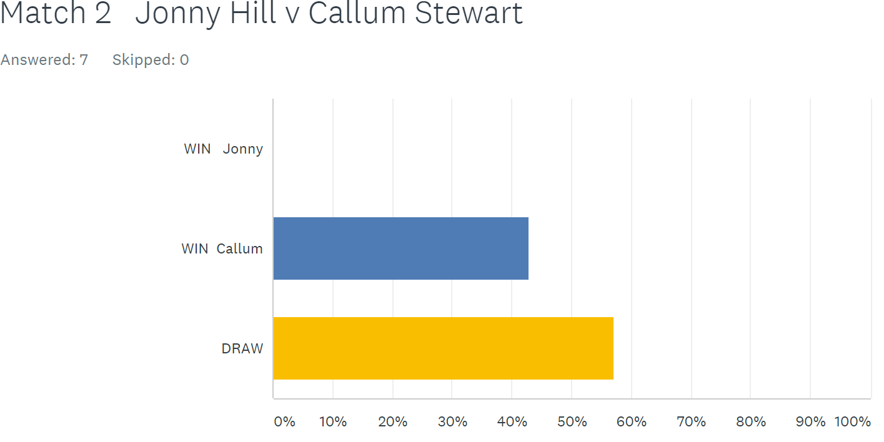

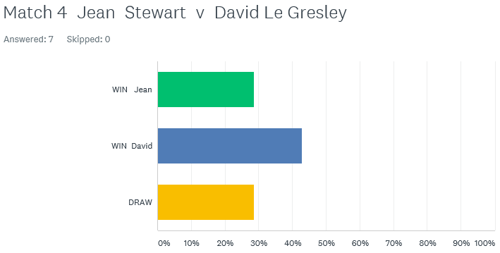

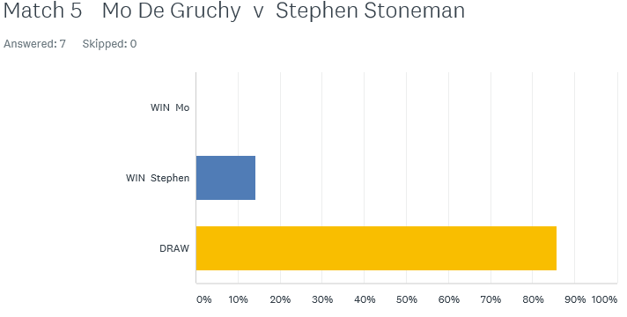

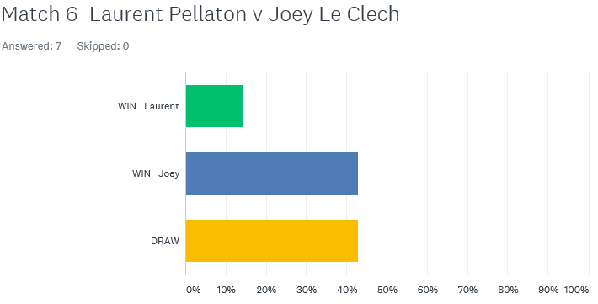

Just two matches played in the Premier League. The bottom two players in the league, Jonny Hill and Callum Stewart played each other knowing a win could make a massive difference to survival. Jonny won comfortably in game one before Callum fought back to gain a valuable draw.

Father and daughter Alice and David also played each other, with every point counting. One game went to 13-12 and it was a decisive win for Alice in game two as she took the win to move above David and out of the bottom three as a result.

Division 1 saw the two form players play each other as Laurent Pellaton on three straight wins played Joey Le Clech, league leader and title favourite. The first game was a close as expected with Laurent taking in 13-12, from 11-2 down! Joey though regained composure to win 13-5 in the second for a draw.

Two other players undefeated were Richard Williams and John McGaw also in with a shout for the title and promotion. The result John’s sixth draw out of seven matches this season and with one win still with a shout of a top three place. Richard moved into third above Laurent after also drawing a catch up match with David Le Gresley.

Newcomer Stephen Stoneman took on his doubles partner Mo De Gruchy with both players looking for valuable points. Another draw as they shared the spoils.

As we move into the second half of the singles season wins were needed for Cassie Stewart and Harrison Marie if any hopes of promotion were to stay alive. Cassie handed Harrison a heavy defeat 13-3, 13-2 moving Cassie up to fifth just two points off the top three.

Alex Stewart looking for back to back promotions to the top flight took on undefeated Brigitte Ibitson, also looking for promotion. A close match with the second game going 13-12 in Alex favour for a big win. Alex followed this up with two more wins in catch up matches against Matt Hutchings, which included a 13-0, and a win over David Le Gresley.

This means Alex Stewart now tops the league on 19 points, 5 points above second place Joey Le Clech.

In a very close league, Matt Hutchings and Paul Bell played each other also looking to make the move up the league. Paul handed Matt his first defeat of the season. An ever improving Jean Stewart taking on experience David Le Gresley, with a good draw resulting in Jean moving out of the bottom three.

**Best of Luck to everyone playing in England this weekend and the Carrefour Singles.**

***NEXT WEEK***

**13th June – Doubles League – Week 4**

**WEBSITE** [**www.liberationpetanque.co.uk**](http://www.liberationpetanque.co.uk)

**EMAIL** [**liberationpc@gmail.com**](mailto:liberationpc@gmail.com)

**Kind Regards**

**Toby Northern**

**Chairman**

**Liberation Petanque Club**

# Summer 2018 Season

# Week 12 – 13.06.18

# Doubles League Report

# 

**Remember if you cannot play on the scheduled fixture date; please try to play in advance and notify club of new date.**

**Liberation Doubles Cup (Members Only – Free)**

**Wednesday 20th June 2018**

**Entry Now Closed**

Matt Pinel & Toby Northern had a scare against Tom McMinigal & James Rondel, but came good in the end to take another valuable three points. This was also the case for Callum Stewart & Andrew Bellamy-Burt who beat PES teammates Joey Le Clech & Jonny Hill.

Fresh from their win over Matt & Toby last time out, Matt Ryan & David Ibitson faced Jake Romeril & Mark Nicol needing another win to keep their title hopes on track. It wasn’t to be as Jake & Mark top the table with four straight wins as they aim for back to back titles.

Brian Harris & Paul Le Moine took on Keith & Sue Pinel with both teams searching for three valuable points. This was a very one sided match as Brian & Paul only let Keith & Sue score three points including a 13 – 0 win.

**Premier League Outstanding Matches Re-arranged Date Expiry Date**

Callum & Andrew **v** Matt & Geoffroy N/A 27.06.18

Mark & Jake **v** Alan & Craig N/A 27.06.18

James & Tom **v** Brian & Paul N/A 27.06.18

Alan & Craig **v** Ross & Neil N/A 11.07.18

Alex & Cassie **v** Matt & Geoffroy N/A 11.07.18

***Expiry date relates to date to notify club of when match will be played***

Division 1

Mo de Gruchy & Stephen Stoneman, bottom of the table had a tough match against top of the table Alice & Brigitte Ibitson. This resulted in the Seventh!! Fanny certificate in the Doubles league so far this season, with Brigitte & Alice running out 13 – 5, 13 – 0 winners.

Alan Mitchel & Mike Robinson won a close match against Karen & Colin Hidrio with the second game going to 13 – 12. Three vital points towards a potential top three finish.

Harrison Marie & Richard Williams were another team with promotion aspirations and faced Martin & Teresa Koradi who were in the relegation zone. A good win for Harrison & Richard who move up to third place as a result.

The tie of Division 1 this week though was second place, playing third place in Paul Bell & David Le Gresley verses Colin Myers & Steve Simpkin. Both teams undefeated with Paul & David on a 100% record. Colin & Steve rediscovered some form of old as they inflicted the first defeat on David & Paul to move second in the league but are seven points off the top spot.

**Division 1 Outstanding Matches Re-arranged Date Expiry Date**

Eamonn & Karen v Paul & David 19th June N/A

Eamonn & Karen v Martin & Teresa N/A 27.06.18

Eamonn & Karen v Laurent & Matt N/A 27.06.18

Christophe & Iwona v Mo & Stephen N/A 27.06.18

Christophe & Iwona v Jean & Chris N/A 11.07.18

**Outstanding Singles Matches**

**Premier League Re-arranged Date Expiry Date**

Alice Ibitson v Paul Le Moine N/A 20.06.18

Andrew Bellamy-Burt v Paul Le Moine N/A 20.06.18

Andrew Bellamy-Burt v David Ibitson N/A 20.06.18

Andrew Bellamy-Burt v Toby Northern 27th June N/A

Neil Selby v Geoffroy Buffetrille N/A 04.07.18

Keith Pinel v Matt Pinel N/A 04.07.18

***Expiry date relates to date to notify club of when match will be played***



**SUPER RESULTS**

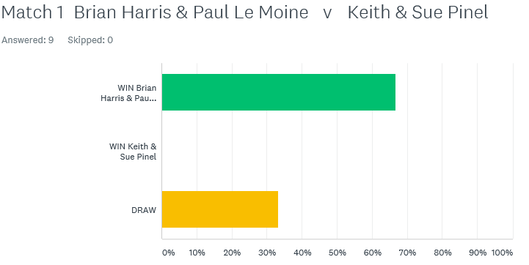

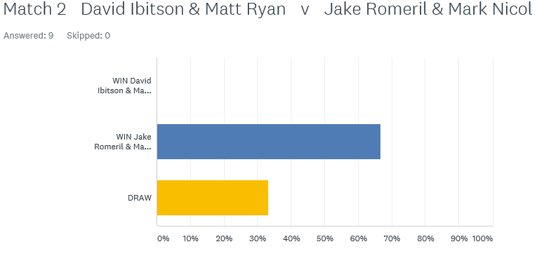

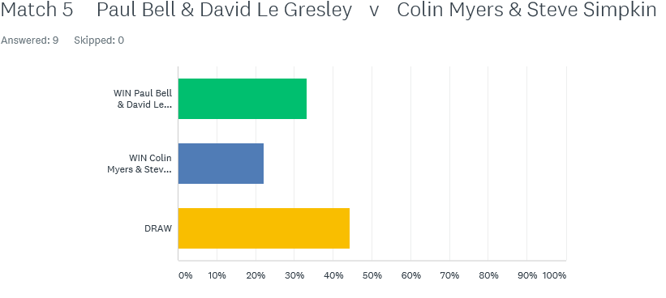

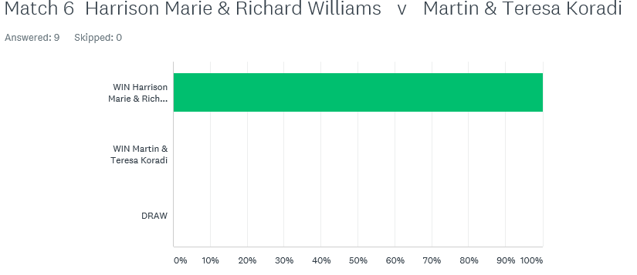

Best of Luck to everyone

***NEXT WEEK***

**20th June – Liberation Cup (Doubles) Members Only**

**Entry Closed**

**WEBSITE** [**www.liberationpetanque.co.uk**](http://www.liberationpetanque.co.uk)

**EMAIL** [**liberationpc@gmail.com**](mailto:liberationpc@gmail.com)

**Kind Regards**

**Toby Northern**

**Chairman**

**Liberation Petanque Club**

# Summer 2018 Season

# Week 13 – 20.06.18

# Liberation Cup Report

# 

With entries increasing to 15 this year and many new partnerships it was going to be a tough competition.

Well we have to start off with a special mention for Mo De Gruchy and Stephen Stoneman who beat on paper one of the best doubles teams in the Island in Geoffroy Buffetrille and Matt Buesnel 13 – 10. Not bad for the pair especially considering Stephen has only been playing 2 months!!

The biggest win of the round was a 13 – 3 win for Toby Northern & Matt Pinel over Colin & Karen Hidrio. There were also big wins for Alan Oliveira & Craig Kelly over Brigitte & Alice Ibitson and Joey Le Clech & Jonny Hill over Chris Le Gallais & Jean Stewart.

Round two saw the top two teams play each other in Toby & Matt v Jake & Mark. Despite the increase in quality of the opposition Toby & Matt repeated the score from round 1 beating Jake & Mark 13 – 3 with some excellent placing and firing.

Geoffroy & Matt turned disappointment from round one into a positive 13 – 1 win over Colin & Karen. There were good wins for Matt Hutchings & Laurent Pellaton taking their game against David Le Gresley & Paul Bell to the very last end winning 10-9.

Neil Selby & Ross Payne avenged a 13 – 0 defeat in last years Doubles Cup to Joey & Jonny winning 13 – 6. Callum & Cassie Stewart made it two wins against Mo & Stephen.

Brian Harris & Paul Le Moine made it three straight wins in a close game against Callum & Cassie 13 – 8. Alan Oliveira & Craig Kelly moved back into contention after a defeat in round two to Brian & Paul by beating Chris & Jean 13 – 1.

Mo & Stephen continued to provide the shocks by beating another Premier League doubles team in Joey & Jonny 13 – 10, this gave them a chance of making the semi-finals.

Another team making it two wins was Alice & Brigitte who thrashed Geoffroy & Matt Buesnel 13 – 4 and if you can’t guess the score between Toby & Matt v Ross & Neil then the first two rounds scores is a big hint. That’s right Toby & Matt won 13 – 3 for the third straight round.

Going into the final round two teams were on three wins who played each other in Brian & Paul v Toby & Matt but several others on two wins as the final battle for the top four spots reached its climax.

In an incredibly close match Brian fired with his last two boules on the very last end to win the match for himself & Paul 9 – 8 over Toby & Matt. Brian & Paul topping the rankings with Toby & Matt finishing second.

Alan & Craig won a close match against Callum & Cassie 13 – 9 to take third place. Several teams though could have taken forth spot. A big win for Alice & Brigitte over Mo & Stephen ended the fairly tale run for the latter.

Alice & Brigitte finished with 3 wins, 8 BHN and +11 points difference. Jake & Mark recovered well to beat Ross & Neil 13 – 5 to also finish on 3 wins, 8 BHN but their points difference was significantly damaged in their round two defeat to Toby & Matt 13- 3 and only finished + 5 to miss out on a top 4 spot by a narrow margin.

This was exactly what happened to Brigitte last year playing with husband David when they finished 5th by two points on points difference.

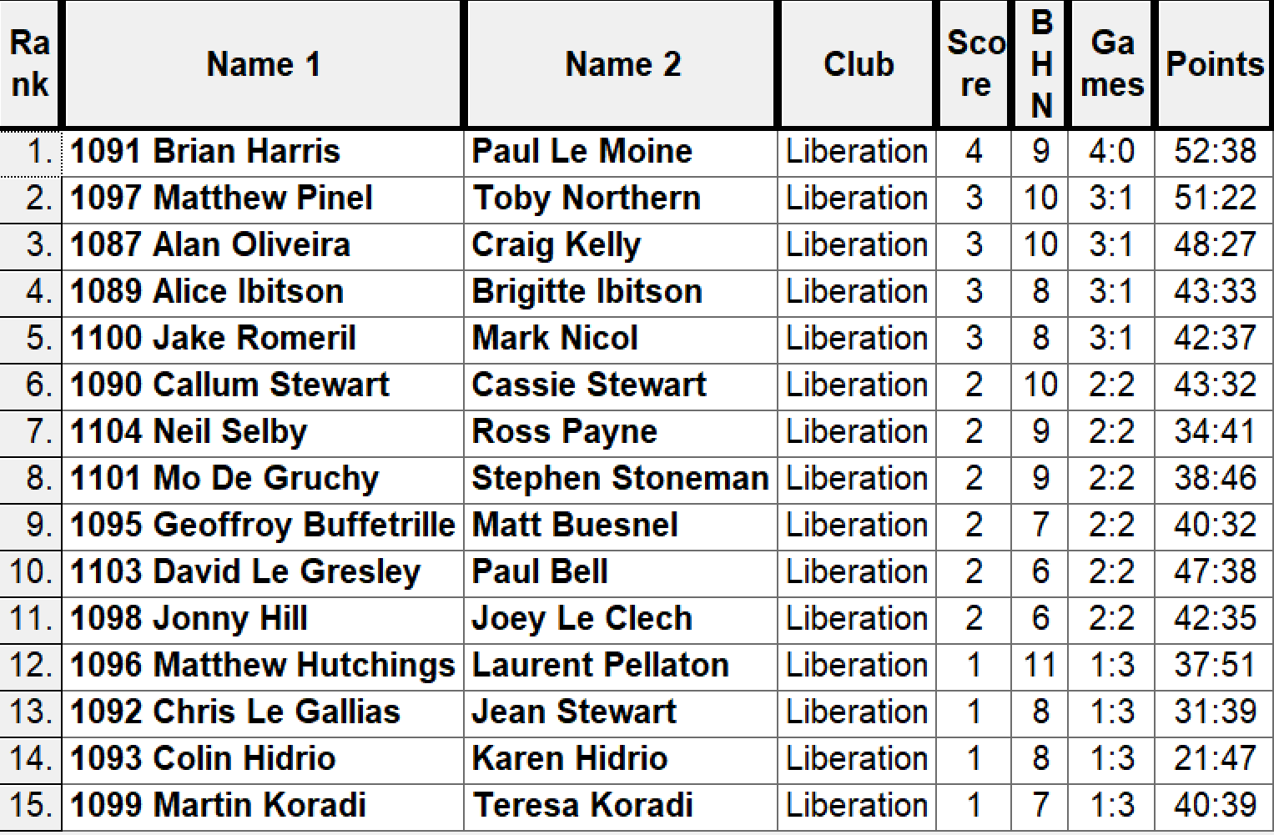

Semi-Finals

Rank 1st Brian Harris & Paul Le Moine v Alice & Brigitte Ibitson Rank 4th

Rank 2nd Matt Pinel & Toby Northern v Alan Oliveira & Craig Kelly Rank 3rd

Well it was a repeat of the 2017 semi-final between Alan & Craig & Toby & Matt. Last year Toby & Matt raced into a 12 – 1 lead before a fight back ending with a 13 – 9 win for Toby & Matt. This year though there was going to be no fight back and not even a point as Toby & Matt fannied their semi-final opponents to make yet another final.

Alice & Brigitte almost got the perfect start against Brian & Paul winning 5 points on the first end and were 6 – 1 and 8 four up before Brian & Paul moved into a 12 – 9 lead. Alice & Brigitte then got two points to make in 12 – 11 but it wasn’t to be as Brian & Paul made the final 13 – 11.

Third place for the second successive year went to Alan Oliveira & Craig Kelly as they recovered from their disappointing semi-final to beat Alice & Brigitte 13 – 2.

With Brian & Paul having already beaten Matt & Toby and actually taken the same numbers of points off them as Matt & Toby’s other 4 opponents put together, they would have been confident of a title win.

The first few ends went Brian & Pauls way as Matt missed a number of fires at six metres to gave away the early advantage. But 13 – 3 seems to be a favourite score line for Matt & Toby as Matt’s firing went back to its usual exceptional best and with Toby constantly out placing Paul and Matt firing all three of Brian’s boules out on the last end as the 2017 (and 2015) champions turned on the style to win 10 ends in a row and hand Brian & Paul a technical fanny winning 13 straight points to become the first team to retain the Liberation Doubles Cup.

Not only that though they handed out several heavy defeats to some exceptional players proving yet again they are the Islands most successful and the top doubles team making it five titles in three years.

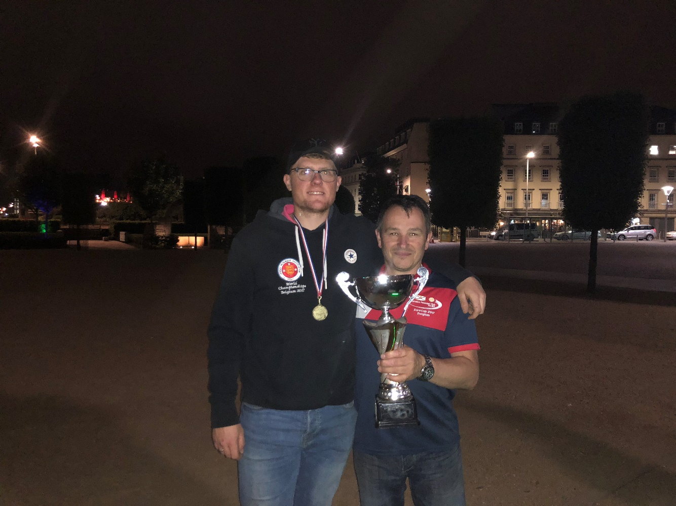

***Special thanks to Ross Payne for setting up and clearing the terrains for the competition really appreciated*** and for members for supporting the club’s tournaments.

Runners Up

Paul & Brian



***NEXT WEEK***

**27th June – Singles League – Week 9 & 10**

**(Last Double Fixture Week)**

**WEBSITE** [**www.liberationpetanque.co.uk**](http://www.liberationpetanque.co.uk)

**EMAIL** [**liberationpc@gmail.com**](mailto:liberationpc@gmail.com)

**Kind Regards**

**Toby Northern**

**Chairman**

**Liberation Petanque Club**

# Summer 2018 Season

# Week 14 – 27.06.18

# Singles League Report

# 

**Remember if you cannot play on the scheduled fixture date; please try to play in advance and Notify the Club if you are not playing and the date your match is arranged for.**

**Liberation Singles Cup (Members Only – Free)**

**Wednesday 11th July 2018**

**Still Time to Enter**

Well, we are only at the beginning of July, but we are already 75% of the way through the Singles League fixtures. However, there are no Singles League fixtures in July just the club Singles Cup.

If results went Matt Pinel way, he could have won the title. So which way did they go, well Andrew Bellamy-Burt and Matt Buesnel were the only ones realistically who could catch Matt, but they played each other in the first fixture of the day with both needing a win to keep the pressure on.

Andrew came out on top and by some margin and is now the only one who can catch Matt. Andrew though drew his second match with Neil and then drew a catch up match with Toby who raced to a first game win, before losing a close second game.

Top played almost bottom as Matt played Jonny Hill as he tried to keep his 100% record going with Jonny needing vital points to avoid relegation. Jonny became the latest person to suffer a 13 – 0 defeat at the hands of Matt, Jonny now sits four points away from anyone else at the bottom of the table after also losing to Keith Pinel.

Matt then also handed Paul a 13 – 0 beating before winning 13 – 2. The next game was much closer with Matt just holding on to his 100% record taking the second game 13 – 12.

Therefore, Matt Pinel is just 11 points clear at the top of the league and will become the Summer Premier League champion unless he loses all his last four matches and Andrew wins all of his.

Neil Selby and Ross Payne, doubles partners played each other and with both sitting in the top half of the table and performing well, made for a good match. It certainly was in the first game going to 13 - 12 with an easier game in the second one as Ross to the bragging rights.

Brian Harris on good form and in third in the league before today’s matches were played, his opponent David Ibitson who was just above relegation. Another win for Brian who is heading for his best ever season.

Callum Stewart needed 3 points to move towards safety against Paul Le Moine but could only draw which leaves himself and Paul in the relegation zones.

Another player struggling for wins was Toby Northern, who played Alice Ibitson, Toby though was always in front in the first game, although the second game was very close Toby held on to win and pick up 3 vital points.

The second round of matches saw Toby play Brian Harris. With Brian playing really well he took the first game but the second went to the very last end at 12 – 12, with Toby gaining a valuable draw. Matt Buesnel played Alice Ibitson in his second game and just holds on to second place in the league on point’s difference after drawing this match.

Ross Payne capped but day with a big win over Geoffroy who only score 7 points in total. Ross now in fifth in the league with Geoffroy in danger of relegation after also drawing the Keith Pinel.

In a catch up match, Neil Selby fought out a great match, with Neil just taking the first game 13-12 with neither player getting more than 2 or three points away from the other.

The second one saw Neil go 9-0 down before fighting back to eventually take the lead 12-11 before Geoffroy pointed in for 2 to seal the victory.

Outstanding Matches

23rd May Andrew Bellamy-Burt v Paul Le Moine (Arranged for 4th July)

23rd May Andrew Bellamy-Burt v David Ibitson (Arranged for 18th July)

23rd May Alice Ibitson v Paul Le Moine (Arranged for 25th July)

6th June Keith Pinel v Matt Pinel (No Date)

A big match in Division 1 was Cassie Stewart and Richard Williams, with both players aiming for a top three finish, but Richard took this game comfortably and now sits in top spot but only on points difference over Alex Stewart who has a match in hand on Richard.

Joey Le Clech needed to take advantage of more favourable fixtures based on league positions as he played Mo De Gruchy, but Mo is getting better every week, could a shock be on the cards. Not quite but another good performance from Mo. Joey though could not beat Matt Hutchings with a draw leaving Joey 1 point off the top but having played more matches.

Brigitte Ibitson had dropped down the table in recent weeks but after performing well in the Doubles Cup with daughter Alice would have been confident of getting a few results. Brigitte did that with a win over Jean before drawing with Paul to hold on to a slim chance of promotion but looks certain to finish in the top half of the table.

Laurent Pellaton also in with a chance of a top three finish in successive seasons took on Harrison Marie, whose last few results leave him off the pace with the top of the league. In a close match Laurent just edged out Harrision 13 – 10, 13 – 10. Unfortunately, though Laurent then drew with Mo losing the second game 13 – 11 to drop 2 vital league points, which is the same number of points he is off third place.

Outstanding Matches

27th June Cassie Stewart v Alex Stewart (No Date)

John McGaw v Alex Stewart (No Date)

John McGaw v Jean Stewart (No Date)

David Le Gresley v Paul Bell (No Date)

David Le Gresley v Stephen Stoneman (No Date)

Richard Williams v Harrison Marie (No Date)

Best of Luck to everyone

***NEXT WEEK***

**4th July – Doubles League – Week 5**

**WEBSITE** [**www.liberationpetanque.co.uk**](http://www.liberationpetanque.co.uk)

**EMAIL** [**liberationpc@gmail.com**](mailto:liberationpc@gmail.com)

**Kind Regards**

**Toby Northern**

**Chairman**

**Liberation Petanque Club**

# Summer 2018 Season

# Week 15 – 04.07.18

# Doubles League Report

# 

**Remember if you cannot play on the scheduled fixture date; please try to play in advance and Notify the Club if you are not playing and the date your match is arranged for.**

**Liberation Singles Cup (Members Only – Free)**

**Wednesday 11th July 2018**

**Still Time to Enter (until Friday)**

The Doubles league is not quite at the half way stage but the leagues are starting to take shape.

A number of Premier League matches were played in advance with Ross & Neil beating David & Matt and Mark & Jake just beating James & Tom.

Unfortunately, club members are suffering a series of injuries (none club related) with Sue Pinel the latest and will be out of action for a number of weeks. We wish you a speedy recovery Sue.

Matt Buesnel & Geoffroy had only played two matches before today, so playing catch up, they took on strugglers Joey & Jonny. It didn’t get any better for the latter as Geoffroy & Matt moved into the top three, but this was hampered by a draw with Alex & Cassie, with a heavy loss 13-3 in the first game before recovering winning the second game 13 – 1!

Callum Stewart & Andrew Bellamy-Burt also with a catch-up game to play took on Liberation Cup runners-up Brian Harris & Paul Le Moine. The latter would be disappointed with a draw after losing the first game 13-12 before making light work in game two winning 13 – 5.

Bottom team Alan Oliveira & Craig Kelly played fellow strugglers Alex & Cassie Stewart and got their first win of the season to move out of the bottom three. They did suffer another heavy loss though in a catch-up match against Mark & Jake and now have a minus 45 points difference.

**Outstanding Matches**

Callum & Andrew v Geoffroy & Matt (Scheduled for 25th July)

James & Tom v Brian & Paul (Scheduled for 30th July)

Alan & Craig v Ross & Neil (No Date)

Keith & Sue v Matt & Toby (No Date)

A big match in Division 1 was Alice & Brigitte Ibitson v Alan Mitchell & Mike Robinson with the former on a 100% record playing against previous Premier league team. Well done to Alan & Mike who played exceptionally well to take the first points off the league leaders with a draw.

Another former Premier League team was Colin Myers & Steve Simpkin who were second in the table, they faced Martin & Teresa Koradi who were hoping for points to get out of the bottom three. Colin & Steve failed to take advantage of Alice & Brigitte draw as they also drew, a great result for Martin & Teresa.

Harrison Marie & Richard Williams were just outside the top three on points difference but had played more matches. They took on Matt Hutchings & Laurent Pellaton who could move above them with a win. It was Harrison & Richard two of the club’s players rising through the ranks who took the win to move into second place in the league.

Mo De Gruchy & Stephen Stoneman would have been hoping to translate their recent cup form into the league as they aimed for their first league points of the season against Jean Stewart & Chris Le Gallais. Well done Mo & Stephen as they did just that winning one game 13-1 to move out of the bottom three, onwards and upwards.

Eamonn & Karen Bougeard are playing catch up and could move into the top three but needed to beat Colin & Karen Hidrio first, which they did but they drew with Laurent & Matt sharing 13-6 wins. This moves Eamonn & Karen up to third in the league.

**Outstanding Matches**

Martin & Teresa v Eamonn & Karen (Scheduled for 10th July)

Best of Luck to everyone

***NEXT WEEK***

**11th July – Club Singles Cup**

**WEBSITE** [**www.liberationpetanque.co.uk**](http://www.liberationpetanque.co.uk)

**EMAIL** [**liberationpc@gmail.com**](mailto:liberationpc@gmail.com)

**Kind Regards**

**Toby Northern**

**Chairman**

**Liberation Petanque Club**

# Summer 2018 Season

# Week 16 – 01.08.18

# Liberation Singles Cup Report

# 

**Remember if you cannot play on the scheduled fixture date; please try to play in advance.**

**Liberation Charity Triples Open (Members Free Entry)**

**In Aid of Jersey Children’s Charity**

**Saturday 20th October**

**Still Time to Enter**

With an increase in this year’s entries despite several late withdrawals and a re-arranged date, 20 players took part hoping to lift the Golden Trophy.

Round 1 saw Matt Pinel carry on his league exploits of handing out 13 – 0 defeats, this time to Paul Bell.

Callum Stewart finished bottom in the singles cup in 2017 just two places below Matt Buesnel, Callum made his first steps to improving his singles record by beating Matt 13 – 8.

Ross Payne suffered a thrashing at the hands of Laurent Pellaton 13 – 3 and 2017 champion Geoffroy lost to Stephen Stoneman who continues his giant killing in cup competitions running out 12 – 11 winner.

Round two saw Laurent win again but a much closer affair against Toby who beat James Rondel in round 1. A bigger shock though was Steve Simpkin who beat Matt Pinel 13 – 12 with some outstanding placing.

Alan Oliveira made it two wins with a 13 – 4 win over Matt Hutchings and Jake Romeril just beat Andrew Bellamy-Burt 11 – 10.

Geoffroy was heading for an early bath after losing two in a row, this time to James Rondel 13 – 9 and two other close matches saw Callum Stewart just beat Stephen Stoneman 9 – 7 and Harrison Marie beat Paul Bell 10 – 9.

In round 3 Laurent’s giant killing ended with a 11 – 7 defeat to Jake Romeril who made it three straight wins. Also making it three straight wins was Callum Stewart against Steve Simpkin and Alan Oliveira against Toby Northern.

Matt Pinel just managed to win against Matt Buesnel 10 – 9 and Mo De Gruchy won 9 – 8 against Jean Stewart.

Round 4 saw Jake lose to Alan 10 – 7 as Alan become the only player with a 100% record.

Andrew beat team mate Callum 9 – 4and Ross moved into contention beating Cassie 13 – 11. Mo De Gruchy lost to team mate Stephen 9 – 5 and Laurent moved back into contention handing Steve Simpkin his second straight defeat 10 – 8.

The final round saw many players still in with a chance of making the quarter finals.

Matt Pinel ended Alan Oliveira 100% record winning comfortably 13 – 5, this mean’t Jake Romeril took top spot in the rankings after he beat Callum Stewart 10 – 8. Matt finishing in 5th place and Callum 6th.

James Rondel missed out on a place in the top 8 after losing his final match 13 – 12 to Matt Hutchings and last years champion Geoffroy tournament ended with a 13 – 12 defeat to Cassie finishing 16th.

Mo gave Toby a run for his money as they shared several two pointer ends with Toby running our 12 – 10 winner.

Ross Payne lost to Andrew 13 – 9 but made the top 8, finishing 7th thanks to the Swiss system as he had a BHN of 13 +1 points diff compared to Cassie Stewart also with 3 wins and despite a + 5 only had a BHN of 10. Andrew finished 2nd.

Matt Buesnel made the top 8, finishing 8th as he beat Steve Simpkin 11 – 9, ending Steve’s hopes of a top 8 finish.

Some really good performances with Matt Hutchings just missing out in 9th place by 1 BHN point and Stephen Stoneman with 2 wins.

The Quarter Finals were as follows:

Ranked 1st Jake Romeril 2 v 13 Matt Buesnel Ranked 8th

Ranked 2nd Andrew Bellamy-Burt 13 v 5 Ross Payne Ranked 7th Ranked 3rd Laurent Pellaton 13 v 11 Callum Stewart Ranked 6th

Ranked 4th Alan Oliveira 5 v 13 Matt Pinel Ranked 5th

The curse of the top ranked player in the Swiss system returned as Jake Romeril (2017 Runner Up) lost heavily to Matt Buesnel with Jake placing way off on several occasions and an unlucky coche move bouncing of his own boule towards Matt on the last end for game.

The first of two matches repeating round 5 fixtures saw a much more comfortable win for Andrew over Ross. The second match was Alan and Matt with a repeat of the round 5 score going Matt’s way.

The closest match was Laurent and Callum, with some excellent play by both players and on the penultimate end Callum was holding two for game, but both boules were together and with his last Boule Laurent firing them both out taking a point to make it 11 – 11 before gaining two points on the next end for the win.

The Semi-Finals were

Matt Buesnel v Matt Pinel

Laurent Pellaton v Andrew Bellamy-Burt

Despite a very close 10 – 9 win in round three for Matt Pinel, he made much lighter work this time winning 13 – 3. Andrew also took advantage of a dip in Laurent’s consistency taking the win 13 – 6.

Third place went to Laurent beating Matt Buesnel 13 – 9 for a fantastic tournament again matching his third place in the super 7’s.

So with Andrew winning the Cup in its first year 2012 and Matt Pinel winning in 2016 who was going to be the first player to lift the trophy twice. Matt was playing in his third final after losing to Matt Ryan in the 2013 final.

Andrew started off in brilliant style with some excellent placing and firing as he quickly moved into a 6 – 1 lead. Matt though on top form recently and with some superb firing got back to 6 all, it was then 10 – 9 to Matt who firing a perfect shot leaving his boule just in front of the coche holding two, only for Andrew to place perfectly just in front on Matts boule to take it to 10 – 10.

Unfortunately on the next Matt’s placing was not quite good enough leaving Andrew to placing two more in, he just managed it to take the title 13 – 10, in a high quality final from both players.

**WEBSITE** [**www.liberationpetanque.co.uk**](http://www.liberationpetanque.co.uk)

**EMAIL** [**liberationpc@gmail.com**](mailto:liberationpc@gmail.com)

**Kind Regards**

**Toby Northern**

**Chairman**

**Liberation Petanque Club**

# Summer 2018 Season

# Week 17 – 18.07.18

# Doubles League Report

# 

**Remember if you cannot play on the scheduled fixture date; please try to play in advance and Notify the Club if you are not playing and the date your match is arranged for.**

**Liberation Singles Cup (Members Only – Free)**

**Wednesday 1st August 2018**

**Still Time to Enter**

Another week and another certificate handed out and guess what Matt Pinel was again involved. This time it was revenge for last season’s certificate given out by Andrew Bellamy-Burt and Callum Stewart and Matt and Toby won the first game 13 – 0, but couldn’t capitalise as the second game went the other way 13 – 9 for a draw, which leaves Toby & Matt 5 points off top spot.

Matt Ryan & David Ibitson moved back into a medal position following a win over Alan & Craig who suffered their forth loss in five matches.

Neil & Ross were held in a very close match going 13 – 10 each way with James & Tom who are holding their own in the top flight

Division 1 see’s new league leaders as Karen & Eamonn Bougeard took two wins, first over Martin & Teresa and then Alan & Mike. They are though just one point above Alice & Brigitte who have a match in hand, as do Paul & David who are four points off top spot after overcoming ever improving Mo & Stephen.

Colin & Steve drew their second successive match and as a result dropped to 5th place in the league. The latest one was against Laurent & Matt Hutchings.

Outstanding Matches

30th May Callum & Andrew v Matt & Geoff (Arranged for 25th July)

30th May James & Tom v Brian & Paul (Arranged for 30th July)

13th June Alan & Craig v Ross & Neil (Arranged for 14th August*)

4th July Keith & Sue v Matt & Toby (No Date)

18th July Keith & Sue v Mark & Jake (No Date)

18th July Joey & Jonny v Alex & Cassie (No Date)

18th July Brian & Paul v Matt & Geoff (Arranged for 22nd Aug)

18th July Jean & Chris v Brigitte & Alice (Arranged for 8th Aug)

18th July Harrison & Richard v Colin & Karen (No Date)

Outstanding Matches - Singles

23rd May Alice Ibitson v Paul Le Moine (Arranged for 25th July)

6th June Keith Pinel v Matt Pinel (Arranged for 24th July)

Outstanding Matches

27th June Cassie Stewart v Alex Stewart (No Date)

John McGaw v Alex Stewart (No Date)

David Le Gresley v Stephen Stoneman (No Date)

Richard Williams v Harrison Marie (No Date)

***NEXT WEEK***

**25th July – Triples Mini League – Week 2**

**WEBSITE** [**www.liberationpetanque.co.uk**](http://www.liberationpetanque.co.uk)

**EMAIL** [**liberationpc@gmail.com**](mailto:liberationpc@gmail.com)

**Kind Regards**

**Toby Northern**

**Chairman**

**Liberation Petanque Club**

# Summer 2018 Season

# Week 18 – 25.07.18

# Triples Mini League Report

# No fixtures

# 

**Remember if you cannot play on the scheduled fixture date; please try to play in advance.**

**Liberation Charity Triples Open (Members Free Entry)**

**In Aid of Jersey Children’s Charity**

**Saturday 28th July 2018**

**Still Time to Enter**

Best of Luck to everyone

***NEXT WEEK***

**1st August – Singles League – Week 11**

**WEBSITE** [**www.liberationpetanque.co.uk**](http://www.liberationpetanque.co.uk)

**EMAIL** [**liberationpc@gmail.com**](mailto:liberationpc@gmail.com)

**Kind Regards**

**Toby Northern**

**Chairman**

**Liberation Petanque Club**

# Summer 2018 Season

# Week 19 – 01.08.18

# Singles League Report

# Some key results with just a few weeks to go to the end of the season. Matt Pinel dropped points for just the second time this season with a draw against David. This was one of four draws as Andrew and Ross, Toby and Callum and Neil and Alice all shared the spoils this week.

# Wins though for Geoffroy over Jonny who was relegated as a result and a big win for Keith meant Paul was looking likely to be relegated. Matt Buesnel beat Brian Harris to stay in the top half of the table.

# There were five draws in Division 1, including the top two Alex and Richard along with Harrison and Mo, Joey and David, John and Paul and Stephen And Brigitte.

# Good wins though for Cassie over Jean and Matt Hutchings over Doubles partner Laurent.

# 

**Remember if you cannot play on the scheduled fixture date; please try to play in advance.**

**Liberation Mixed Doubles Open – Saturday 25th August 2018 – Free for Members – Still Time to Enter.**

Best of Luck to everyone

***NEXT WEEK***

**8th August – Doubles League – Week 7**

**WEBSITE** [**www.liberationpetanque.co.uk**](http://www.liberationpetanque.co.uk)

**EMAIL** [**liberationpc@gmail.com**](mailto:liberationpc@gmail.com)

**Kind Regards**

**Toby Northern**

**Chairman**

**Liberation Petanque Club**

# Summer 2018 Season

# Week 20 – 08.08.18

# Doubles League Report

# 

**Remember if you cannot play on the scheduled fixture date; please try to play in advance.**

**Liberation Mixed Doubles Open – Saturday 25th August 2018 – Free for Members – Still Time to Enter.**

This season is heading for a record number of 13 – 0 certificates as Brian Harris & Paul Le Moine became the latest team to suffer as they lost the first game to Joey Clech & Jonny Hill, they did though recover to take the second game 13 – 8. Joey & Jonny remain bottom though.

James Rondel & Tom McMinigal moved to within one point of second place after handing Alan Oliveira & Craig Kelly their sixth defeat in seven matches to remain in the relegation zone.

David Ibitson & Matt Ryan could only manage a draw with Cassie & Alex Stewart as their slim title hopes have probably (if not mathematically) ended. Alex & Cassie still without a win.

Title hopefuls Toby Northern & Matt Pinel played Matt Buesnel & Geoffroy Buffetrille, Toby & Matt took the first game comfortably 13 – 6 and were 6 – 6 in the second game before Matt & Geoffroy gained a valuable point winning 13 – 7. They must win their next match against Mark Nicol & Jake Romeril to have any chance of the title.

In Division 1 an ever improving Jean Stewart & Chris Le Gallais gained a valuable point against promotion chasing David Le Gresley & Paul Bell, who just hang on to third place.

Mo De Gruchy & Stephen Stoneman moved clear of the relegation zone with their second win in three matches, this time over Martin & Teresa who remain bottom.

***NEXT WEEK***

**15th August – Triples Mini League – Cancelled**

**WEBSITE** [**www.liberationpetanque.co.uk**](http://www.liberationpetanque.co.uk)

**EMAIL** [**liberationpc@gmail.com**](mailto:liberationpc@gmail.com)

**Kind Regards**

**Toby Northern**

**Chairman**

**Liberation Petanque Club**

# Summer 2018 Season

# Week 21 – 15.08.18

# Triples Mini League Report

# CANCELLED

# 

**Remember if you cannot play on the scheduled fixture date; please try to play in advance.**

**Liberation Mixed Doubles Open – Saturday 25th August 2018 – Free for Members – Still Time to Enter.**

Best of Luck to everyone

***NEXT WEEK***

**22nd August – Doubles League – Week 8**

**WEBSITE** [**www.liberationpetanque.co.uk**](http://www.liberationpetanque.co.uk)

**EMAIL** [**liberationpc@gmail.com**](mailto:liberationpc@gmail.com)

**Kind Regards**

**Toby Northern**

**Chairman**

**Liberation Petanque Club**

# Summer 2018 Season

# Week 22 – 22.08.18

# Doubles League Report

# 

**Remember if you cannot play on the scheduled fixture date; please try to play in advance.**

**Liberation Mixed Doubles Open – Saturday 25th August 2018 – Good Luck to all those takings part.**

The Premier League is proving as tough as ever for some teams as Joey & Jonny just avoided becoming the eleventh 13 – 0 victim as they were beaten heavily by Matt & Toby to remain bottom of the league.

Alex & Cassie Stewart kept the heads just above the relegation zone with a good draw against Brian & Paul who are just two points above them.

With so many top teams, there are lots of draws as Neil & Ross recovered to get a good draw against Andrew & Callum. Andrew & Callum also drew a catch up match against Geoffroy & Matt, handing the latter a 13 – 0 to gain a draw.

David Ibitson & Matt Ryan retained third place with a win over ever improving James & Tom.

Outstanding Matches

Joey & Jonny v Cassie & Alex (5th Sept)

Mark & Jake v Andrew & Callum (No Date)

Mark & Jake v Matt & Geoffroy (No Date)

Division 1 saw Alice & Brigitte take a big step towards the title as they beat promotion hopefuls David & Paul with Alice firing exceptionally well.

Eamonn & Karen, there nearest rivals could only manage a draw against Harrison & Richard and narrowly avoided defeat with a 13 – 12 win in the second game.

Colin & Steve’s promotion chances were handed a huge blow as they lost their first match of the season to Alan & Mike. Mo & Stephen drew with Laurent & Matt.

Outstanding Matches

Harrison & Richard v Alan & Mike (No Date)

Harrison & Richard v Colin & Karen (No Date)

Colin & Steve v Colin & Karen (No Date)

Brigitte & Alice v Eamonn & Karen (No Date)

***NEXT WEEK***

**29th August – Singles League – Week 12**

***And 1st August fixtures***

**WEBSITE** [**www.liberationpetanque.co.uk**](http://www.liberationpetanque.co.uk)

**EMAIL** [**liberationpc@gmail.com**](mailto:liberationpc@gmail.com)

**Kind Regards**

**Toby Northern**

**Chairman**

**Liberation Petanque Club**

# Summer 2018 Season

# Week 23 – 29.08.18

# Singles League Report

# 

**Remember if you cannot play on the scheduled fixture date; please try to play in advance.**

**Liberation Doubles Open (Members Free Entry)**

**Saturday 29th September**

**Still Time to Enter**

With this week becoming a double fixture week due to the 1st August fixtures being moved due to the World Cup, there was a good chance titles and promotions would be secured.

One such player looking certain to seal the title was Matt Pinel looking to win the Summer Premier league title for just the second time. Matt was on a 100% record and looked to keep that beating Toby 13 – 3 in the first game, but Toby played much better in the second game and became the first person to take points off Matt all season winning the second game 13 – 11, but this did not stop Matt winning the title. Matt went on to draw his second game against David Ibitson.

**PREMIER LEAGUE CHAMPION**

**MATT PINEL**

Callum Stewart play Neil Selby in advance of the final week of the season and despite leading 10 – 0 in one game lost the match, this mean’t Callum needed to beat both Matt Buesnel and Toby Northern. Callum won a very close match against Matt Buesnel which didn’t help Matt’s chance of top three finish.

Callum though lost his first game to Toby 13 – 3, before just sealing a draw in the second game. Callum now has a nervous wait on Paul Le Moine who beat Jonny Hill (now relegated) before losing to Keith Pinel.

David Ibitson is another who could move above Callum but needs to beat Jonny Hill in his final match of the season to have any chance of staying up. David drew with Keith and Matt Pinel to give him a glimmer of hope.

The big mover on the day was Geoffroy Buffetrille who beat Andrew Bellamy-Burt and Jonny Hill to move clear of relegation and into Midtable safety.

Andrew Bellamy-Burt also drew with Ross as his slim hopes of a title evaporated, but with one match to go should seal second place. Ross beat Alice Ibitson to give him a chance of a top three finish and is in third place above Matt Buesnel on points difference.

Premier League Singles – Outstanding Fixtures

NO FIXTURES OUTSTANDING

Division 1 saw Richard Williams beat Jean Stewart tof catching Alex Stewart who he play next. Alex though took a close first game 13 – 11 to seal promotion with two matches to play, before Richard won the second game a bit easier 13 – 5. Richard now needs to win his last match and hope Alex gets no more than 1 point from his final two matches. Richard though has also secured promotion to the Premier League.

Joey Le Clech, the Division 1 favourite at the start of the season failed to win again, this time it was Brigitte whole gained a good draw. Joey though should take the final promotion spot unless he loses his final two matches.

Laurent Pellaton gave himself hope of promotion with a big win over David Le Gresley but then blew his chance of taking third place with a defeat to Matt Hutchings.

Cassie Stewart won one and lost one as she stayed above relegation, her win was against Jean Stewart who after two defeats sits in the relegation zone with Mo De Gruchy who drew with Matt Hutchings and Stephen Stoneman who drew with Brigitte Ibitson, but was one point away from winning his first league match losing the first game 13-12.

***NEXT WEEK***

**5th September – Doubles League – Week 9**

**WEBSITE** [**www.liberationpetanque.co.uk**](http://www.liberationpetanque.co.uk)

**EMAIL** [**liberationpc@gmail.com**](mailto:liberationpc@gmail.com)

**Kind Regards**

**Toby Northern**

**Chairman**

**Liberation Petanque Club**

# Summer 2018 Season

# Week 24 – 05.09.18

# Doubles League Report

# 

**Remember if you cannot play on the scheduled fixture date; please try to play in advance.**

**Liberation Doubles Open (Members Free Entry)**

**Saturday 29th September**

**Still Time to Enter**

With Mark & Jake looking odds of for the title leading by 1 point with two matches in hand a win this week over bottom of the league Joey & Jonny and a loss for Toby & Matt would see them virtually guaranteed back to back Summer Premier League titles.

Toby & Matt, played Brian & Paul who they beat 13 – 3 in the Liberation Club Doubles Cup final. Well that score seems to be magic for Toby & Matt as they repeated that score in both games against Brian & Paul to keep the pressure on Mark & Jake.

Mark & Jake also won easily, at least that’s what the score suggests winning 13 – 4, 13 – 4. But in a catch up match they not only dropped their first points of the season they lost, but not only that they were fannied by Andrew & Callum.

If Mark & Jake win their next match against Brian & Paul they will win the title, anything less and it will go down to the final match of the season against Toby & Matt.

Ross & Neil played Matt & Geoffroy with anything but a win ending any slim hopes of a title for either pair. Matt & Geoffroy though have been off the boil recently and with Ross & Neil playing really well again, it was the latter who took the win.

James & Tom became the latest 13 – 0 victims losing to Alex & Cassie in the first game before coming back to win the second one for a good draw.

Alan & Craig desperately needs points from their match against Callum & Andrew who also need points after drawing 5 out of 6 matches. Alan & Craig though suffered another 13 – 0 defeat and only scored 4 points in the other game, so must win their final matches to have a chance of staying up.

Brigitte & Alice look odds on for the title having beaten Richard & Harrison with Karen & Eamonn drawing with Colin & Steve, although they do have to play each other.

Richard & Harrison though still in with a chance of the top three with a match in hand over Paul & David who could only draw against Martin & Teresa.

Jean & Chris played Laurent & Matt with both teams needing points to avoid the drop, but a draw did neither teams any favours.

***NEXT WEEK***

**12th September – FREE WEEK**

**WEBSITE** [**www.liberationpetanque.co.uk**](http://www.liberationpetanque.co.uk)

**EMAIL** [**liberationpc@gmail.com**](mailto:liberationpc@gmail.com)

**Kind Regards**

**Toby Northern**

**Chairman**

**Liberation Petanque Club**

# Summer 2018 Season

# Week 25 – 12.09.18

# Triples Mini League Report

# 

**Remember if you cannot play on the scheduled fixture date; please try to play in advance.**

**Liberation Doubles Open (Members Free Entry)**

**Saturday 29th September**

**Still Time to Enter**

Cancelled

Best of Luck to everyone

***NEXT WEEK***

**19th September – Doubles League – Week 10**

**WEBSITE** [**www.liberationpetanque.co.uk**](http://www.liberationpetanque.co.uk)

**EMAIL** [**liberationpc@gmail.com**](mailto:liberationpc@gmail.com)

**Kind Regards**

**Toby Northern**

**Chairman**

**Liberation Petanque Club**

# Summer 2018 Season

# Week 26– 19.09.18

# Doubles League Report

# 

**Remember if you cannot play on the scheduled fixture date; please try to play in advance and Notify the Club if you are not playing and the date your match is arranged for.**

**Liberation DOUBLES OPEN**

**SATURDAY 29TH SEPTEMBER 2018**

**Still Time to Enter**

**CHARITY TRIPLES OPEN**

**SATURDAY 20TH OCTOBER 2018**

**STILL TIME TO ENTER**

**REMEMBER THE ABOVE COMPETITIONS ARE**

**FREE FOR MEMBERS**

**DONATIONS ARE WELCOME FOR THE CHARITY COMPETITION THOUGH IF YOU WISH TO.**

With Matt, Matt and Mark away at the world championships and Callum on his Honeymoon four big matches went un-played. There were still a top team fighting for a medal position as well as one team hoping to avoid relegation in action.

Just outside the top three by two points on point’s difference were Ross & Neil who played relegation threatened Joey & Jonny. Ross & Neil had been playing well recently as they moved up the table after a difficult start to the season. Relegation could be looming for Jonny again who is already relegated from the Singles Premier League as himself and Joey lost 13 – 6, 13 – 7 to Ross & Neil who look odds on to finish in the top three.

Division 1 saw Alice & Brigitte hope to seal the title with a win over Martin & Teresa, but as requested Martin & Teresa made the pair wait as they won the first game 13 – 7, before Alice & Brigitte recovered to take the second game 13 – 4. Alice & Brigitte still have to play Eamonn & Karen, a win for the latter could make it a nail-biting finish.

Paul Bell & David Le Gresley position in the top three was under threat after a number of recent draws, which meant they needed to beat Laurent & Matt who were off the pace of the top three. This was almost a defeat for Paul & David as they just won the first game 13 – 12, before losing 13 – 6 in the second game, with teams below them with matches in hand and just one scheduled match to go it could be any of three teams.

Jean Stewart & Chris Le Gallais were hoping to move clear of the bottom of the table with a win over Colin & Karen who had just beaten Mo & Stephen earlier in the week. Jean & Chris though won this relegation match to move out of the bottom three with Colin & Karen dropping back in.

Alan & Mike were hoping a win would propel them towards a medal position but took on ever improving Mo & Stephen. Another up and down match as a 13 – 5 win for Mo & Stephen in game one changed to a 13 – 7 win for Alan & Mike in the second game.

**Outstanding Matches – Singles Premier League**

**NONE**

**Outstanding Matches – Singles Division 1**

John McGaw v Paul Bell (29th Aug)

John McGaw v Stephen Stoneman (29th Aug)

Alex Stewart v Harrison Marie Playing 24th Sept

**Outstanding Matches – Doubles Premier League**

Toby Northern & Matt Pinel v Alex & Cassie Stewart Playing 26th Sept

Callum Stewart & Andrew v David Ibitson & Matt Ryan (19th Sept)

Matt Buesnel & Geoffroy v Alan Oliveira & Craig Kelly (19th Sept)

Jake Romeril & Mark Nicol v Brian Harris & Paul Le Moine (19th Sept)

**Outstanding Matches – Doubles Division 1**

Harrison Marie & Richard Williams v Colin & Karen Hidrio Playing 21st Sept Rescheduled

Harrison Marie & Richard Williams v Alan Mitchel & Mike Robinson (8th August)

Alice & Brigitte Ibitson v Eamonn & Karen Bougeard (8th August)

Colin & Karen Hidrio v Colin Myers & Steve Simpkin (8th August)

Harrison Marie & Richard Williams v Colin Myers & Steve Simpkin (19th Sept)

***NEXT WEEK***

**26th September – Singles League >Final scheduled matches**

**WEBSITE** [**www.liberationpetanque.co.uk**](http://www.liberationpetanque.co.uk)

**EMAIL** [**liberationpc@gmail.com**](mailto:liberationpc@gmail.com)

**Kind Regards**

**Toby Northern**

**Chairman**

**Liberation Petanque Club**

# Summer 2018 Season

# Week 28 – 03.10.18

# FREE WEEK

# 

**Remember if you cannot play on the scheduled fixture date; please try to play in advance.**

Best of Luck to everyone

***NEXT WEEK***

**10th October – Doubles League – Week 11**

**SEASON ENDS SUNDAY 14th October 2018 – All Fixtures Must be Played no later than this date.**

**WEBSITE** [**www.liberationpetanque.co.uk**](http://www.liberationpetanque.co.uk)

**EMAIL** [**liberationpc@gmail.com**](mailto:liberationpc@gmail.com)

**Kind Regards**

**Toby Northern**

**Chairman**

**Liberation Petanque Club**

# Summer 2018 Season

# Week 29 – 10.10.18

# Doubles League

# 

The final scheduled date for fixtures could have seen a big title deciding match between Mark Nicol & Jake Romeril v Toby Northern & Matt Pinel but the former just managed to beat Brian Harris & Paul Le Moine to have already sealed back to back titles before they played Toby & Matt.

The latter started slowly in game one going 7- 0 down before coming back to 7 – 7, but couldn’t keep the momentum going losing 13 – 7. Toby & Matt then went 11- 1 down in the second game before coming back to win 13 – 11 scoring a 6 point end for a good drawn.

This mean’t both Ross Payne & Neil Selby and Andrew Bellamy-Burt & Callum Stewart could finish above them with wins in their final matches.

Ross & Neil took on Brian Harris & Paul Le Moine in a marathon match lasting 2 ½ hours but is was the closest possible match ending with a 13 – 12 win for each team as they drew.

Quite the opposite though Andrew & Callum who had tough opposition in Matt Ryan & David Ibitson it a catch up match and so it proved as the most unlikely result saw Andrew & Callum received a double 13 – 0 loss!!!.

Matt & David could have finished in the top three with win over Gaeoffroy Buffetrille & Matt Buesnel but could only draw to miss out on a medal by 2 points on points difference from Ross & Neil.

Joey Le Clech & Jonny Hill needed to win their last match to stay up against Alan & Craig who need a big win. Unfortunately for Joey & Jonny they couldn’t do it suffering their seventh loss of the season.

It wasn’t to be either though for Alan & Craig who missed survival on points difference with Alex & Cassie Stewart staying up.

Division 1 saw Alice & Brigitte Ibitson crowned champions in style winning 13- 2, 13 – 1 over promotion hopefuls Colin Myers & Steve Simpkin, whose chances ended with that heavy defeat.

Martin & Teresa Koradi shocked rising stars Laurent Pellaton & Matt Hutchings to win their first match of the season and as a result ensure Division 1 safety for next Summer.

Eamonn & Karen Bougeard won their final match as they finished second in the league, finishing 4 points above third place which went to David Le Gresley & Paul Bell would won their last match of the season 13 – 11, 13 – 6 over Colin & Karen Hidrio.

Jean Stewart & Chris Le Gallais got a good draw against Alan Mitchell and Mike Robinson to move up to seventh.

Best of Luck to everyone

**SEASON ENDS SUNDAY 14th October 2018 – All Fixtures Must be Played no later than this date.**

**WEBSITE** [**www.liberationpetanque.co.uk**](http://www.liberationpetanque.co.uk)

**EMAIL** [**liberationpc@gmail.com**](mailto:liberationpc@gmail.com)

**Kind Regards**

**Toby Northern**

**Chairman**

**Liberation Petanque Club**