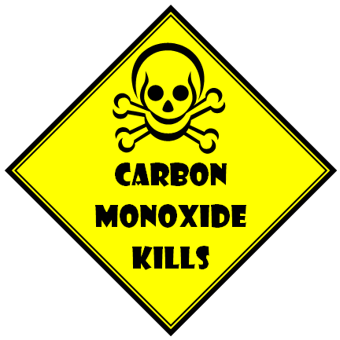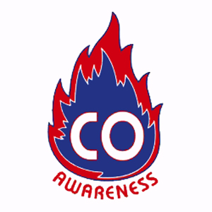

#### CO Poisoning Symptoms

http://epi.publichealth.nc.gov/oii/carbonmonoxide/pdf/CObrochure.pdf

The initial symptoms of CO poisoning resemble the flu. These symptoms include:

* Headache
* Fatigue
* Shortness of breath
* Nausea
* Dizziness

Purchasing a CO detector…

* Select a detector listed by a qualified independent testing laboratory (such as UL)
* Do not place a CO detector in proximity to your furnace or woodstove or you may get false alarms.
* Test your CO detector at least once a month following the manufacturer’s instructions.

CO Poisoning Prevention:

* Never burn charcoal indoors.
* Never use portable camping equipment indoors.
* Never leave a car running in an attached garage.
* **Never use gas appliances, such as a stove, to heat your home.**
* Do not operate un-vented fuel burning appliances in rooms with closed doors and windows or in rooms, where people are sleeping.

Carbon monoxide, also known as CO, is called the “Invisible Killer” because it’s a colorless, odorless, poisonous gas created whenever fossil fuels (such as gasoline, wood, oil, propane, and liquefied natural gas) burn.

**Provided by**:

FHSU Nursing Students

# What is Carbon Monoxide?

**The Silent Danger**

**Carbon Monoxide**