Home Grown Gel Electrophoresis

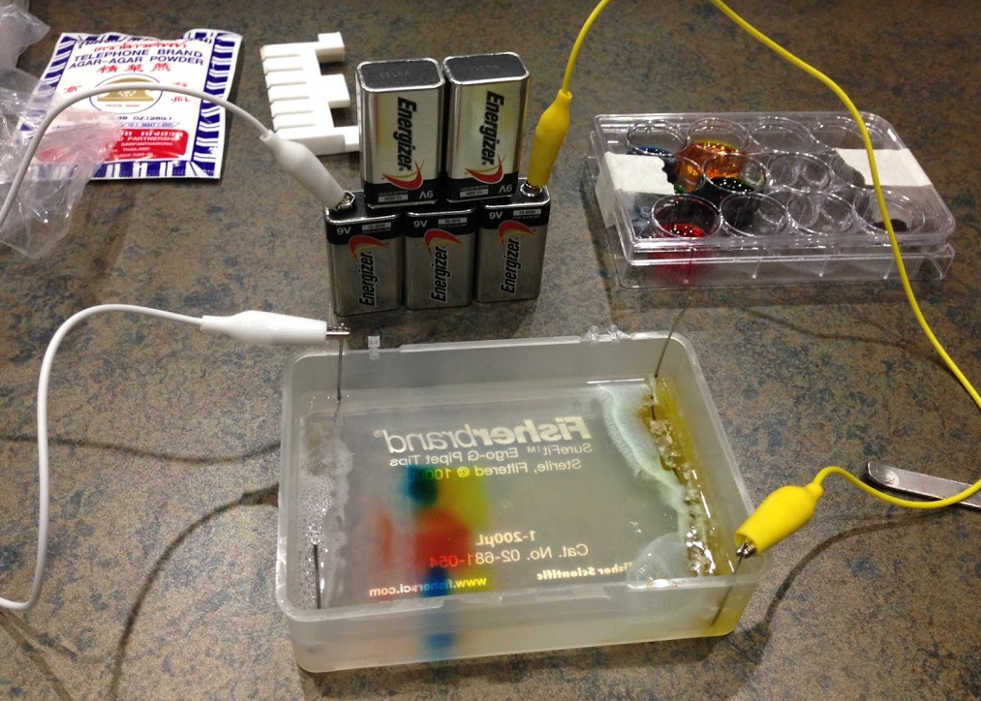

Adapted from:
Micro World Investigate Lab - North Carolina Museum of Natural Sciences - November 2015

Purpose: the separation of large macro-molecules by size, shape, and/or charge is one of the most commonly used technologies in molecular biology. This usually involves separation of DNA/RNA or proteins for subsequent analyses and/or purification.
Requires:
- A matrix (gel) for molecules to travel through; usually agarose or polyacrylamide
- A constant electrical current forcing molecules to move in one direction
Apparatus for doing these separations are expensive and not generally available outside of research labs.
Solution: a home-made apparatus demonstrating the principles of electrophoresis that is affordable and safe for classroom use.

North Carolina Essential Standards Bio.3.3.1
- Summarize the process of gel electrophoresis as a technique to separate molecules based on size. Students should learn the general
steps of gel electrophoresis – using restrictions enzymes to cut DNA into different sized fragments and running those fragments on gels with longer fragments moving slower than faster ones
- Interpret or “read” a gel.
- Exemplify applications of DNA fingerprinting - identifying individuals; identifying and cataloging endangered species.

Materials

Ingredients

Agar-agar (for the food color demo) or agarose (for actual DNA gels); both supplied in the kit
Baking soda; user supplied

250 ml baking soda gel running buffer (0.2%, 0.5 g); need 100 ml for gel and rest for running buffer
1% agar-agar gel
Need 100 ml/gel for the micropipette tip box; 1 g agar-agar or agarose in100 ml of 0.2% baking soda buffer

Electrophoresis Unit & Power Supply (supplied in kit)

• Used micropipette tip box lid or bottom
• four 20 gauge stainless steel wires (16 cm); paper clips can be used
• 3 clip leads
• 3-5 9V batteries

Samples from Food Color kit (red, blue, yellow, green)

Per sample:
• 0.5 ml corn syrup (high fructose or karo; supplied by user)
• 3 ml water
• 1 drop food color

mix with small transfer pipette (use one pipette per sample)
use separate small transfer pipettes to load each sample, large transfer pipette to prepare master samples

Hard Candy Sample (alternative to corn syrup only)
• 1 piece of hard candy
• 4 ml water

Miscellaneous Supplies

Supplied with kit unless noted in bold as user supplied

• Plastic transfer pipets (large with gradations, small for gel loading)
• Gel comb (6 well for agar-agar; 10 well for agarose)
• Metal spatula (for cutting the gel; razor blade also ok)
• Digital scale; user supplied – jewelers’ scale suggested (ebay @ $10-15)
• Small weigh boats
• 12-well tissue culture plates (for samples)
• Microwave; user supplied
• Glass flask; 250 ml supplied with kit
• Glass beaker (or graded mason jar) for measuring buffer; user supplied
Oven mitt; user supplied

Procedures

For making running buffer (0.2% Baking Soda Solution)

1. Weigh out amount of baking soda required to make and run gel.
2. Pour baking soda into beaker or large glass, swirl to mix.
3. Use a 250 ml flask to measure out enough water (distilled or tap) to make and run one gel.
4. Pour water into beaker or large glass.
5. Gently swirl water in flask until baking soda dissolves.

For making 1% agar-agar gel

1. Weigh out amount of agar required to make gel (1 g for 100 ml gel).
2. Use a graduated cylinder or other to measure out enough running buffer to make gel.
3. Pour running buffer into 250 ml glass flask.
4. add agar to flask, swirl.
5. Place beaker in microwave and heat until boiling; stop before it boils over. Remove and gently swirl flask.
6. Return flask to microwave until boiling. Remove and swirl
7. Repeat the above once or twice until most of agar is suspended.
8. Allow liquid to cool until about 55 °C (or until cool enough to hold beaker to the count of five).
9. While liquid cools, prepare Electrophoresis Unit by positioning the appropriate Gel Comb about 3 cm away from one end of the used tip box.
10. When liquid is cool enough, pour 90-100 ml into the gel box. (If liquid solidifies before pouring, gently re-melt in the microwave.)
11. Allow gel to cool and solidify in the tip box.
12. When gel has solidified, gently remove the gel comb vertically. The empty spaces in the gel left when the comb is removed are called "wells."
13. The gel is ready to be loaded with samples and run.

For making Food Color Samples

1. Use (and re-use) 12-well tissue culture plate supplied.
2. Decide which colors you would like to test (suggested samples below).
3. For each color to be tested:
a. Put 0.5 ml light corn syrup into each well needed. Corn syrup (or sugar below) is used to add density to sample so it will sink into the well and stay,
b. Add 3 ml water to the same wells. For step a and b, use large transfer pipette with gradations.
c. Add one drop of food color to the same well with small transfer pipette.
d. mix with small transfer pipette; also use this to load wells

Alternative to corn syrup
For making Hard Candy Samples
1. Place a piece of hard candy (no color) into a small cup.
2. Add 4 ml water to the cup.
3. Allow candy to dissolve; use 0.5 ml as in the above corn syrup example.

Suggested samples for agar gel electrophoresis
1 Red
2 Blue
3 Yellow
4 Green
5 Purple (mix one drop of blue and red)

For loading and running samples in the 1% Agar Gel

1. Make two buffer reservoirs by using a thin metal spatula to carefully cut and remove a 5 mm-wide strip of gel material from the top and bottom of the gel.
2. Use two of the steel wires and bend each into a shape that has two vertical short ends of approximately equal connected by a longer straight horizontal piece. The horizontal piece should be as long as the tip box is wide on its short end. Alternatively, paper clips can be used. Paper clips degrade in quality, only useful for one gel. Anode (-) end clip also discolors gel if run long enough.
3. Place a bent wire in each reservoir, making sure the horizontal piece touches the bottom of the tip box.
4. Pour enough running buffer into the tip box to cover the gel and fill the reservoirs.
5. Using a small transfer pipette, fill a well with one of the samples to be tested. Avoid puncturing the bottom of the well with the pipette tip.
6. If there are multiple samples to be tested, repeat Step 5 but use a clean pipette for each sample.
7. After all samples have been loaded into the wells, clip one vertical piece of each wire with a separate clip lead. Do not let samples sit too long as they will eventually diffuse out of the well.
8. Using their own positive (+; anode) and negative (-; cathode) terminals, snap three-five 9V batteries together into a pyramid.
9. Place the 9V battery tower near the tip box.
10. Attach the free end of the clip lead that is connected to the paperclip nearest the wells to the negative (-) terminal of the 9V battery tower.
11. Attach the free end of the clip lead that is connected to the paperclip farthest away from the wells to the positive (+) terminal of the 9V battery tower. Samples will move toward the cathode.
12. Look for small bubbles forming along the submerged vertical piece of the paperclip that is connected to the negative terminal. If no bubbles are forming, check the clip connections to the paperclips and the batteries' terminals. Also, make sure that the batteries are charged.
13. Allow the gel to run for about 20-40 minutes or until samples have moved through the gel as far as desired.
14. To stop the gel from running, unclip the leads from the batteries and paperclips.
15. Gently pour off the running buffer and examine the gel.
16. Document result with a picture

Questions to ask your students or other things to try:

- Did your samples move out of the wells?

- Which sample moved the farthest?

- What does the direction of the movement say about the charge of the dyes?

- Which sample is made up of the smallest molecule?

- Did any of your samples have more than one color?

- What do you think would happen if you used more batteries?

- What do you think would happen if you tested different samples.

