Pleasant Township Board of Trustees Meeting Highlights
Date __January 10, 2023 Next Resolution No.__ 15-----01-10-2023_______

- Call to Order -- The meeting tonight will also be on WebEx. (held a special meeting prior to this meeting at 6:30 p.m. to reorganize.)
- Please stand for moment of silence. --Pledge of Allegiance-----Roll Call – (Trustee Sheets is attending via WebEx)
- Minutes to approve- none
- Financial Reports – Motion to pay expenditures.
- Visitors –
- Hanna Poling with the Southwest Messenger via WebEx.
- Department Reports
- Franklin County Sheriff’s Report- Deputy Hamilton
  - Total calls for service for 12-27--22 to 1-10-23 were _130__
  - Total reports – 5
  - Arrest – 0
  - Tickets-2
  - Burglary/B & E- 1 (unfounded)
  - Thefts – 2 (unfounded)
  - Accidents – 8
  - Suspicious Activity –10
  - Alarm Drops –3
  - Traffic Stops –15
  - Disabled vehicles –6
  - Sheriff’s office is now taking applications for the Citizens Academy that is projected to start in April.
- Road Department- Robert Bausch, Superintendent
  - Equipment maintenance
  - Truck # 22 at ELW – waiting on parts
  - Annual report for FSWCD
  - Building maintenance
- Fire Dept. – Fire Chief, David Whiting
***Ed has the propane taken care of.
Staffing
- Swearing in ceremony for FF Noonan and FF Krebs
- Resolution 15 to Remove FF Joshua Burke from department.
Medic
- New medic is in service
·Equipment
- Extra medic is at Prairie
- Extra engine is at Prairie
Community Risk Reduction
Training
- ESO Training in Texas
- Requesting approval to send one firefighter to the training at a cost of $2000.00
Trustees gave approval.
Miscellaneous
- Bay heater has been fixed – cost was approximately $1,550
- Grants
- OTARMA-$1000 and $500 for equipment – Chief Whiting applied for and received these grants.
- Announcements-
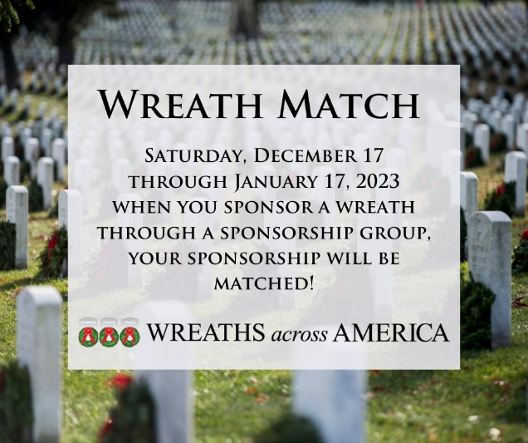
  - Carrie Cole, Coordinator for Oak Grove Cemetery Wreaths Across America reports there are approximately 200 veterans buried at Oak Grove Cemetery. The Wreaths Across America service to honor these veterans will be December 16,, 2023. The next 7 days is a great opportunity to sponsor a wreath because your sponsorship will be matched by a sponsorship group. So today through next Tuesday, January 17th, sponsor a wreath for $15 and we get two wreaths. Or sponsor 2 and we get 3. For example, I paid for 5 today which means we get 12.5 wreaths. If I had known they were matching 2 get 3, I would have gotten 6, but this matching opportunity is not listed on their website when donating, please be aware of that. A total including the matching wreaths is sent to the coordinator, Carrie Cole. To date we have 75 wreaths sponsored, which is already 35 more than what we had in December. Only 125 to go and all veterans at Oak Grove Cemetery will be recognized. If just 10 people sponsored 5 wreaths by January 17th the goal would be met. Everyone is welcome to participate in the laying of the wreaths during the ceremony. You do not have to sponsor to participate. Your help is greatly appreciated. Please use the link found on the Township website, Facebook page or Nextdoor to support Oak Grove Cemetery Wreaths Across America Project.
- Clerk Updates- Paula
  - Misc. emails and notifications
- Adjourn-

