Public Aquarium California Specimen List
Marine Aquaria Receiver’s Lis 84973

FISH SPECIMEN LIST
Robert Burhans: (858) 774-2806 or email: Bob@matsucollections.com

**Special order specimens are those which are infrequently encountered or pose specific collecting challenges.
 | Example |  | Common Name  Latin Name | Comments* | Size & Distribution |  | US$
 | 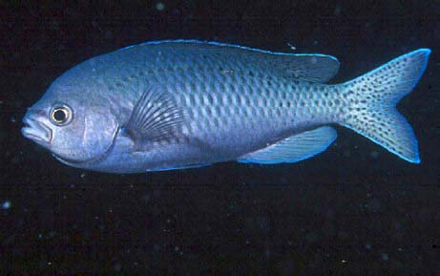 |  | Blacksmith  Chromis  punctipinnis | Excellent in aquarium.  Mid water schooling fish. | Large 6-10”  Medium 3-5” |  | 50.00  30.00
 | 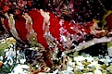 |  | Painted Greenling or Convict fish  Oxylebius pictus | Aggressive toward own species, territorial. | To 10”  From Kodiak Island to Baja |  | 60.00
 | 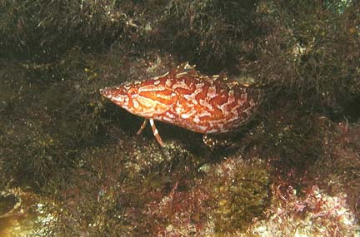 |  | Giant Kelpfish  Heterostichus rostratus | Great cryptic display | British Columbia to Cape San Lucas, Baja Mexico |  | <7” $35.00  >7” $55.00
 | 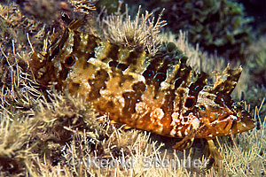 |  | Kelpfish  Gibbonsia spp. | Does best with crevices or other habitat to hide in. | 4 to 7” (17cm)  Canada to Baja |  | 35.00
 | 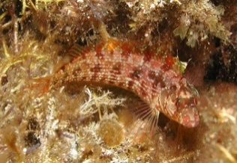 |  | Island Kelpfish  Alloclinus holderi | Does best with crevices or other habitat to hide in. | To 4” (10cm)  Santa Cruz to Baja California |  | 60.00
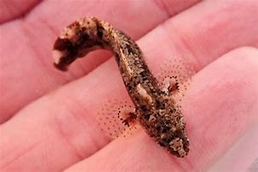 |  |  | Reef Onespot Blenny  Paraclinus integripinnis | Rocky reefs with algae cover | To: 2.5”  Southern CA to Baja CA |  | 25.00
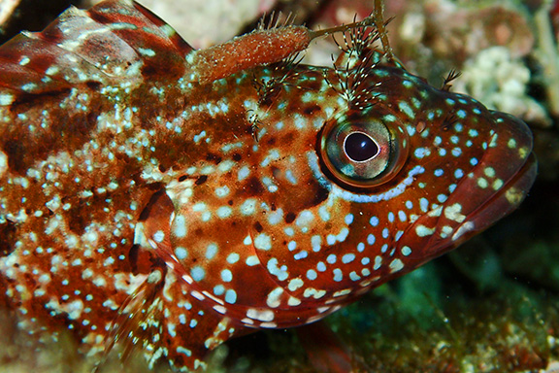 |  |  | Largemouth Blenny  Labrisomus xanti | Inhabits shallow waters in rocky outcroppings | We find mostly  7” (17.8cm)  SanDiego South |  | 75.00
 | 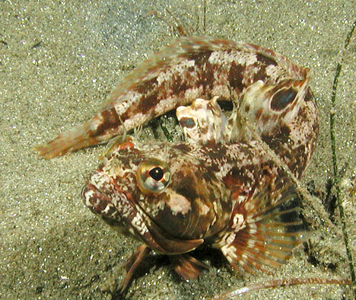 |  | Sarcastic Fringehead  Neoclinus blanchardi | Needs a burrow, shell, or rock cluster to hide in. | To 12” (30cm)  San Francisco, Ca. to Baja California |  | 200.00
 | 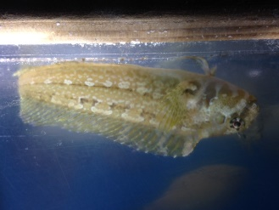 |  | Bay Blenny  Hypsoblennius sp. | Like to hide in holes, shells, and pipes | To: 6”  Range: Southern California to Baja |  | 20.00
 | 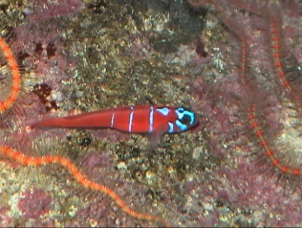 |  | Bluebanded Goby  Lythripnus dalli | Inhabit open rocky areas. Perch in open, retreat when threatened. | To: 2 inches (5cm)  Range: Southern  California to Baja |  | 26.00
 | 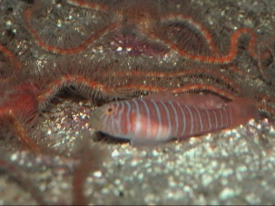 |  | Zebra Goby  Lythrypnus zebra | Inhabit open rocky areas. Perch in open, retreat when threatened. | To: 2 inches (5cm)  Range: Southern  California to Baja |  | 26.00
 | 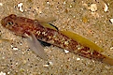 | Blackeye goby  Coryphopterus nicholsii |  | Common on sandy bottoms and kelp bed rocky bottoms. |  | To 6 inches (15 cm). From northern British Columbia to central Baja | 35.00
 | 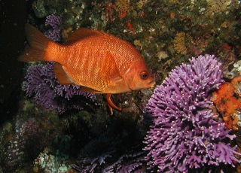 | Black Surfperch  Embiotoca jacksoni |  | Common in kelp beds and around jetties.  Season:  August 1 to April 30 |  | To 15” (38cm)  Fort Bragg, California to Baja California Sur | 35.00
 | 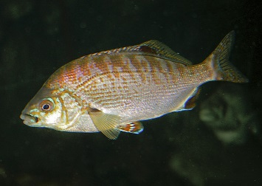 | Rainbow Surfperch  Hypsurus caryi |  | Has bright blue and red-orange pelvic fins.  Season:  August 1 to April 30 |  | To 12” (30cm)  Cape Mendocino California to San Martin Island, Baja California | 65.00
 | 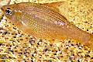 | Kelp Surfperch  Brachyistius frenatus |  | Blends in to macro algae.  Season:  August 1 to April 30 |  | To 8.5 inches (22 cm). From northern British Columbia to central Baja. | 50.00
 | 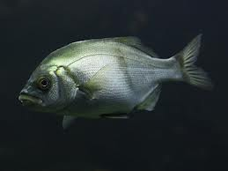 | Rubberlip Surfperch  Rhacochilus toxotes |  | Found in reefs, kelp beds, and piers.  Season:  August 1 to April 30 |  | To 15 inches (38 cm). From Wrangell, Alaska to northern Baja. | 65.00
 | 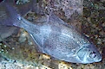 | Pile Surfperch  Rachocilus vacca |  | Found around reefs, kelp beds, and piers.  Season:  August 1 to April 30 |  | To 8.5” (22cm)  Alaska to Guadalupe Island, Baja California | 50.00
 | 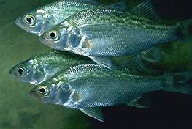 | White Surfperch  Phanerodon furcatus |  | Found around reefs and piers.  Season:  August 1 to April 30 |  | To: 10.5” (30cm)  Bodega Bay, Ca. to North Baja California | 50.00
 | 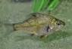 | Dwarf Surfperch  Micrometrus minimus |  | Found in schools above surf grass and other macro algae.  Season:  August 1 to April 30 |  | To 6.3” (16cm)  Bodega Bay, Ca. to Cedros Island, Baja California | 25.00
 | 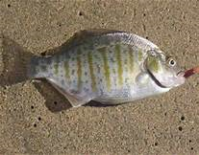 | Barred Surfperch  Amphistichus argenteus |  | Found just outside the surf zone along sandy beaches.  Season  August 1 to April 30 |  | To 17” (43cm)  Bodega Bay, Ca. to North Baja California | 50.00
 | 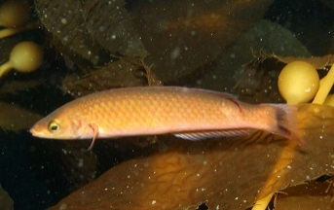 | Seniorita  Oxyjulis californica |  | Found around reefs and kelp beds. |  | To 10” (25cm)  Sonoma County, to Cedros Island, Baja California, | 35.00
 | 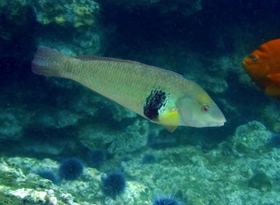  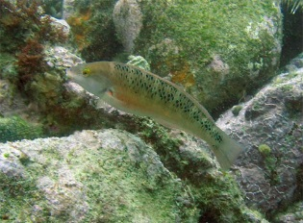 | Rock Wrasse  Halichores semicinctus  Female |  | Males have a dark blue bar on their sides.  Found around reefs and kelp beds. |  | To 15 inches (38 cm). From Point Conception, to Gulf of California. | 45.00
 | 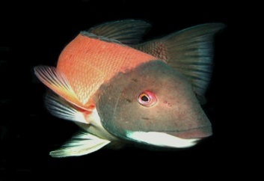 | Male Sheep Head  Semicossyphus pulcher |  | Found around reefs and kelp beds. |  | To 3 feet (91 cm). From Monterey , California to Cape San Lucas, Baja California, Mexico | 18” < 250.00  18” > 150.00
 | 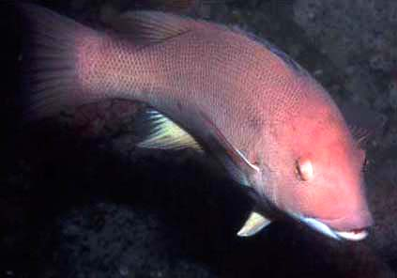 | Female Sheep Head  Semicossyphus pulcher |  | Found around reefs and kelp beds.  Minimum size 6” |  | To 2 feet (60cm) | 100.00
 | 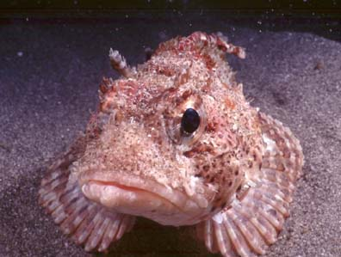 | California Scorpionfish  Scorpaena guttata  Must be >10” |  | Good aquarium fish, care must be taken around spines. |  | To 17 inches (61 cm). From Santa Cruz, California to Baja California. | 55.00
 | 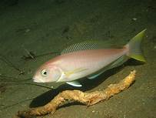 | Ocean Whitefish  Caulolatilis princeps |  | In the tilefish family. Found on sandy or rocky bottoms. |  | To: 24”  From California to Peru | 85.00
 | 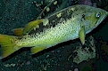 | Olive Rockfish  Sebastes Olivaceus |  | Minimum size 6” (15 cm)  Found around rocky reefs and kelp beds. |  | To 24 inches (61 cm)  Humbolt, California to Baja Mexico | 100.00
 | 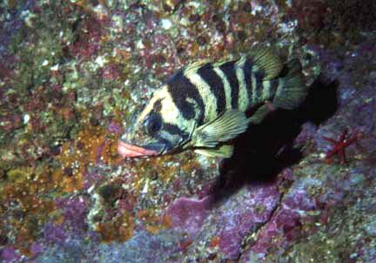 | Treefish  Sebastes serreceps |  | Minimum size 6” (15 cm)  Found around rocky reefs, are solitary. |  | To 16 inches (41 cm)  San Francisco to Cedros Island, Baja Mexico | 150.00
 | 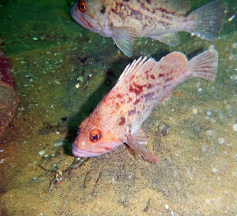 | Brown Rockfish  Sebastes auriculatus |  | Minimum size 6” (15 cm)  Found on low profile reefs in sandy or silty areas |  | To 21.5 inches (55 cm)  Alaska to Baja California Sur | 85.00
 | 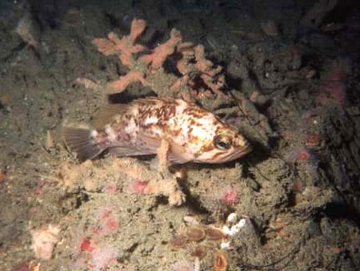 | Kelp Rockfish  Sebastes atrovirens |  | Minimum size 6” (15 cm)  Found primarily in kelp forests. |  | To 17 inches (42 cm). California to Baja California | 85.00
 | 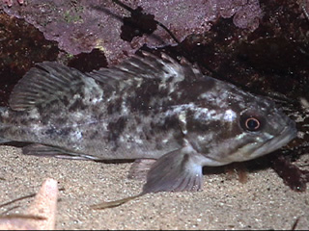 | Grass Rockfish  Sebastes rastrelliger |  | Minimum size 6” (15 cm)  Found around eelgrass beds and rocky outcroppings. |  | To 22 inches (56 cm)  Oregon to Baja California | 85.00
 | 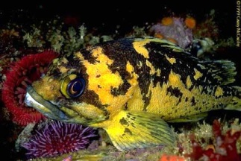 | Black-and-Yellow Rockfish  Sebastes chrysomelas |  | Minimum size 6” (15 cm)  Found around shallow rocky reefs. |  | To 15.5 inches (39 cm)  Eureka, California to Baja California Sur | 150.00
 | 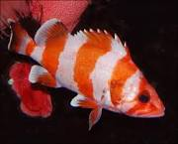 | Flag Rockfish  Sebastes rubrivinctus |  | Minimum size 6” (15 cm)  Found around offshore reefs (deep water). |  | To 25” (64 cm)  San Francisco, California to Baja California | 175.00
 | 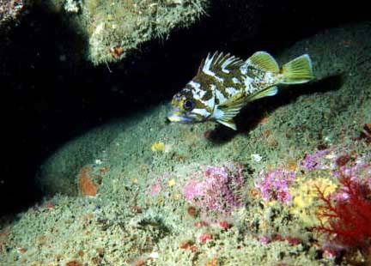 | Gopher Rockfish  Sebastes carnatus |  | Minimum size 6” (15 cm)  Found in and around rocky reefs and crevices. |  | To 15.6” (40 cm)  Eureka, California to Baja California Sur | 85.00
 | 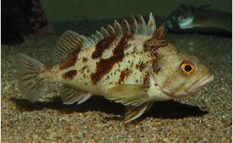 | Calico Rockfish  Sebastes dalli |  | Minimum size 6” (15 cm)  Found around rocky reefs and crevices. |  | To 10” (25 cm)  San Francisco to Baja California | 100.00
 | 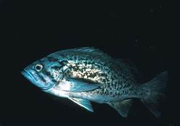 | Blue Rockfish  Sebastes mystinis |  | Minimum 6” (15 cm) Found in and around rocky reefs, crevices, and kelp forests. |  | To 10” (25 cm)  San Francisco to Baja California | 85.00
 | 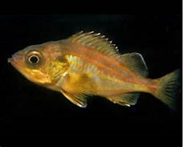 | Split-nose Rockfish  Sebastes |  | Minimum 6” (15 cm) Found offshore over muddy bottoms. |  | To 18” (46cm)  Alaska to Baja California | 75.00
 | 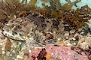 | Cabezon  Scorpaenichthys marmoratus |  | Minimum size is 15” (37.5 cm).  Found around rocky reefs. |  | To 39” (99 cm). From Sitka, Alaska to central Baja California. | 150.00
 | 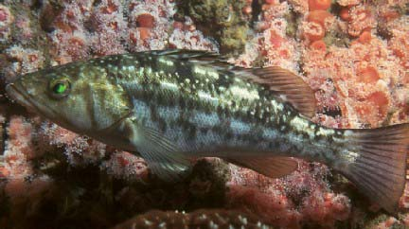 | Kelp (Calico) Bass  Paralabrax clathratus |  | Minimum catch size is 14”  Found around reefs and kelp beds. |  | To 28.5 inches (72 cm)  Columbia River to Baja California Sur | 50.00
 | 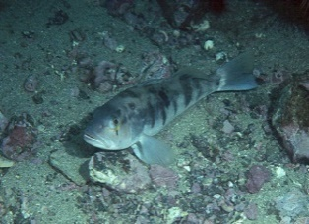 | Sand Bass  Paralabrax nebulifer |  | Minimum catch size is 14”  Found on Sandy bottoms around reefs. |  | To 25.6 inches (65 cm). Santa Cruz, California to Baja California Sur | 50.00
 | 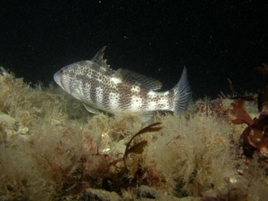 | Spotted Sand Bass  Paralabrax maculatofasciatus |  | Minimum catch size is 14”  Found on Sandy bottoms around reefs. |  | To 22 inches (56 cm). Monterey, California to Mazatlan, Mexico | 50.00
 | 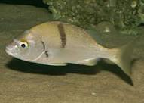 | Sargo  Anisotremus davidsonii |  | Schooling fish. Found around reefs and kelpbeds. |  | To 23 inches (58 cm). Santa Cruz, California to Baja California Sur | <4” 30.00  >4” 50.00
 | 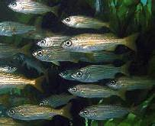 | Salema  Xenistius californica |  | Silvery schooling fish. |  | To 10” (25cm)  Monterey Bay, CA to Peru | <3” 20.00  >3” 30.00
 | 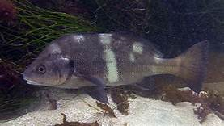 | Black Croaker  Cheilotrema saturnum |  | Found in and around rocky crevices during the day. More active at night. |  | To 15” (38 cm).  Point Conception, California to Baja California Sur | 50.00
 | 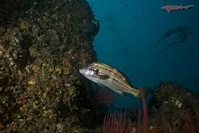 | Black Croaker (juv)  Cheilotrema saturnum |  |  |  |  | 30.00
 | 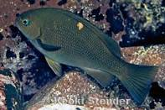 | Opaleye  Girella nigricans |  | Found around shallow reefs and kelp beds. |  | To 26” (66 cm).  San Francisco, to Baja | <4” 30.00  >4” 50.00
 | 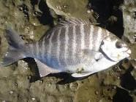 | Zebra Perch  Hermosilla azurea |  | Found around kelp beds and off rocky and sandy bottoms |  | To 17.4 inches (44 cm).  Klamath, California to Gulf of California | <4” 30.00  >4” 50.00
 | 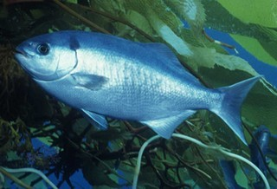 | Halfmoon  Medialuna californiensis |  | Found around reefs and kelp beds |  | To 19 inches (48 cm).  Vancouver to Gulf of California | 60.00
 | 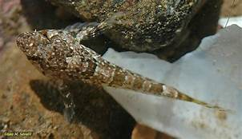 | Tidepool sculpin  Oligocottus maculosus |  | Found in rocky reefs and crevices. |  | To 3 inches (8 cm).  Alaska to Baja California Sur | 10.00
 | 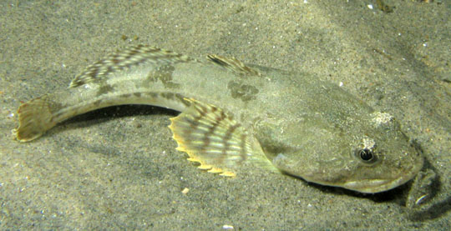 | Pacific Staghorn Sculpin  Leptocottus armatus |  | Common on muddy/sanding bottoms in Bays and Estuaries |  | To 18” (46 cm)  Bering Sea to Baja | 25.00
 | 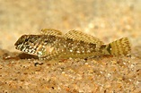 | Wooly Sculpin  Clinocottus analis |  | Found in tide pools and shallow reefs |  | To 5 inches (10 cm).  Southern California | 35.00
 | 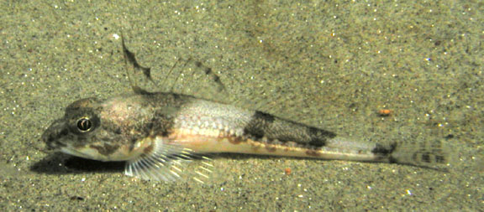 | Roughback Sculpin  Chitonotus pugetensis |  | Found on Sandy Bottoms |  | To 7 inches (15cm)  Northern BC to Alaska | 50.00
 | 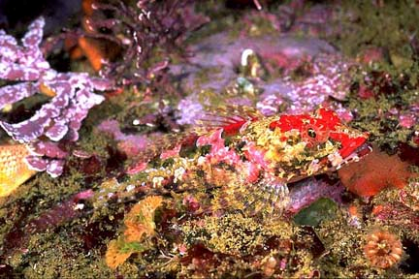 | Coralline Sculpin  Artedius coallinus |  | Rocky areas near sandy bottom |  | To 5” (12cm)  Washington to Baja CA | 60.00
 | 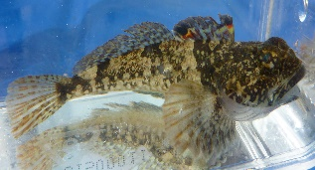 | Padded Sculpin  Artedius fenestralis |  | Rocky areas near sandy bottom |  | To 5” (12cm)  Washington to Baja CA | 60.00
 | 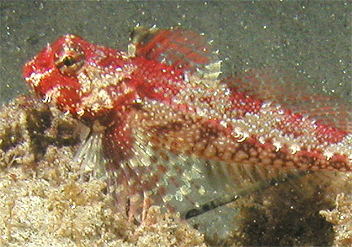 | Snubnose Sculpin  Orthonopias triacis |  | Intertidal rocky areas |  | To 4 inches (10cm)  Monterey CA to Baja | 55.00
 | 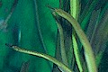 | Bay pipe fish  Syngnathus griseolineatus |  | Found in eelgrass beds or under sloughing kelp. |  | To 13 inches (33 cm). From Sitka, Alaska to southern Baja. | 25.00
 | 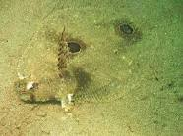 | Fantail Sole  Xystreurys liolepis |  | Found on mud and sand bottoms. Two eye spots make good defense story. |  | To 21 inches (53 cm).  From Monterey Bay, California to Gulf of California | 35.00
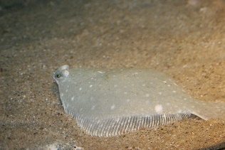 | Diamond Turbot Hypsopsetta guttulata | Found on sandy or muddy bottoms | Juvenile 3-5”  Mendecino, CA to Baja California | 40.00
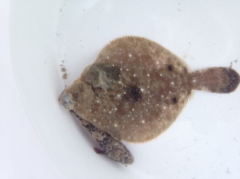 | Spotted Turbot  Pleuronichthys ritteri | Found on sandy or muddy bottoms | Juvenile 3-5”  Monterey CA to Baja California | 35.00
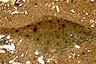 | Speckled Sanddab  Citharichthys stigmaeus | Found on mud and sand bottoms. |  | To 6.75 inches (17 cm).  Alaska to Baja California Sur | 30.00
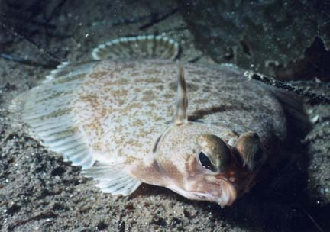 | Hornyhead Turbot  Pleuronichthys verticalis | Found on mud and sand bottoms. | To 14.5 inches (37 cm).  Point Reyes, California to Baja California Sur |  | 35.00
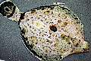 | CO Sole or Turbot  Pleuronichthys coenosus | Found over rocky and soft bottoms. | To 14 inches (36 cm). From south east Alaska to northern Baja. |  | 50.00
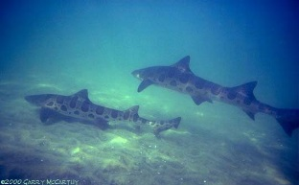 | **Leopard Shark  Triakis semifasciata | 36” Minimum  Unless on SCP. | To 7 feet (2.1m)  Oregon to Gulf of California |  | 1500.00
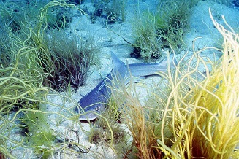 | Gray Smoothhound  Mustelus californica | Found over shallow sandy bottoms and muddy bays.  Maximum size is 18” | To 4 feet (1.3m)  San Francisco, California to Gulf of California |  | Juv. 300.00  15”< $400
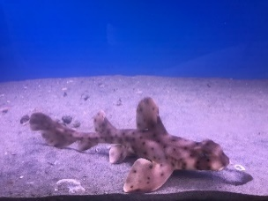 | Horn Shark  Heterodontus francisci | Common around rocky shallow reefs. | Adult  To 4 feet (1.2 m).  From Monterey to the Gulf of California. |  | 10” > 150.00  <10” $200
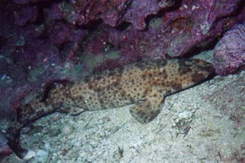 | Swell Shark  Cephaloscyllium ventriosum | Found around shallow reef caves and crevices. | Adult  Sub Adult  To 3.3 feet (1m).  Monterey to Acapulco |  | 150.00  Eggs 75.00
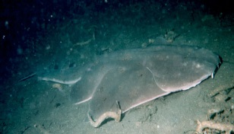 | **Angel Shark  Squatina californicus | Buries itself under the sand to wait for prey | To 5 feet (1.5 m).  Southeastern Alaska to Gulf of California. |  | 450.00
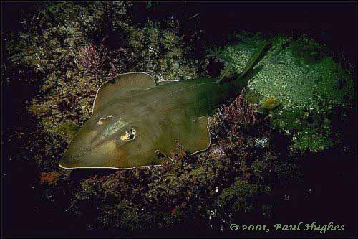 | Shovelnose Guitarfish  Rhinobatis productus | Found on sand or sand/mud bottom. | 5.5 feet (1.7m).  San Francisco, California to Gulf of California. |  | 200.00
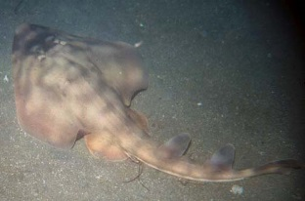 | **Mottled Guitarfish Zapteryx exasperatus | Found on sand or sand/mud bottom. | To 3 feet (90 cm).  Newport Beach, California to Gulf of California. |  | 350.00
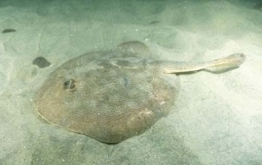 | Round Ray  Urobatis halleri | Found on sand or sand/mud bottom. | To 22 inches (56 cm).  Humbolt Bay, California to Panama |  | 45.00
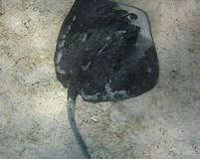 | Diamond Ray  Dasyatis dipterura | Found on sand or sand/mud bottom. | Size 8” to 1M diameter  California to Northern Chile |  | 200.00
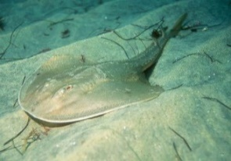 | Thornback (Ray)  Platyrhinoides triseriata | Found on sand or sand/mud bottom. | To 3 feet (90 cm).  Tomales Bay, California to Gulf of California. |  | 50.00
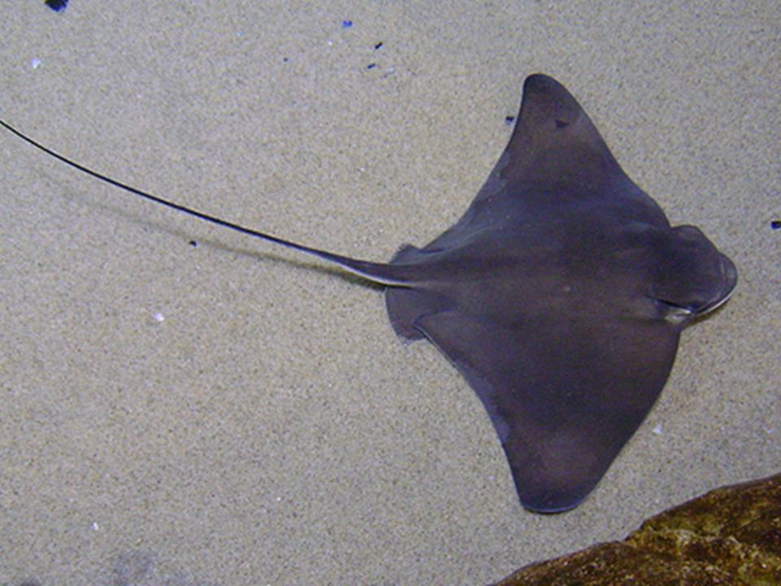 | Bat Ray  Myliobatis californica | Found in bays and off beaches over sandy or muddy bottoms. | To 6 feet (1.8M)  Oregon to Gulf of California. |  | 15” > 250.00  15” < 350.00
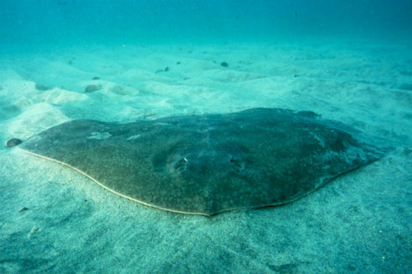 | Butterfly Ray  Gymnura marmoratus |  |  |  | 10” > 150.00  10” < 250.00
Prices do not reflect boxes and shipping prices.

