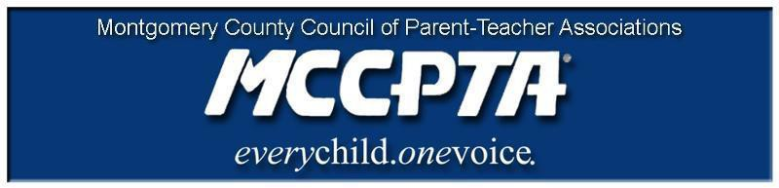

DELEGATES’ ASSEMBLY MEETING AGENDA
Tuesday, March 23, 2021
Meeting Held on Zoom

7:00 pm WELCOME

- Approve Agenda; Approve February minutes

7:05 pm INFORMATIONAL UPDATES

- National/MDPTA Update

7:10 pm OFFICER REPORTS

- Cynthia Simonson, President
- Rodney Peele, Vice President- Educational Issues
- Rochelle Fink, Vice President- Administration
- James Modrick, Vice President- Programs
- Laura Stewart, Vice President- Advocacy
- Khristy Kartsakalis, Treasurer
- All Reports - https://mccpta-my.sharepoint.com/:f:/g/personal/office_mccpta_org/Ev_-_vv3TXZMoP1sByvJjiIBQKQlpe2ISET8SDm3c7La_Q?e=3JcHkh

7:22 pm COMMITTEE REPORTS

- All Reports – https://mccpta-my.sharepoint.com/:f:/g/personal/office_mccpta_org/Em25H1ua1JFBh7a9uT2fRyIBgQxcgDZB1r734KNU90lBLw?e=wZyGIf

7:25 pm OLD BUSINESS

- 2021 SRO Resolution
- 2010 SRO Resolution

8:35 pm NEW BUSINESS

      - Upcoming PTA Elections –
        - AVP and Cluster Coordinator – nominations, election, and why sit on the MCCPTA board!!
        - Local Unit Elections – Nominating Committee, Elections, Next Actions
      - Area Summer Meetings

8:55 pm ANNOUNCEMENTS & ADJOURNMENT

DATES:

- March 24, 2021 – DEI Training
- March 30, 2021 – Special Education Awards Deadline
- April 14, 2021 – MCCPTA BOD Meeting
- April 15, 2021 – Blake Cluster Meeting
- April 22, 2021 – Poolesville Cluster Meeting
- April 27, 2021 – Delegates Assembly & Elections
- May 6, 2021– Gaithersburg Cluster Meeting
- May 27, 2021 – MCCPTA Celebration of Excellence, Virtual Event

