REGULAR MEETING

NOVEMBER 21, 2024

The Regular Meeting of the Town Board of the Town of Hampton, County of Washington and the State of New York was held at the Town Hall, 2629 State Route 22A, Hampton, New York, on the 21st day of November 2024.

PRESENT: David K. O’Brien------------Supervisor

Donald Sady----------------- Councilman

Tamme Taran----------------Councilwoman

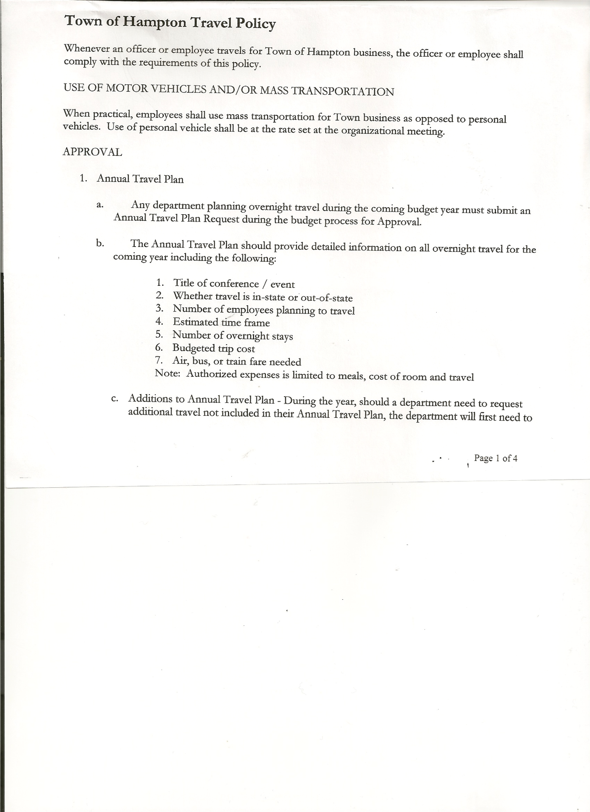 Michael Pietryka------------Councilman

Andrea Kugler---------------Councilwoman - absent

Rebecca Jones---------------Town Clerk

Camilla Shaw----------------Deputy Town Clerk

Tyler McClure---------------Highway Superintendent

Planning Board Member (s):… Bonnie Hawley, Chair; Matthew Pratt and Rene Rountree

Others present at the Town Hall: see attached sheet

The Regular Meeting was called to order by Supervisor O’Brien at 7:30pm, followed by the Pledge of Allegiance. Location of Fire Exits were given. Quorum of board members present.

Supervisor O’Brien asked for a moment of silence in memory of a Washington County Sheriff Deputy

**RESOLUTION NO. 98-2024**

**APPROVAL OF THE MINUTES**

On a motion of Councilwoman Taran, seconded by Councilman Sady, the following resolution was ADOPTED: AYES 4 O’Brien, Sady, Pietryka, Taran

NAYS 0

ABSENT 1 Kugler

RESOLVED, that the Regular Town Board Meeting Minutes for October 17th, 2024 and the Special Town Board Meeting Minutes for November 6th, 2024 are approved.

**PERMITS AND SUBDIVISIONS**

A subdivision application from Michael Kavanagh to John Prentice was presented to the Board for review. The subdivision consists of .87 acres Mirror Lake Estates, Lot 3.

**RESOLUTION NO. 99-2024**

**KAVANAGH – SHORT ENVIRONMENTAL ASSESSMENT FORM/NEGATIVE DECLARATION**

On a motion of Councilwoman Taran, seconded by Councilman Sady, the following resolution was ADOPTED: AYES 4 O’Brien, Sady, Pietryka, Taran

NAYS 0

ABSENT 1 Kugler

RESOLVED, that the Short Environmental Assessment Form is complete and to adopt a negative declaration and finding that there will be no adverse environmental impacts and to consider it a minor subdivision, therefore waving the public hearing.

TOWN BOARD MEETING

NOVEMBER 21, 2024 PAGE 2

**RESOLUTION NO. 100-2024**

**KAVANAGH – APPROVAL OF SUBDIVISION**

On a motion of Councilman Sady, seconded by Councilwoman Taran, the following resolution was ADOPTED: AYES 4 O’Brien, Sady, Pietryka, Taran

NAYS 0

ABSENT 1 Kugler

RESOLVED, to approve the Kavanagh subdivision.

Dog Control Officer….no report

Tax Collector Report….Zero balance. The Town Clerk/Collector had Board Members review and sign bank reconciliation statements for the Tax Collector Account dated October 31st.2024.

Bonnie Hawley, Chair Planning Board….Planning Board Meeting was held November 13th, 2024, copy of the minutes is attached. Next meeting will be December 11, 2024 @7:00 at the Town Hall.

Tyler McClure, Highway Superintendent…submitted his report, copy of which is attached.

**SUPERVISOR’S REPORT/COUNTY UPDATES/COMMUNICATIONS**

County budget passed on Friday, November 16th. One of the few counties in the State under the tax cap.

**RESOLUTION NO. 101-2024**

**APPROVAL OF SUPERVISOR’S MONTHLY REPORT**

On a motion of Councilman Sady, seconded by Councilwoman Taran, the following resolution was ADOPTED: AYES 4 O’Brien, Sady, Pietryka, Taran

NAYS 0

ABSENT 1 Kugler

RESOLVED that, the Supervisor’s Monthlyreport be accepted as submitted for **OCTOBER**

ACCOUNT 9/01/24 Receipts Disbursed 9/30/24

Citizens Cemetery $ 3,028.46 $ .13 $ .00 $ 3,028.59

Citizens Total $ 3,028.46 $ .13 $ .00 $ 3,028.59

GFNB Fire, Trust & Agency $ 1,418.04 $ $ 0.00 $ 1,418.04

GFNB Fire, Trust & Agency ICS $ 33,805.00 $ $ $ 33,805.00

GFNB Health Insurance $ 2,591.23 $ $ $ 2,591.23

GFNB Trust & Agency $ 3,587.72 $ 8,495.54 $ 4,330.71 $ 7,752.55

GFNB General Fund $ 6,445.22 $ 5,039.19 $ 7,155.72 $ 4,328.69

GFNB General Fund ICS $ 56,315.63 $ 366.96 $ 4,000.00 $ 52,682.59

GFNB Total $104,162.84 $13,901.69 $ 15,486.43 $102,578.10

GFNB Highway Fund $ 17,361.36 $ 25,774.93 $ 32,366.88 $ 10,769.41

GFNB Highway Fund ICS $ 143,411.54 $ 504.56 $ 25,000.00 $118,916.10

GFNB Capital Reserve $ 1,005.02 $ $ $ 1,005.02

GFNB Capital Reserve ICS $ 152,476.29 $ 649.71 $ $153,126.00

GFNB Total $ 314,254.21 $ 26,929.20 $ 57,366.88 $283,816.53

TOTALS $421,445.51 $ 40,831.02 $ 72,853.31 $389,423.22

All Board Members present signed Supervisor’s Report.

TOWN BOARD MEETING

NOVEMBER 21, 2024 PAGE 3

**OLD BUSINESS**

**RESOLUTION NO. 102-2024**

**HIGHWAY - BOND PAPERWORK FOR PURCHASE OF NEW HIGHWAY TRUCK**

On a motion of Councilwoman Taran, seconded by Councilman Pietryka, the following resolution was ADOPTED: AYES 4 O’Brien, Sady, Taran, Pietryka

NAYS 0

ABSENT 1 Kugler

RESOLVED to authorize Supervisor O’Brien to start the preparation of Bond Paperwork to purchase a Highway Truck, with the Town Attorney.

**NEW BUSINESS**

End of Year Meeting to Close the Books for 2024 will be at the Regular Monthly Town Board Meeting on December 19th, 2024.

**RESOLUTION 103-2024**

**ORGANIZATIONAL MEETING**

On a motion of Councilman Sady, seconded by Councilwoman Taran, the following resolution was ADOPTED: AYES 4 O’Brien, Sady, Taran, Pietryka

NAYS 0

ABSENT 1 Kugler

RESOLVED, to set the Organizational Meeting for 2025 for Thursday, January 2nd, 2025 at 7:00pm.

**RESOLUTION NO. 104-2024**

**TOWN HALL USE**

On a motion of Councilwoman Taran, seconded by Councilman Pietryka, the following resolution was ADOPTED: AYES 4 O’Brien, Sady, Pietryka, Taran

NAYS 0

ABSENT 1 Kugler

RESOLVED, to approve the request of Rebecca Jones to use the Town Hall on Saturday, December 7th, 2024 from 4 to 8 pm for Board Game Night.

**RESOLUTION NO. 105-2024**

**TOWN HALL USE**

On a motion of Councilman Sady, seconded by Councilman Pietryka, the following resolution was ADOPTED: AYES 4 O’Brien, Sady, Pietryka, Taran

NAYS 0

ABSENT 1 Kugler

RESOLVED, to approve the request of Emily Stockwell & Bob Sady to use the Town Hall on Saturday, December 28th, 2024 from 1 to 4 pm for a Family Christmas Party.

**PUBLIC/COUNCIL COMMENTS**

Matthew Pratt confirmed that the Fire Department is covered under Workers’ Compensation if they go over the border for a mutual aid call.

Supervisor O’Brien attended a First Responder Wellness Clinic on how stressful Police Officer; 1st Responders and Firemen work is.

TOWN BOARD MEETING

NOVEMBER 21, 2024 PAGE 4

**RESOLUTION NO. 106-2024**

**AUDIT OF CLAIMS**

On a motion of Councilwoman Taran, seconded by Councilman Sady the following resolution was ADOPTED: AYES 4 O’Brien, Sady, Pietryka, Taran

NAYS 0

ABSENT 1 Kugler

RESOLVED that the bills have been reviewed by the Town Board and are authorized for payment in the following amounts.

General Fund No. 115 through No 128 $ 13,023.63

Highway Fund No. 153 through No.165 $ 99,053.27

Total both funds $112,076.90

The Town Clerk’s report for October 2024 was submitted to the Board. The Town Clerk had Board Members review and sign bank reconciliation statements for the Town Clerk Account and Special Town Clerk Account dated October 31st, 2024.

**RESOLUTION NO. 107-2024**

**MEETING ADJOURNED**

On a motion of Councilman Sady, seconded by Councilwoman Taran the following resolution was ADOPTED: AYES 4 O’Brien, Sady, Pietryka, Taran

NAYS 0

ABSENT 1 Kugler

RESOLVED that the meeting adjourned at 8:22pm.

Respectfully submitted,

Rebecca S. Jones, RMC

Town Clerk