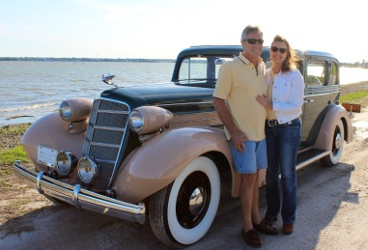
Real Restorations
By Pistorius Collectible Autos

With my last article, you progressed up to the time to actually paint your car.
You have made the important decisions which paint to buy. By now you also bought the reducer to match the paint. Make sure you buy the correct curing time based reducer on ambient temperature. Do not paint when temperature is above or below what your paint temperature range is. Read the instructions!
Clean your paint area and thoroughly wet the floor. Mix the paint and pour it through a strainer into a very clean spray gun. Be sure to use an air filter on your gun. Get rid of all water in your lines. You should have a water separator on the air line. Tape all areas the roll-back style.
Put your paint suit and mask on, and apply your paint to all the interior parts first- door jams, engine compartment, trunk, etc. Once this is all dry, you can remove tape and paint the rest of the car.
All your exterior parts, hood, trunk lid, and whatever loose parts you may have will be painted afterwards. If it is base coat, now is the time to paint several layers of clear coat.
Now all is done! Peel off masking material as soon as paint is completely dry. A few days later, you are going to wet sand and buff all the painted areas, until you feel satisfied with the results.
It’s time for some adult refreshments so you can now sit back to admire your work. You deserve it!
Next month is assembling your car!
Cheers!
Brando & Joanne Pistorius

