NAMES OF PETS: _____________________________OWNER’S NAME:_________________
PLEASE BE AS DESCRIPTIVE AS POSSIBLE. Check the box next to item. If more than one, please specify. Please label your belongings, or allow us to label them.
- Leash (type, color): ______________________________________________________
- Collar and/or Harness (type, color):_________________________________________
- Blanket (type/color):_____________________________________________________
- Bed (color/shape):________________________________________________________
- Food (please specify container color/number of bags/brand of food): ______________________________________________________________________ ______________________________________________________________________
- Treats (Brand): __________________________________________________________
- Toys (Type, Color):________________________________________________________
- Medication: _____________________________________________________________
- Misc. items (tote bags, bowls, food scoop): ____________________________________
Aspen Meadows Pet Resort takes pride in the service and love we provide for your pets, and we do everything possible to ensure all items return home. Please understand that there may be a risk of an item being damaged or destroyed, and we may write the pet’s name on their bed or other belongings to ensure it stays with them. THANK YOU!

Can we administer first aid to your pet?______________________________________________________
Can we give Human grade products if needed, such as Benadryl, Neosporin, Antacids?________________
Does your pet have any allergies?___________________________________________________________
Does your pet have any health issues, or injuries at this time?____________________________________
If yes, please explain:________________________________________________________________
________________________________________________________________________________________

_______________________________________ ______________
Owner Signature Date
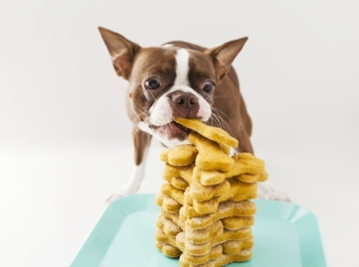
Extra Treats and Services Menu

- Bully Stick $3.00 Daily Every Other Day Other _________________
- Pig Ear $2.25 Daily Every Other Day Other ________________
- Rib Bone $5.00 Daily Every Other Day Other _________________
- Ice Cream $1.50 Daily Every Other Day Other _________________
- Dental Treat: Small $.75 Medium $1.25 Large $1.75 (circle one size) Daily Every Other Day Other _________________
- Turkey Biscuit $.50 Daily Every Other Day Other _______________
- Peanut Butter Hoof $5.00 Daily Every Other Day Other ____________
- Turkey Jerky $.50 Daily Every Other Day Other _______________
- Duck Foot $1.00 Daily Every Other Day Other _______________
- Pork Yumm Stick $2.00 Daily Every Other Day Other _____________
- Knee Cap Bone $2.25 Daily Every Other Day Other _______________
- Duck Sausage $1.00 Daily Every Other Day Other _______________
- Alligator Jerky $.50 Daily Every Other Day Other _______________
- Buffalo Chew $1.25 Daily Every Other Day Other _______________
- Marrow Bone $6.00 Daily Every Other Day Other _______________
- Gingerbread Biscuit $.25 Daily Every Other Day Other _____________

- Report Card $3.00 (This is a picture and emailed update of how your pet is doing for their stay.) Daily Every Other Day Other _____________

- One-on-One time with Handler $10/ 15 min. session Chose from: Playtime, Cuddle time, or Command Reinforcement (please circle one) Daily Every Other Day Other ____________

- Toy (we have a variety of soft and squeaky toys) $10.00 How many?

