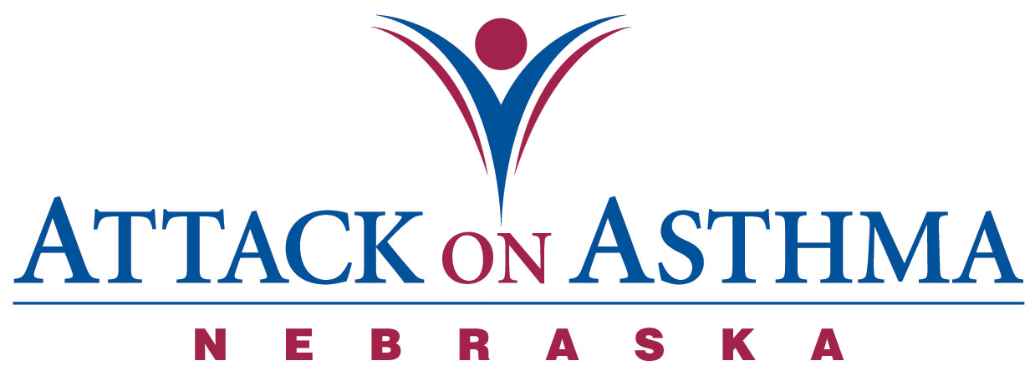

Characteristics of Individuals and Protocol Use in Nebraska Schools
2004-05

Data was voluntarily reported to Attack On Asthma Nebraska (AOAN) during and following the 2004-2005 school year. During this period of time there were 55 reported incidents of the Emergency Response to Life-Threatening Asthma or Systemic Allergic Reaction (Anaphylaxis) protocol being implemented. Schools submit data using a standardized form. This year was the first year schools were asked to report this data and there are some gaps in data submitted. These gaps are noted as a number unknown.

- While most schools reported only one incident of protocol administration with a student, there were 2 schools that reported two incidents with the same student. [17 unknowns]

- Almost half the incidents occurred during the months of August, September, October, November (49%).

- More females (45.5%) than males (25.5%) were administered the protocol. [16 unknown]

- Elementary school students (36%) and High School students (38%) split almost evenly on the administration of the protocol. Middle School students (22%) reported the least number of protocol administrations. There was also one staff and one parent incident reported.

- The greatest percentage of incidents was reported in conjunction with activity; PE class and recess (45%). Classroom (25%) incidents as a location followed with the cafeteria (5%). [12 unknown]

- The majority of the incidents were with an individual with a history of asthma (49%). Eleven reported no history of either asthma or anaphylaxis (20%) and eight reported a history of anaphylaxis (15%). [14 unknown]

- Slightly over one-third (33%) received epinephrine as a correct usage of the protocol. [12 unknown]

- Two individuals (4%) with no history of asthma returned to school with an action plan. [14 unknown]

- Five individuals (9%) with a history of asthma and no action plan on file returned to school with an action plan after protocol administration. [14 unknown]

- Of those individuals with a history of asthma, one fifth (20%) had an action plan on file. [14 unknown]

- Of the individuals with a history of anaphylaxis three did not have an action plan on file at school. One individual returned to school with an action plan and two did not. [14 unknown]

- No one required the administration of CPR.

- There were nine (16%) incidents in which albuterol only was administered. [12 unknown]

- Emergency Medical Services (EMS) was summoned 85% of the time. Of the eight times that EMS was not summoned, seven of those incidents were treated with albuterol only. [13 unknown]

- Thirty-two individuals (58%) were transported to a medical facility via the Emergency Medical System. [13 unknown]

- Twenty-two school districts reported the 48 incidents.

Assumption made: Action plans on file at school include prescribed medication(s).

Notes: The numbers and percentages above include all incidents, not to exclude the students of repeat protocol administration.

