Daily Log of Mouth care
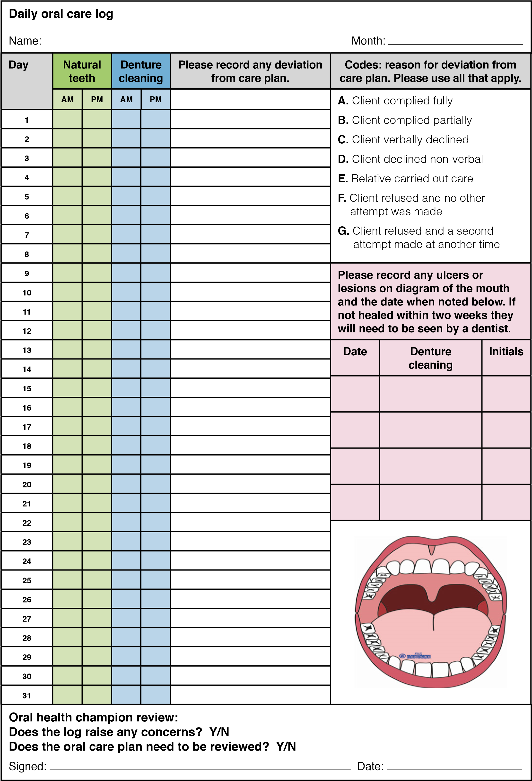
Reproduced with kind permission from RIS Healthcare

