Hello Academy Members,
I hope this year has been going well for you and your families! I am honored and humbled to serve as your President for 2017! I am very excited to be a part of the Academy in this great state! The seasoned audiologists and long-time members among us have done great things while in South Carolina and the new batches of Au.D.’s bring a renewed passion and fire. And we have a fabulous group of highly committed leaders serving as your board!
As the professional organization of audiologists and friends of the audiology community dedicated to providing quality hearing and balance services to the public in the State of South Carolina, we must maintain a culture of excellence and transparency. We have established a common vision, mission and goals. However, it is each board’s responsibility to provide the communication and direction. To do so, we must create the path and medium for member engagement.
With that in mind, here are some specific committee initiatives we have begun working on…
Conference Committee (President-Elect Meredith Holcomb, Au.D.) - Charleston, here we come! Planning of the 2018 conference has begun. Some great speakers and events are being lined up. Complete information and a save the date will be sent out to all members in early fall.
Membership Committee (Rachel Van Oosbree, Au.D.) - We need to increase our communications with current membership and reach out to non-member licensed audiologists in the state. This committee has been immediately tasked with authoring and establishing this regular and quarterly newsletter in order to provide a continual medium for the dissemination of pertinent information. Within it includes sections on member spotlights, practice spotlights, educational and ethical minutes, advocacy update, member and specialty directory, and regular listing of conferences and CEU opportunities.
Outreach Committee (Lisa Leen, Au.D.) - This group has been tasked with increasing our value to our membership by doing more to foster inclusion and serve them by providing resources, getting involved in interprofessional education and communications and serving and educating the general public in SC on hearing and balance healthcare. We must move to establish our presence in the state as the go-to-organization for hearing healthcare education and resources.
Our Finance (Todd Gibson, Au.D.), Professional issues/Advocacy (Mary Anne Larkin, Au.D.), and Technology (Alexandra Tarvin, Au.D.) committees continue to serve the SCAA in their defined capacities.
*If you are interested in serving on any of the committees, please contact me directly at jwigand@mailbox.sc.edu or email scaaudiology@gmail.com*
I am very excited about the many things we have going on! We are looking forward to a great second half of 2017 and preparing for an even better 2018!
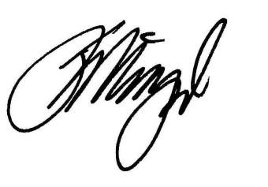
Jason P. Wigand, AuD, CCC-A
Board Certified in Audiology
Clinical Director, Cochlear Implant Program | Assistant Professor
President, South Carolina Academy of Audiology
USC Speech & Hearing Research Center
1224 Sumter Street, Suite 300 ● Columbia, SC 29201
T 803-777-2642 ● F 803-253-4143 ● jwigand@mailbox.sc.edu

