# New Mexico Credentialing Board for Behavioral Health Professionals, Inc.

[**www.nmcbbhp.org**](http://www.nmcbbhp.org/)

**How new applicants can schedule an exam for a Certification Exam for CPSW, CFPSW or CWF**

Here is where you can Apply/Register for your exam: [www.nmcbbhp.org](http://www.nmcbbhp.org) on the Testing tab and select the exam you wish to schedule for:

Peer Support Worker Exam, Family Peer Worker Exam, or Wraparound Facilitator Exam

Please USE this information when going to Certemy and SMT/IQT:

1. You will be sent to Certemy and you will click NO as not having an account,

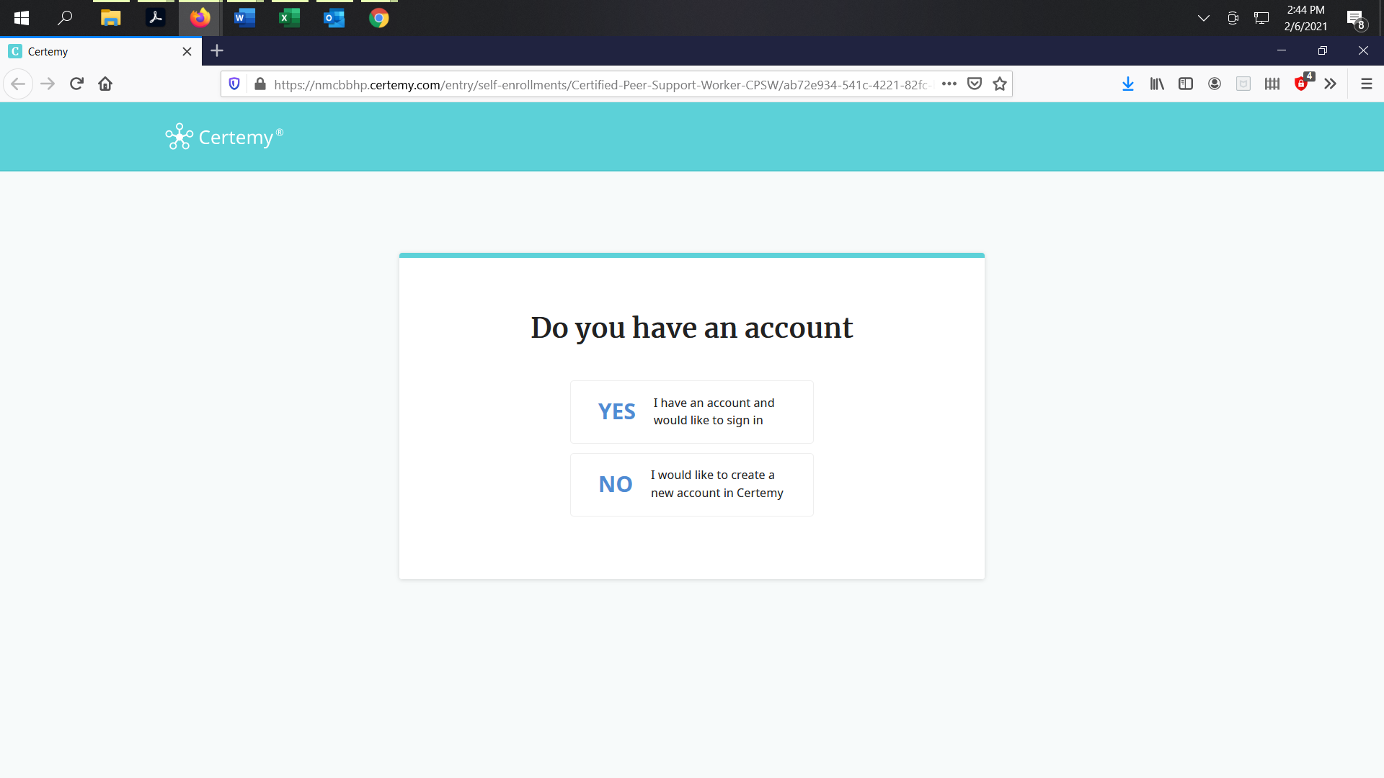

1. You will apply by completing the application with your information and an email address (It is important to use your personal email as an increasing number of agencies are using more secure servers that might block incoming responses from the Board or the Testing Company**).**
2. Once you have registered and logged in. You will see the **“Certified Peer Support Worker-CPSW (Phase-Initial)” “, “Certified Family Peer Support Worker- CFPSW (Phase: Initial) or “Certified Wraparound Facilitator – CWF (Phase: Initial)** on the right side of the screen. Click on application, see screen below:

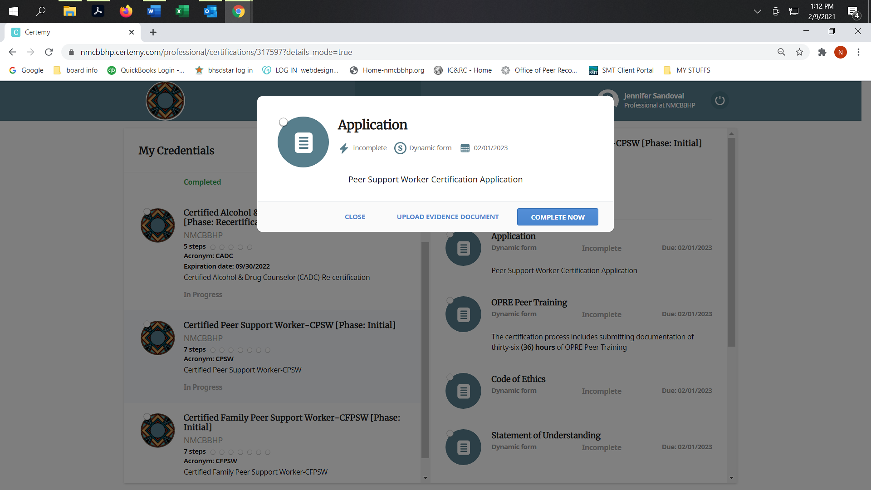

1. Complete this application, sign it electronically.

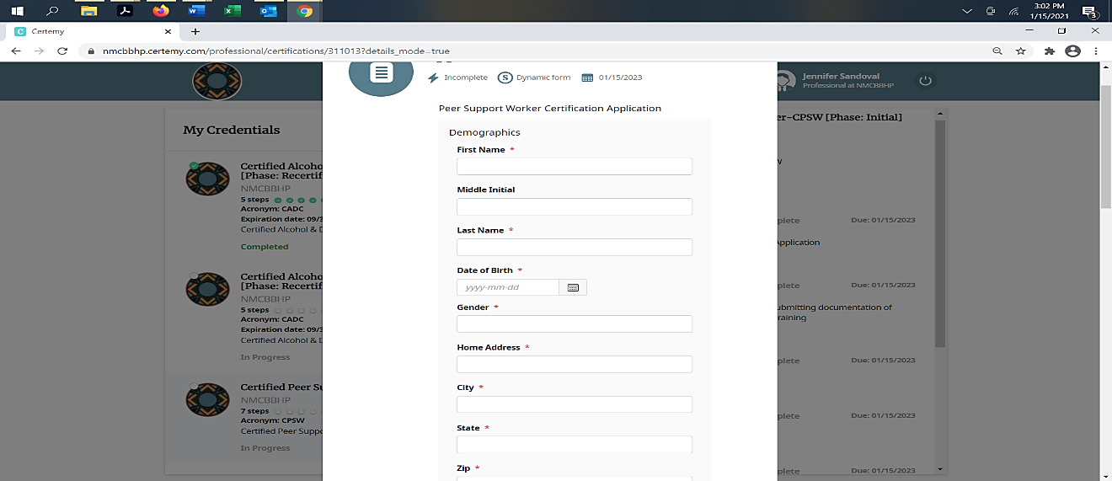

1. Click on “OPRE Peer Training”, Family Peer Training” or “Wraparound Training/Approval Letter”

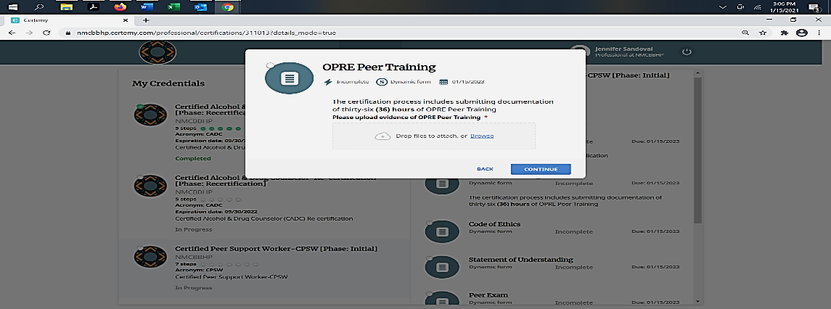

1. You will upload the completed training certificate or a letter of completed training **“Please upload evidence of OPRE Peer Training, Family Peer Training or Wraparound Facilitator approval letter to test”.**
2. You will read the **“Code of Ethics for CPSW, CFPSW or CWF”** and the “**Statement of Understanding”**, complete information and sign it electronically.
3. Peer, Family or Wraparound Exam; you will choose In-person or Online on the dropdown list.

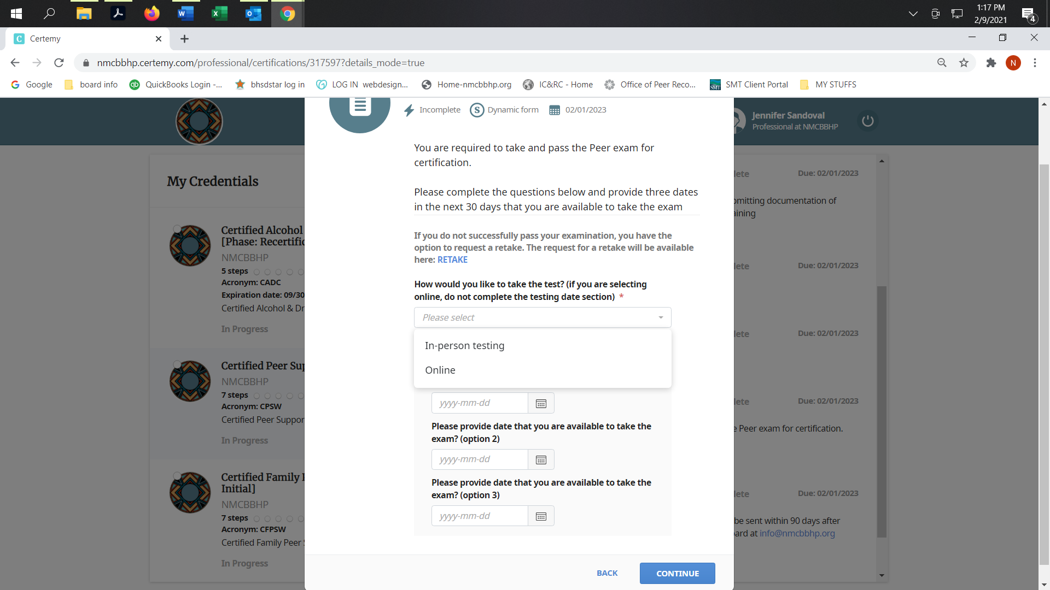

1. Click on In-Person testing, you must provide three (3) dates to take the exam
2. Click on **“Online”** in the drop-down list.

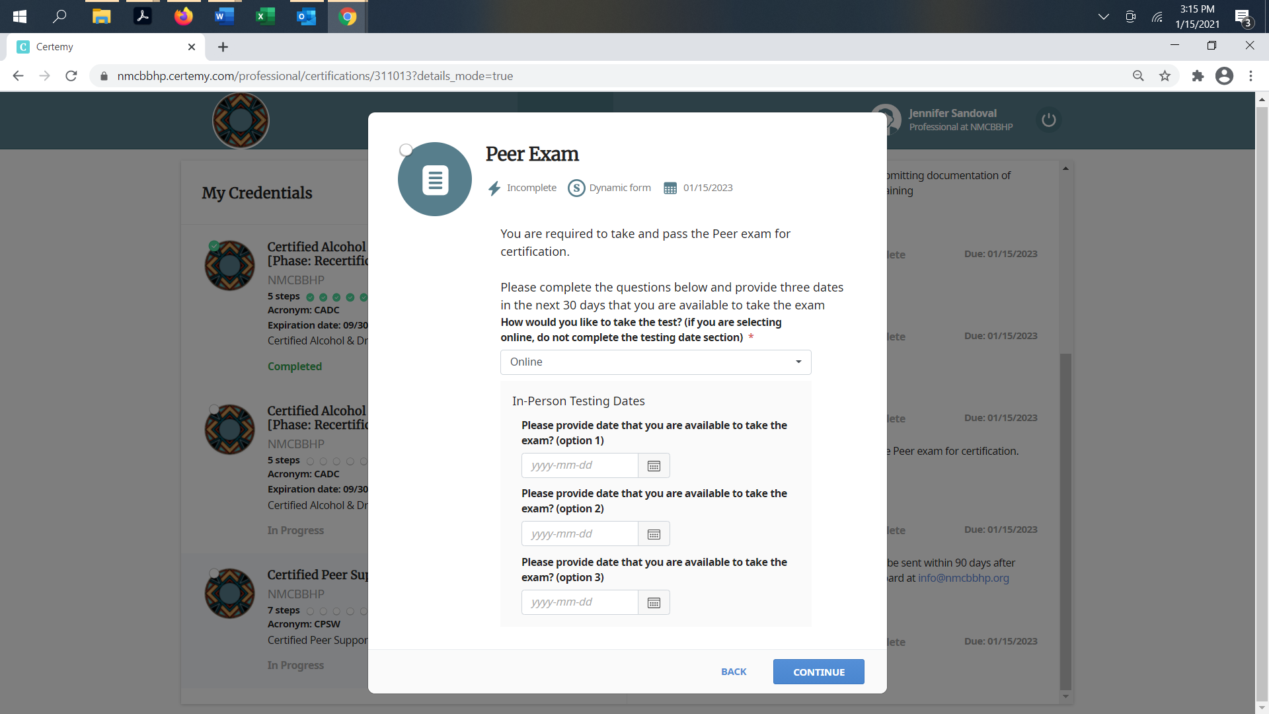

* You will confirm:

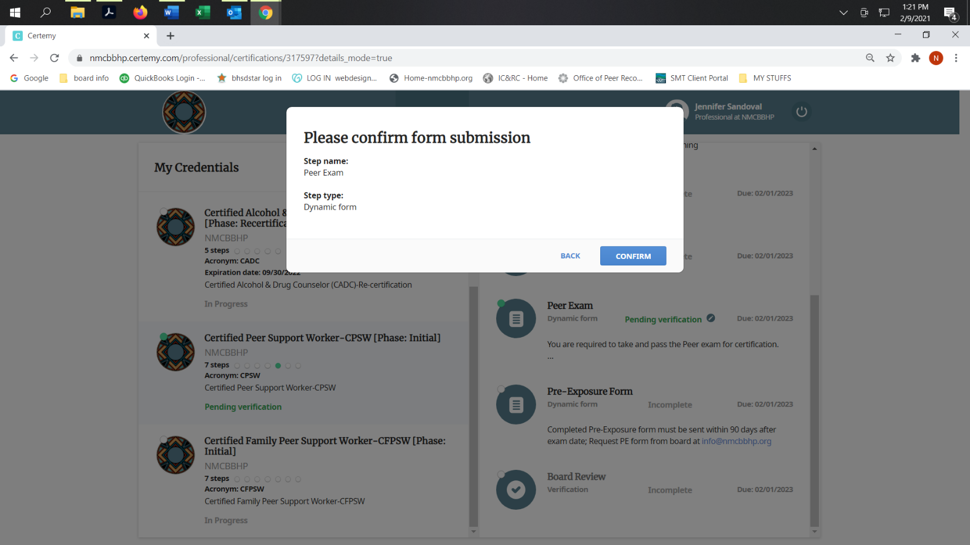

* Once you have made your selection, you will see “Pending Verification” in the steps.

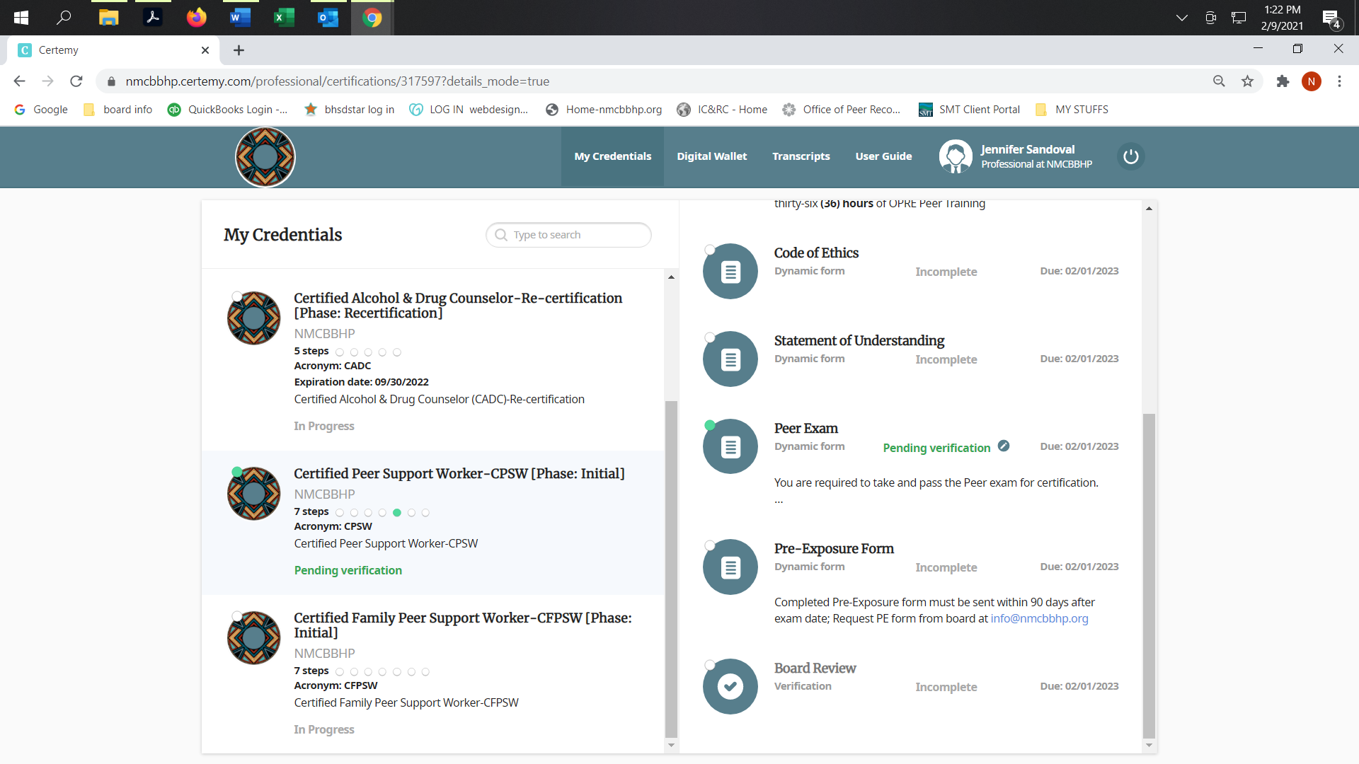

* The application and documents uploaded will be verified by the board through Certemy and you will receive emails when it has been approved. You can log out here.

**Exam scheduling at SMT/IQT Quality Testing, Inc**

1. When approved for an exam, the **board (NMCBBHP) will pre-register** you with the testing company (SMT/IQT Quality Testing, Inc.) the following will happened and must be completed by you:

* You will receive an email from the testing company and email will be from **SMT/IQT-Quality Testing, Inc.** with information on the link and a Username and Password to log in, sample of letter below:



* Go to the link. When you log in, you will complete the registration and schedule or confirm the date/time and/or location of your exam. You will receive an admission letter.



* There are three things that must be done before you test. You can do this before you select an exam.
  + System Readiness Check
  + ProProctor Application (software check)
  + Launch Exam

Check here for the tool: <https://rpcandidate.prometric.com/>

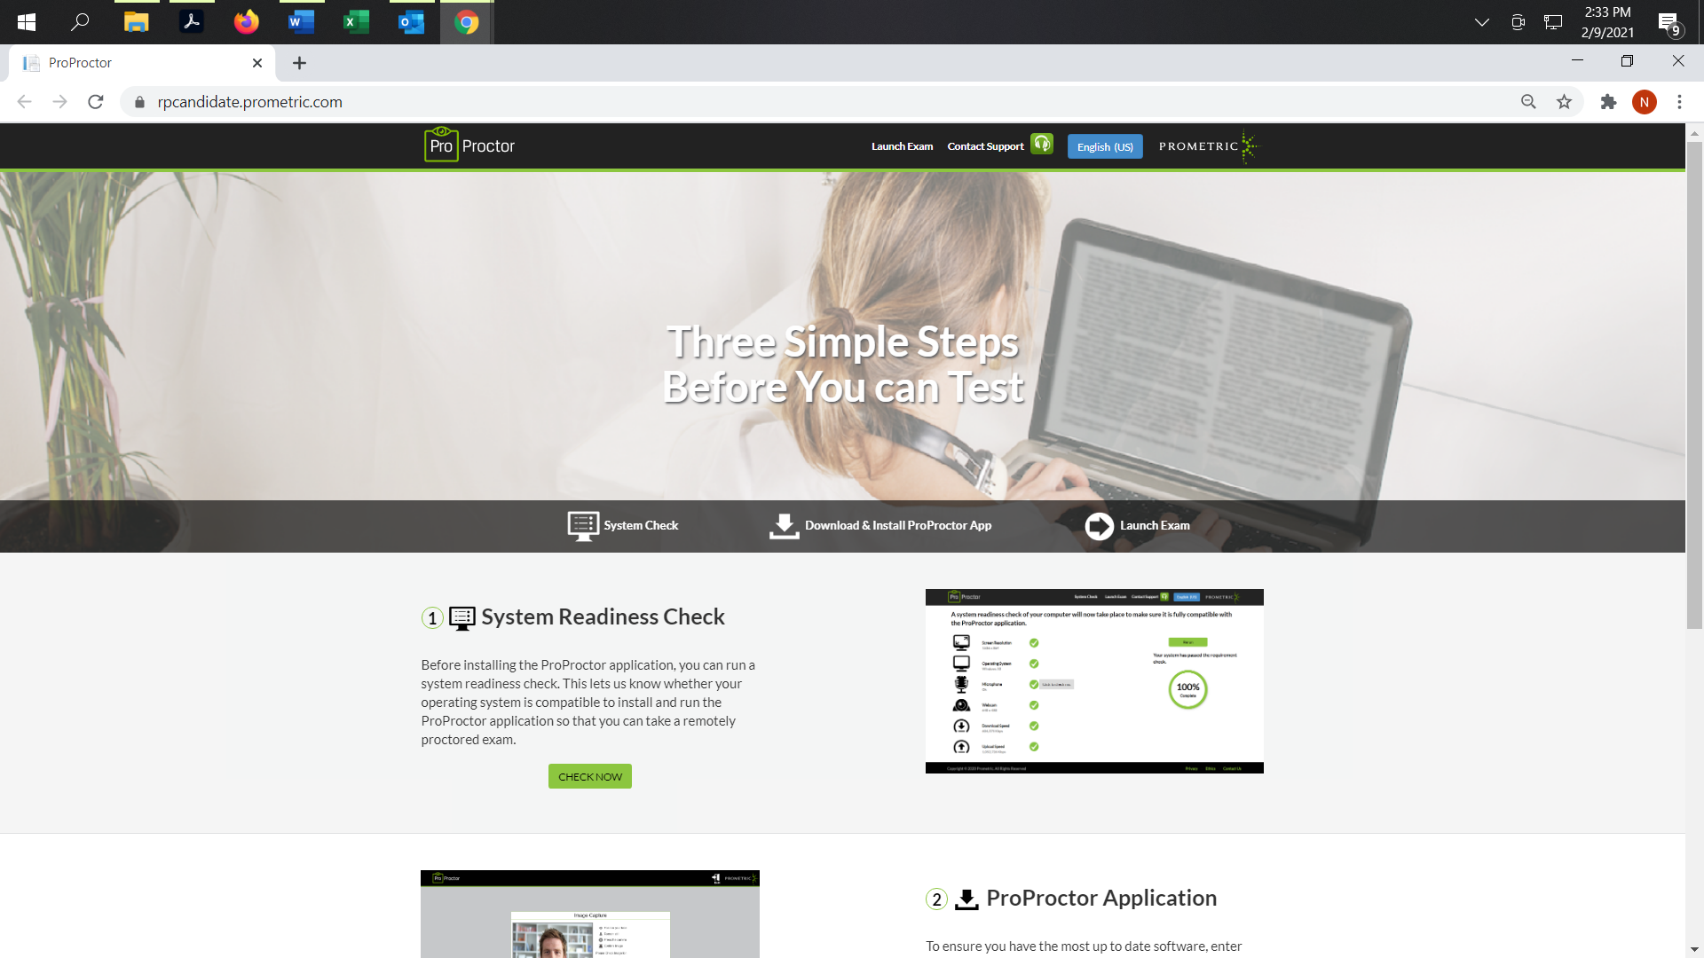

* When logging in to take your exam to take the online exam, you will preview a tutorial of the exam process first, then you will start your exam. The time for the tutorial is not part of the exam time you have. You have 1 ½ hours to complete the exam.

1. This board will log into SMT/IQT to retrieve results of exams taken. We will post official exam results in each person’s profile on Certemy.
2. After you have passed your exam, you will log into Certemy and upload the completed Pre-exposure form for verification, after verification and approval, you will be approved as having the CPSW certification. A certificate will be available in the “Digital Wallet” in your profile.
3. If do not pass the exam, you are eligible to retest one more time, by completing the “*CPSW Examination Retake Request*” application in the Certemy app. There is a fee to retest, check with your training agency to confirm this.

Contact the board, NMCBBHP if you have any questions at

[info@nmcbbhp.org](mailto:info@nmcbbhp.org) or 505-974-5090.