Ladies in Training: Session 8 – January 23rd, 2015
Today’s lesson was all about U.S Geography!
First, the girls were given a blank map of the United States of America and were encouraged to fill out as much of the map as possible! We then taught them the 50 states of our country by visually drawing the states one by one in order. The girls were then quizzed on the information that they were taught and were given some yummy treats!

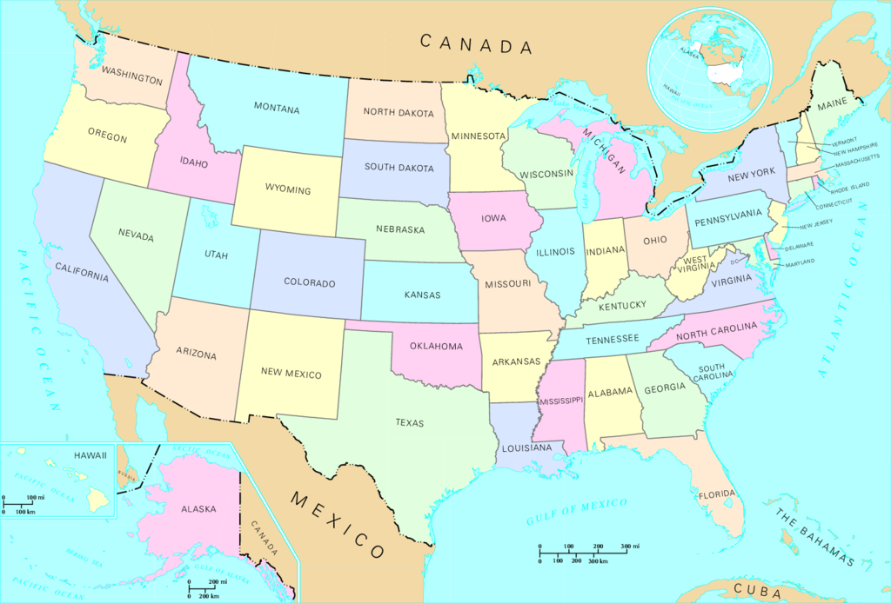
In addition, the girls did an activity focused on teamwork and creativity. We split the girls into two teams and then allowed each team to find a difficult and unique word they thought the other team would not know of. Then, they created two more fake definitions to go with the real one and presented all three. The opposite team had to guess the word’s real definition! Words such as zealot were picked and given crazy definitions like a mythical creature!

