Teaching Guide for First Person: Conversations with a Survivor
PRIOR TO THE PROGRAM
- Share with students the definition of the Holocaust.
- Students then read the biography of the featured survivor. On the student interactive, students answer the following:
ASK THE STUDENTS
- ● What was life like before the Holocaust for the featured survivor?
- ● What are three characteristics of their experience during the Holocaust?
- ● How did they survive?
- ● What was life like for them after the war ended?
- ● What questions do you still have about the survivor’s experience?
DURING THE PROGRAM
3. Using the student interactive, students fill in details of the survivor’s story before, during, and after the Holocaust.
AFTER THE PROGRAM
3. As a class, discuss the student interactive:
- ● What are the particular characteristics of the survivor’s experience before, during, and after the Holocaust? How did hearing the story in the survivor’s words add to your understanding of their particular experience?
- ● What were the survivor’s final words for us today?
- ● How does hearing from a survivor add to your understanding of how and why the Holocaust happened? Students can explore the collections of the survivor to find primary sources to link to the survivor’s experience before, during, and after the Holocaust.
- ● Students can create personal story cards for the survivor using information from the student interactive and primary sources from collections to add to the USHMM Timeline Activity.
- ● Students can view additional First Person programs and create a timeline showing similarities and differences in individual experiences.
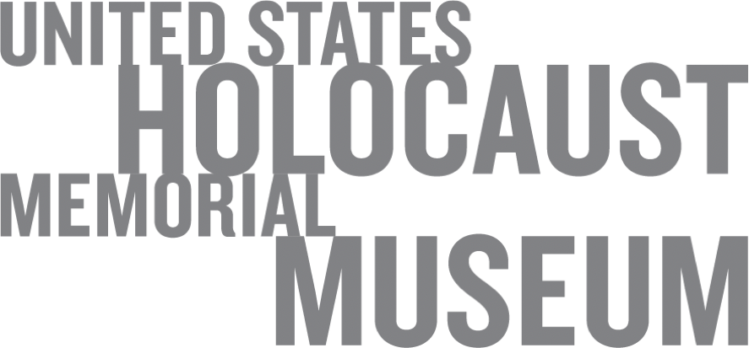
First Person: Conversations with a Survivor |

