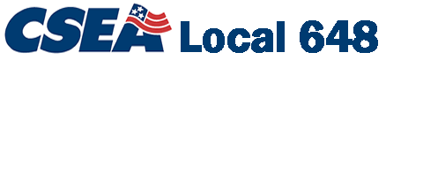

Proudly Representing the Employees of
Binghamton University
(State University of New York)

David W. Lee, President
DaveLee648@csealocal648.org

P.O. Box 6000
Binghamton, NY 13902-6000
(607) 777-4377
Fax (607) 777-4656
Email CSEA@Binghamton.edu
Website www.csealocal648.org

July 11, 2006

Dear Brothers and Sisters of Local 648:

Identity Theft is a growing problem, largely due to the availability of information in computer databases, increased use of credit, debit, and ATM cards, and doing business over the Internet.

Individuals often discover they have been victimized when they learn of purchases they did not make. The victim must then bear the burden and expense of reversing the damage and restoring their credit.

Information provided on individual credit reports can help people remain aware of their financial activity. As of September 1, 2005, New York residents are eligible to receive their credit report once every 12 months...free of charge.

For instant access to your free report from each of the three nationwide consumer-reporting companies, visit www.annualcreditreport.com. You may also request your credit reports by phone by calling 1-877-322-8228.

I hope you will find this information helpful and worth sharing with family and friends.

Sincerely,
David W. Lee
President CSEA Local 648
SUNY Binghamton

CSEA Local 1000 • AFSCME • AFL-CIO

