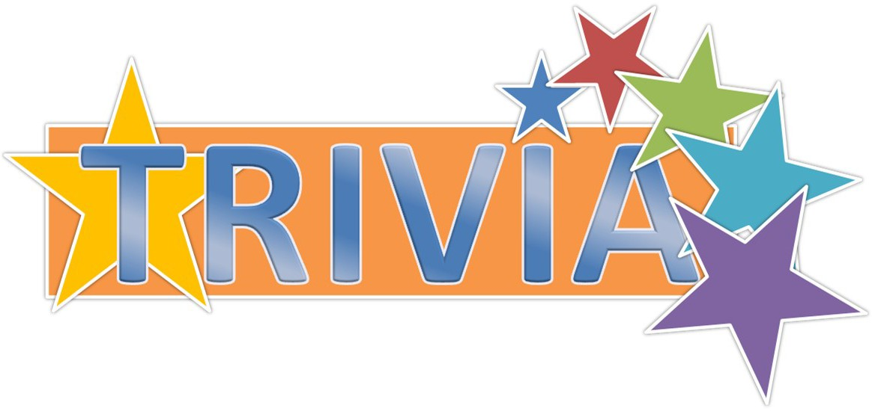





***Karaoke—Bingo—Trivia***

***April 5, 2019***

***6:30—9:00***

***$10***



*Federated Church*

*1031 Thompson Way*

*Placerville, CA 95667*



STARR is unable to accept physically or mentally disabled adults who require attendant care for house- keeping, personal needs, or behavior issues unless their care giving adult stays to assist