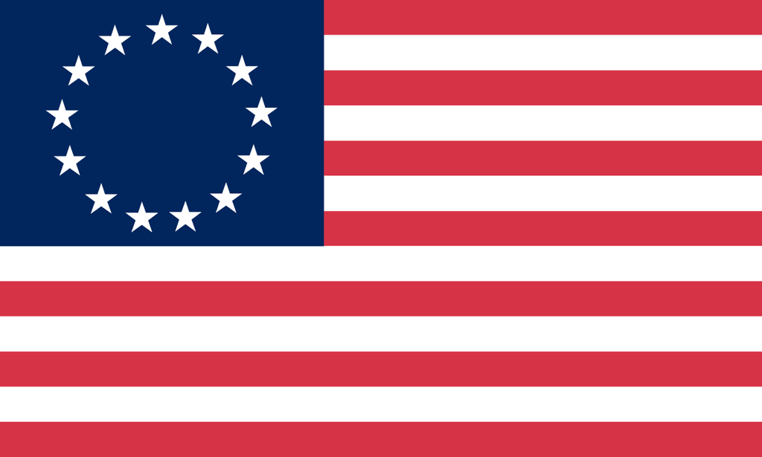U.S. History with Mr. Brown Name _______________________________ Period _____
Chapter 8 Constitution to Confederation
Picture Search
Directions: Use the pictures, maps, charts, graphs, time lines, and info boxes to answer the following questions. Do not look for the answers in the paragraphs of text. (p. 202- )
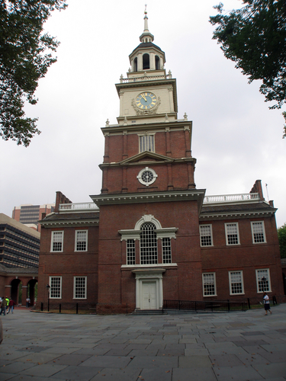
1) In what city did delegates to the 1787 Constitutional Convention meet?
2) What is the Pennsylvania State House known as?
3) In what year did the Articles of Confederation go into effect?
4) What year did Shay’s Rebellion start?
5) What year does George Washington become the first president?
6) What year is the bill of rights ratified?
7) Early travel to what state is shown in “Daniel Boone Escorting Settlers through the Cumberland Gap”?
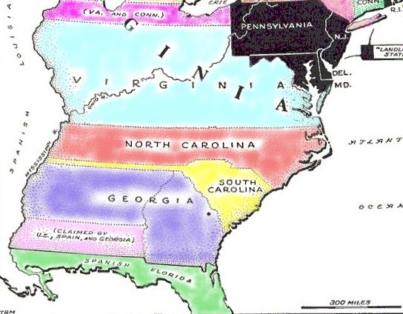
8) Who said “United we stand, divided we fall”?
9) In 1791 what state claimed the land that is now West Virginia?
10) What geographic feature was the western border of US territory in 1781?
11) What three very important things did the Articles of Confederation lack the power to do?
12) According to the stone marker on p.209 on what date was Shay’s Rebellion there?
13) What kind of tool is a theodolite?
14) Besides selling for money what else did the new federal government do with land they reserved on the Township map?
15) Which Constitutional Convention delegate is pictured on page 212?
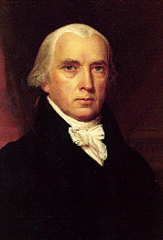
16) Where was the Declaration of Independence signed?
17) Which delegate became known as the Father of the Constitution?
18) Who said, “If men were angels, no government would be necessary”?
19) How does the caption on p. 215 describe the debating over the constitution?
20) The great compromise was a combination of what two plans?
21) Under the great compromise how many house will the legislature have?
22) As of the time this text book was printed, when was the last examination of the original U.S. Constitution documents?
23) What state was Samuel Huntington the governor of?
Federalists and Anti-Federalists
24) Which supported a strong National Government?
25) Which feared that a strong executive might become a Tyrant or King?
26) Which wanted the legislative branch to have more power than the executive?
27) Which believed a Bill of Rights needed to be added to the Constitution?
28) Which proposed a single person to lead the executive branch?
29) What was the purpose of the parade pictured on p.220?
30) When did Thomas Jefferson write the Virginia Statute for Religious Freedom?

