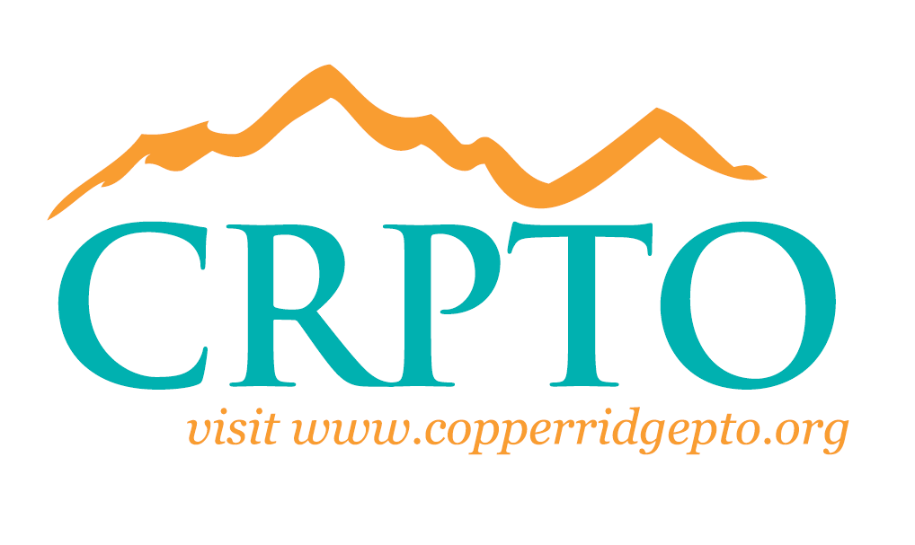

CRPTO General Board Meeting
November 13, 2017

Meeting called to order at approximately 9:00 a.m. by Jennifer Wetzler, CRPTO President.

CRPTO Board Members Present: Excused Absence:
Jennifer Wetzler, President | Carly Parkhill, EVP
Nikki Forman, Secretary | Karla Clay, Co Asst. Treasurer
Stephanie Halvorson, VP Events | Rochelle Gabriel, Past President
Marnee Medress, Asst. Treasurer | Kay Rodgers, Volunteer Coordinator
Andrea Behmer, VP Fundraising | April McCracken, VP Communications
Starr Crist, Treasurer | Special Guests:
Aimee Nordini, VP, Campus Support | Mrs. Slover, Principal
Jenny Shorr, VP Membership | Amanda Rand, Dean of Students
 | Lindsey Harrington, Staff Holiday Luncheon

Welcome
President Wetzler welcomed everyone to the meeting.

Principal Update:
Mrs. Slover stated that we are continuing to reach out to district to see when our water-fill stations will be set up on campus.
We also continue to reach out to district about the safety video concerning drop-off in the morning.
Kindergarten Round-Up
The format for Kinder Round-Up has changed. We are holding 3 Round-Ups at different times in the day and evening. It allows for smaller groups rather than one large group which makes it a more inviting and comfortable setting for all.
Middle School:
Middle School parents should be on the look-out for information regarding registration in December or January.
Middle School Teachers host conferences either by team or individually. If you would like to schedule a conference, parents are encouraged to reach out to teachers via email or phone to sign up.
On Wednesday, November 15th, 6th, 7th, and 8th grade students will have the Human Growth and Development class.
School Label:
Mrs. Slover stated that we are still waiting for information regarding the school label. We are hoping for more information in December. She will inform everyone when she knows more.
Professional Development:
Teachers are looking at AZ Merit scores and scores from Benchmark #1 to help students who are struggling and to continue to progress students who are performing and exceeding.

Holiday Staff Luncheon:
Lindsey Harrington spoke about the Staff Holiday Luncheon on December 20th at 1:15. She will be sending out a Sign-Up Genius for food, desserts, and drinks. She is looking for donations for Gift Cards for teachers.

Mix N Mingle:
The Mix N Mingle is November 30th from 7-9:00 PM at Ciao Grazi. The Mix N Mingle is for all CRS families, new and existing, to enjoy a fun, adults only, night out. Light appetizers will be provided by Nordini & Thompson. Meet other CRS families along with the CRPTO Board of Directors. Come learn more about CRS, CRPTO, ask questions, mix n mingle, and meet new friends!

Family Reading Night:
Aimee Nordini spoke about Family Reading Night scheduled for December 6th from 6:00-7:30 PM in the library. Mr. Gates class will put on a performance. There will be a Library Scavenger Hunt and chocolate chip cookies will be served. Parents are asked to bring in new or lightly used books to donate to our Sister School Tonalea.

TinyPrints and Shutterfly:
Tiny Prints and Shutterfly have some great deals for you to take advantage of this holiday season. Plus, CRPTO earns 13% back on all purchases if you enter via the CRPTO Shutterfly Storefront or TinyPrints Storefront. CRPTO.shutterflystorefront.com

Upcoming Dates

NOVEMBER

20 – Fall Carnival 5:00-8:00 pm

NOVEMBER

14 – Early Release at 1:15 pm
15 – MS Volunteer Committee Meeting 10:00 am Room 608
15 – Early Release at 1:15 pm (Conferences)
16 – CRS Spirit Store Hours 8:15-9:00 am
16 – Early Release at 1:15 pm (Conferences)
22 – 24 – Thanksgiving Recess – NO SCHOOL
30 – Mix & Mingle 7:00-9:00 pm Ciao Grazi

DECEMBER

6 – Family Reading Night 6:00-7:30 pm CRS Library
20 – Early Release at 1:15 pm
25-29 Winter Vacation

Minutes submitted by:
Nikki Forman
Nikki Forman, 2017-18 CRPTO Secretary
Approved by:
__________Jennifer Wetzler___
Jennifer Wetzler, 2017-18 CRPTO President

