Love Me True Rescue’s Suggested Supply List

Pet Carrier  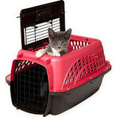 | Please make sure you have a carrier when adopting a kitten or cat from Love Me True Rescue, Inc. A carrier is necessary to ensure the safety of your cat while traveling in a vehicle. It is also important to have a carrier for each one of your kitties in case you ever have to evacuate due to an impending hurricane.  There are many carriers to choose from. We recommend this two door hard carrier. It is easy to clean and makes life easy for you when trying to transport your cat in or out of the carrier. If you have a kitten, make sure you buy one big enough for them to grow into… because they don’t stay little very long!
Litter box  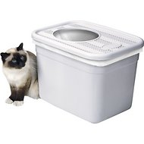 | There are all different kinds of litter boxes ranging in style and price. We recommend Clever Cat top entry box for limited tracking. You can put it anywhere in your house and you don’t see the litter. Some cats love it and some prefer an opened box. Also, very young kittens, obese cats and seniors may not be able to jump in.. In that case you will want to get a large or extra large open litter pan..  To ensure your cat uses the litter box make sure it is cleaned (twice daily). Remember to keep the box away from where you feed your kitty because cats think that is gross! `☺
Pooper scooper  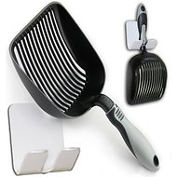 | So many to choose from! We like a large metal scooper for easy and thorough scooping.
Litter  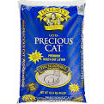 | Well you need something to scoop and Dr. Elsey’s precious cat litter is, in our opinion, the best litter. It scoops great. If you want to get your litter at the food store, Cat Pride “Natural” is a good choice. If you are getting a kitten under 4 months we recommend pellet litter or Worlds Best Litter.

Food   | The great debate! Wet vs. dry? Love Me True Rescue is passionate about this subject. So many studies show that wet is the way to go. At least for one of your cat’s meals. Cats are carnivores. They do not need grain and do best with a raw meat diet. We are not suggesting you make your own food or go hunting for your kitty. We do suggest you take some time to research what would be the best food for your cat and your budget. Dry food is cheaper, but vet bills aren’t. Dry food may contribute to cats becoming over weight, developing bladder stones and kidney problems. Your cat needs moisture, and they don’t always love to drink. Refer to the “feed your kitty” article from Cornell University if you need some assistance in this area or speak with your vet. Remember, you are what you eat! Also, look at feeding guidelines; free feeding can cause obesity and health problems down the road.
Treats  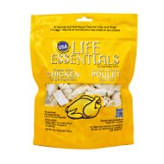 | You don’t want to go overboard, but who doesn’t like a treat? We recommend freeze-dried chicken treat found at pet stores or online. Catnip plants are also nice to have around. Not all cats love catnip, but if you have one that does it is very entertaining to watch. Although, we don’t recommend table feeding, a piece of plain boiled chicken breast also makes a tasty treat.
Bowls  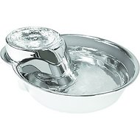 | We think stainless is best for bowls. Ceramic can break and plastic can sometimes cause an allergic reaction. Slightly elevated bowls may create a more comfortable eating experience, but don’t raise the bowls too much. Cats are natural “crouchers” when they eat. Another cool thing to get your cat drinking, is a fountain. It is fun to watch them drink from it.. Our cat Presley thinks it’s a swimming pool, and even though I have to clean it more often, .its worth a good laugh!
Scratching Post  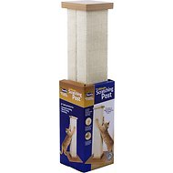 | Cats scratch. They need to, they love to! We know you don’t want them scratching up the furniture, so its important that they have plenty of awesome things to scratch on. This scratching post by smartcat (chewy or amazon) is a must have. I have never met a cat who doesn’t love it. it is a great height, its sturdy and they love the material. Cats can be trained to not scratch furniture. Tender redirection will eventually work and they can be clicker trained. If you are concerned about scratching please speak with us or your vet. Please do not declaw your cat. It is illegal in many countries, painful, may cause behavior problems, and God for bid they get outside, they have lost their only defense against predators.
Toys  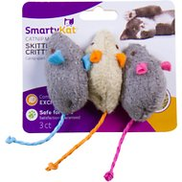 | It is fun to watch your cat chase a laser, roll around with a catnip filled mouse, or jump to grab at a wand toy. Get to know your kitty to find out what he or she likes best. My cat, Willamina’s favorite toy is a rol,led up piece of paper for playing fetch. Whatever you decide, always remember safety first! Do not let your kitty play with something that can get caught in their intestines or they can choke on.,

Grooming Tools  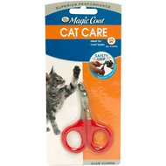 | Nail clippers, a brush, and flea comb are all helpful products to have. Touch your cat’s paws as much as he or she will let you, so clipping nails isn’t a chore. Remember, to only cut the curved part to avoid accidently cutting the “quick”. If you are unsure ask your vet or vet tech to show you. Brushing your cat regularly helps prevent hairballs and keeps his or her coat shiny and matte free. Even though we give our cats flea protection a flea can still find its way on them. A flea comb comes in handy.
Flea & Heartworm Protection  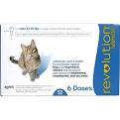 | An easy way to get heartworm and flea protection at once is to use a monthly topical protector like Revolution. This product can be found at 1800 Petmeds or your vets office. Fleas can find their way into your house and on your cat, so it is important to protect them. Talk to your vet for the best advice on this matter. Also, make sure you get a flea comb to ensure yoiur baby is completely flea free.
Cat Furniture  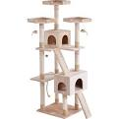 | You can find some really cool cat furniture these days. From shelving to cat trees, there are so many choices.. . Cats like to have beds and furniture to lie on., and call their own. If you don’t want your furry friend stealing your seat on the sofa maybe you want to invest in a cat tree… or let him sit on your lap. ☺

