Adopt one of these wonderfully fluffy dogs today!
See us at www.fluffydog.net in Hartland, WI. Most of our dogs are rescued from kill shelters in southern states. They are all in Wisconsin in loving foster homes awaiting their “furever” homes. All dogs will be spayed/neutered, vaccinated and microchipped.
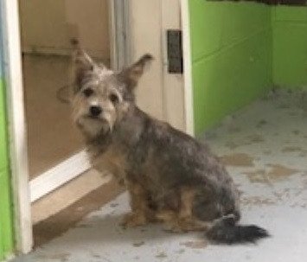 | 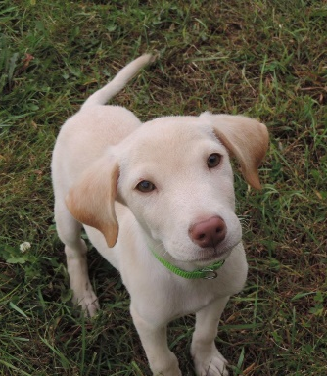 | 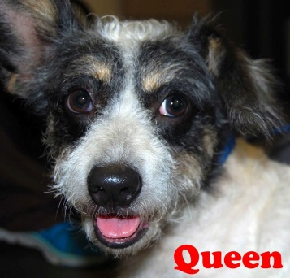
Tiffany  Female  Schnauzer Mix  3 years | Roger  Male  Lab Mix  Young | Dottie  Female  Corgi Mix  Young | Joplin  Female  Lab Mix  Young
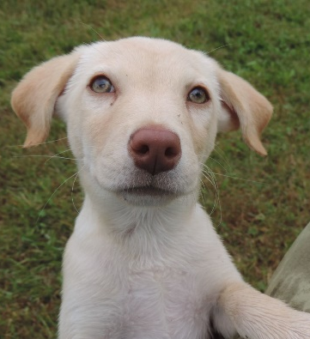 | 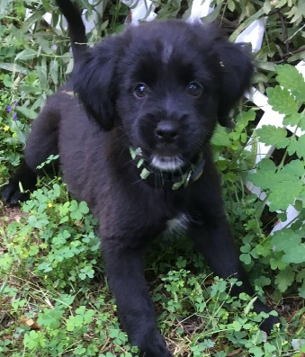 |  | 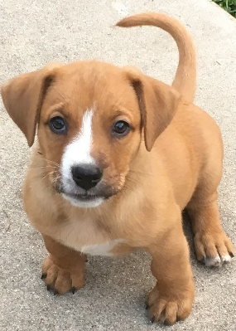
Janice  Female  Lab Mix  Young | Morel  Female  Cairn Terrier Mix  Young | Mimi  Female  Terrier Mix  Senior | Portobello  Male  Cairn Terrier Mix  Young
 | 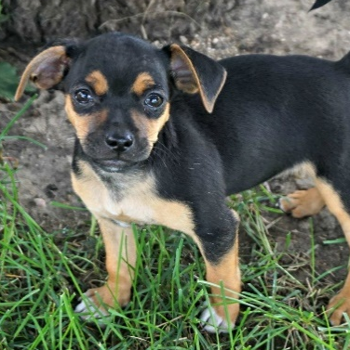 | 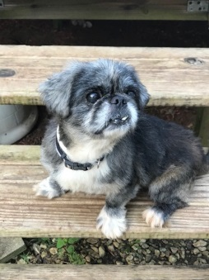
Passion Fruit  Female  Dachshund/Shi Tzu Mix  1 year | Mango  Female  Dachshund/Shi Tzu Mix  Young | Buzz  Male  Peke Mix  6 years | Siren  Female  Lab mix  Young
 |  |  | 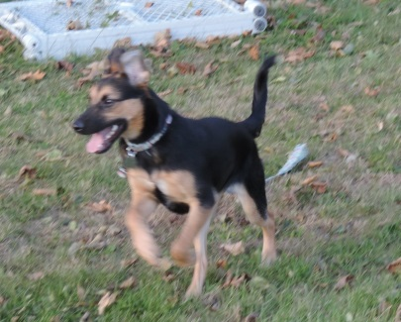
Saffron  Female  Wired Terrier Mix  Young | Bachelor Button  Male  Chihuahua/  Dachshund Mix  Young | Gardenia  Female  Chihuahua/  Dachshund Mix  Young | Kon-Tiki  Female  Shepard Mix  6 months (10/30)
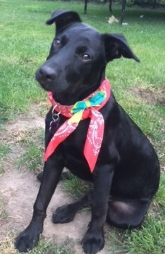 | 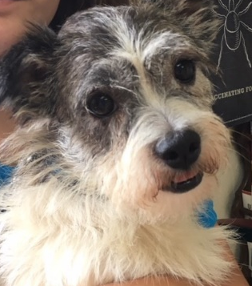 |  | 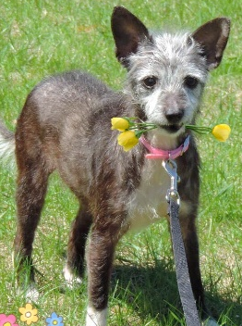
Draper  Male  Flat-Coated/Labrador Retriever Mix  Young | Gizmo  Male  Shih Tzu Mix  6 years | Tammy  Female  Dachshund Mix  5 years | Zinnia  Female  Chihuahua/Chinese Crested Mix  7 years
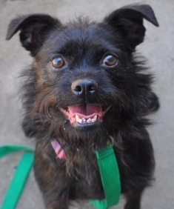 |  | 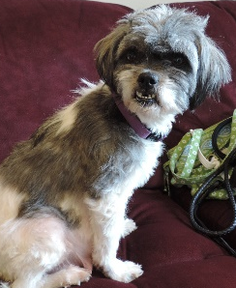 | 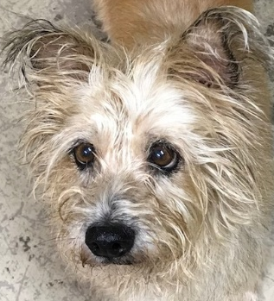
Bella  Female  Brussels/Boston Terrier Mix  3 years | Marigold  Female  Chihuahua Mix  Young | Crouton  Female  Shih Tzu Mix  3 years | Happy  Female  Westie Mix  7 years
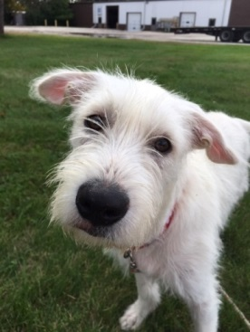 |  |  | 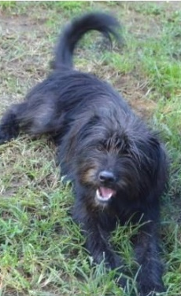
Teddy  Male  Wirehaired Terrier Mix  6 months (10/1) | Lennox  Male  Terrier Mix  1 year | Zuzu  Female  Wirehaired Terrier Mix  7 years | Bramble  Female  Wirehaired Terrier Mix  1 year
 | 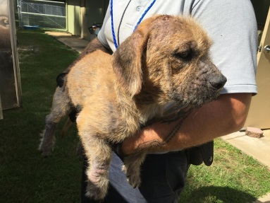 | 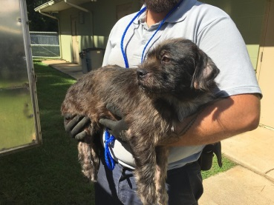 | 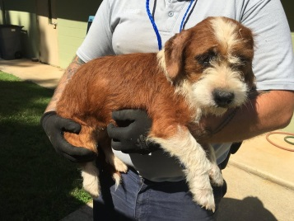
Kepler  Male  Collie/Australian Shepherd Mix  6 years | Chowder  Male  Basset Mix  Young | Cider  Male  Basset Mix  Young | Cranberry  Female  Basset Mix  Young
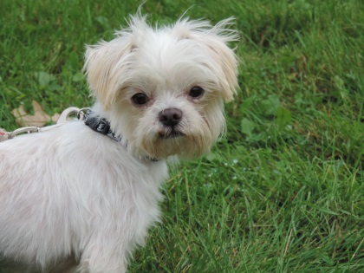 | 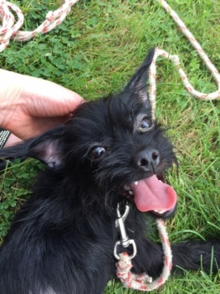 | 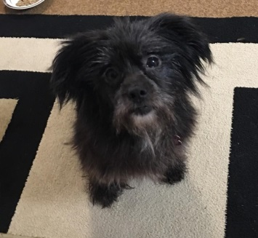
Louie  Male  Maltese Mix  1 year | Sienna  Female  Wirehaired Terrier Mix  Young | Mercedes  Female  Wirehaired Terrier Mix  Young

