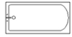
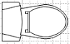
Living Room
16’3” x 12’5”
Kitchen
Dining Room
7’7” x 7’8”
Closet
Closet
Bedroom
14’2” x 11’9”
AC
Closet

