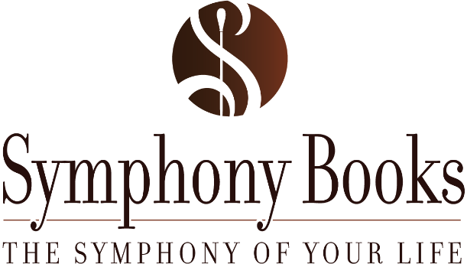
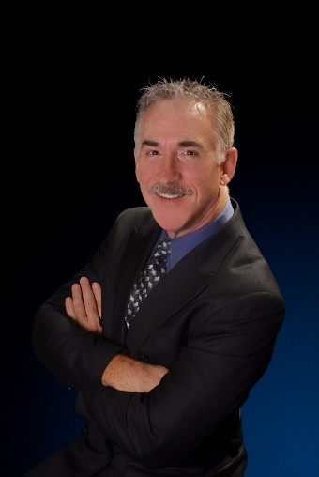

Creating the Symphony of Your Life Workshop Critique

Did you find today’s workshop useful?

What was your favorite concept/story?

What could Mark do to make the day more useful for you?

Would you be willing to provide a testimonial?
If so, written or video (circle one or both and let me know how best to connect with you)

Thank you for attending!

5994 S. Holly St #112, Greenwood Village, CO 80111
www.symphonyofyourlife.com
720.263.0301

