Please complete registration form on desktop and email to itssumnertime@gmail.com.

“IT’S SUMNERTIME!”
Contact: Kathy Sumner (301)-704-8495 Website: www.itssumnertime.com Email: itssumnertime@gmail.com
Summer Camp Registration Enrollment Form
Welcome to “It’s Sumnertime! Kids Fit. Life Enrichment Tips. LLC.” The purpose of this agreement is to define the mutual terms for summer camp arrangements. We, the undersigned, understand that this packet contains important information for parents, guardians, and campers. We acknowledge that we have received a copy of the Sumnertime Kids Fit Life Enrichment Tips camp handbook and have reviewed the information and policies contained in this handbook such as Summer Camp Operation Schedule, Rates and Fees, Liability Waiver and Transportation.
We understand that all campers will be held accountable for their behavior AND actions. Failure to abide by the guidelines for student behavior can result in termination from the program.
We understand further that failure to return this acknowledgment form does not excuse any individual from complying with the camp handbook, policies, regulations, and guidelines. I fully understand all my financial obligations and agree to the terms of this contract for “It’s Sumnertime! Kids Fit. Life Enrichment Tips.” Signature is required in 4 places.
Pick your payment method AND Location: ☐Cash (Preferred) ☐Cash Ap ☐Zelle
☐Largo Church off 193 ☐KidzDen Off Tesla Dr. in Bowie

Camper Name: Click or tap here to enter text.Date of Birth: Click or tap here to enter text.Age: ______
Parent/Guardian Name: Click or tap here to enter text. Phone Number #1: Click or tap here to enter text.
Email Address: Click or tap here to enter text.

Parent/Guardian Name: Click or tap here to enter text.
Phone Number #2Click or tap here to enter text.
Email Address: Click or tap here to enter text.
Friend/Family Name Authorized To Pick Up: Click or tap here to enter text.
Phone Number: Click or tap here to enter text.
Friend/Family Name Authorized To Pick Up: Click or tap here to enter text.
Phone Number: Click or tap here to enter text.
Transportation: I am giving permission (with my signature below) for the camper listed on this form to be transported to and from Sumnertime Camp offsite activities. In addition, I am giving my child permission to participate on the Splash Park/ Swimming field trips which will be held mostly on Tuesdays.
#1 Parent Signature: Click or tap here to enter text.Date: Click or tap here to enter text.
Parents are more than welcome to visit during camp hours and can volunteer as chaperones on field trips.

My child is able to swim : ☐yes ☐no/Splash only

Illness
If your child becomes ill during care, you will be asked to pick up your child within 1 hour. If you cannot be reached, I will call one of the emergency numbers you have listed. Your child may return to camp when they are no longer sick. This includes a cold, flu, stomach bug, vomiting, diarrhea, fever, Covid, any virus, etc.
#2 Parent Signature: Click or tap here to enter text.Date: Click or tap here to enter text.

Food
Children can provide lunch from home or be sent to camp with $8 cash to purchase pizza. Snacks will be provided.
Please explain if the child has special dietary needs or food restrictions. Click or tap here to enter text.

Please help me know more about your child.
Favorite hobbies/ interests: Click or tap here to enter text.

Favorite foods/ snacks: Click or tap here to enter text.

Allergies: Click or tap here to enter text.

Medications taken regularly in case of emergency: Click or tap here to enter text.

Additional information which may be helpful in understanding your child’s needs, encouraging positive behavior, and making the transition to this summer camp program easier:
Click or tap here to enter text.

Please email completed form back to itssumnertime@gmail.com

YOUTH CAMP HEALTH HISTORY
CAMPER
Child’s Name: Click or tap here to enter text.
Current residence: Click or tap here to enter text.
EMERGENCY CONTACT INFORMATION:
Emergency Contact
(Parent or Legal Guardian): Click or tap here to enter text.Phone: Click or tap here to enter text.
2nd Emergency Contact
(Other than Parent Above):Click or tap here to enter text. Phone: Click or tap here to enter text.
Primary Care Physician or
other provider of medical care: Click or tap here to enter text. Phone: Click or tap here to enter text.
HEALTH INFORMATION:
Are there any health problems including physical, psychiatric, or behavioral problems of which
we need to be aware?  NO
 YES, Explain: Click or tap here to enter text.

Are there any medications, dietary restrictions, allergies, or special needs that we need to be
aware of to ensure that your child’s camp experience is positive?  NO
 YES, Explain: Click or tap here to enter text.

IMMUNIZATION INFORMATION:
Must list current residence above.
For campers who currently reside within the United States, a United States territory, or the
District of Columbia: Does the camper have any immunization exemptions because of a
parental or guardian objection or medical contraindication?  NO
 YES, List: Click or tap here to enter text.
For campers who reside outside the United States, a United States territory, or the District of
Columbia: Attach record of vaccination or immunity on Department form MDH-896.
#3 Parent/ Legal Guardian’s SignatureClick or tap here to enter text. DateClick or tap here to enter text.

Summer Camp Operation Schedule- 10 weeks
Camp Starts: Monday June 17, 2024 Camp Ends: Friday August 23, 2024
Camp Hours: 8:00 am-4:00 pm Rate: $240.00 weekly from 8am-4pm. Rate includes 3-4 field trips.
Camp Closed in Observation of Holiday: Wednesday June 19, 2024 and Thursday July 4, 2024
Target Audience: Girls and Boys Ages 3.5-14
​
​*Each service will be provided weekly for an additional $25.00

​*Before Care 7:00 am-8:00 am *After Care 4:00 pm-5:30 pm
Group Me will be the main means of communication with families. Please DO NOT POST or write on the group chat.
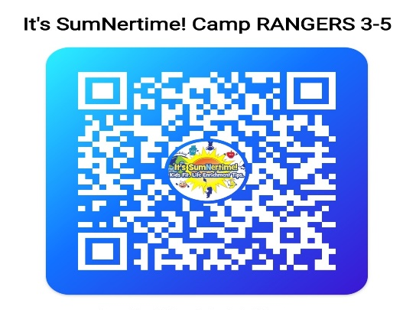
Please scan the Group Me that applies. Rangers are age 3-5, Rockstars are age 6-9, and Champions are age 10 and up.
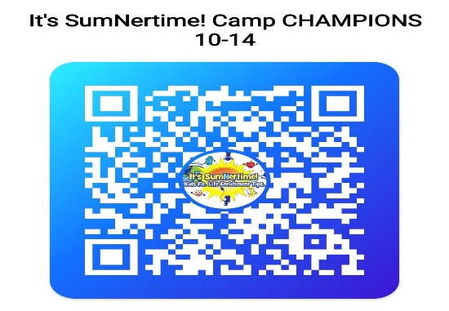

Payments, Rates, and Fees
Childcare fees may be paid weekly on the Monday of each week or the Friday before your camper starts.
$60.00 per day for drop- in rate from 7:00am-5:30pm.
$25.00 Before Care 7:00am-8:00am weekly.
$25.00 for After Care 4:00pm-5:30pm weekly. $1.00 fee every minute for pick up after 5:35 pm.
$15.00 Camp t-shirt worn on field trips. If camper doesn’t attend trip, they must be kept home that day.
$8.00 daily for pizza, if a bagged lunch is not provided.
Fees can be paid by cash ap ($sumnertimecamp), cash, check (Made out to: Kathy Sumner), or via Zelle.
Splash park is every Tuesday rain or shine. All other field trips are on Thursday’s and some Friday’s.
Liability Waiver
I am giving permission for the camper listed on this form to participate in “It’s SumNertime! Kids Fit. Life Enrichment Tips” summer camp program. I realize the staff and instructors will do everything in their power to protect my child when in their care. I will not hold them responsible and waive all claims against SumNertime camp staff members and shareholders for any accidents that may occur when the student is in their care. I also acknowledge that SumNertime camp does not provide medical insurance coverage for accidents.

#4 Parent/ Legal Guardian’s Signature Click or tap here to enter text.DateClick or tap here to enter text.

