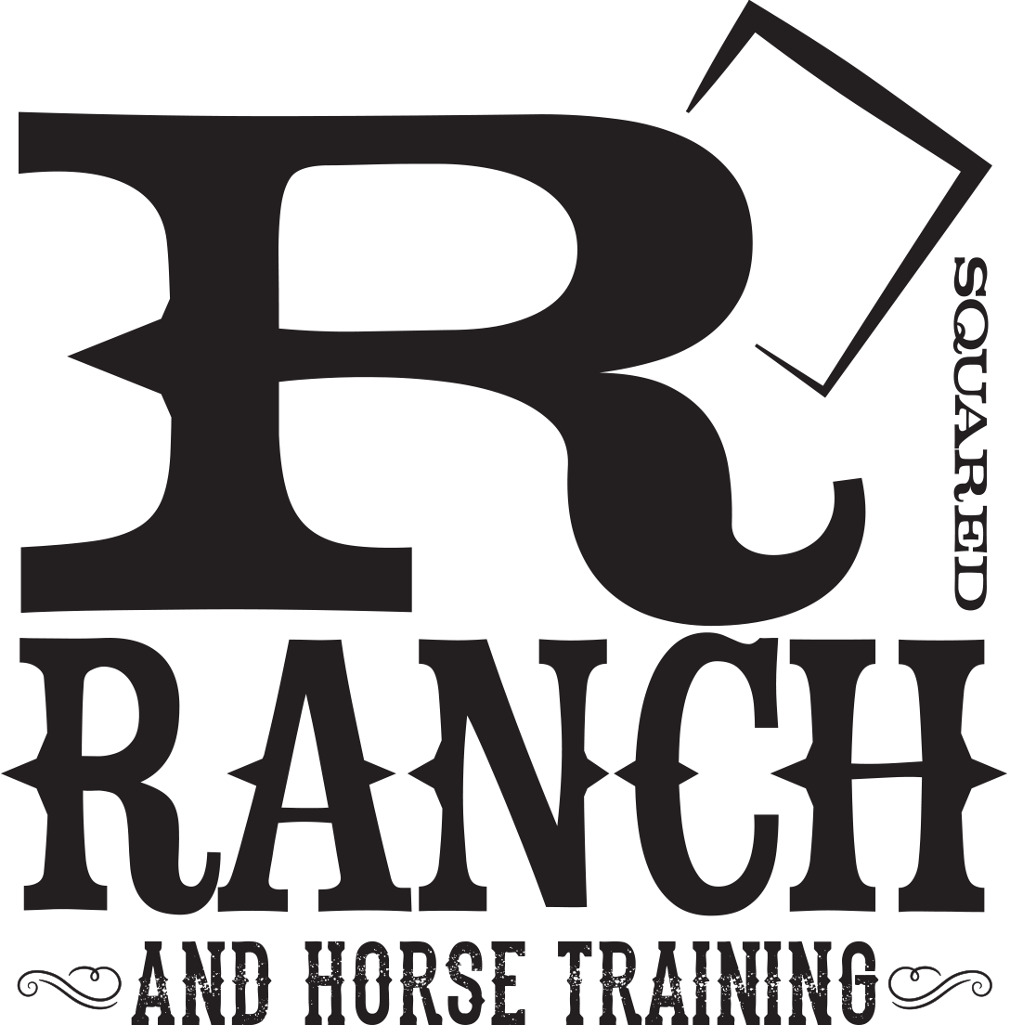
Cassie and Ryan Rose
R Squared Ranch
1791 235th St
St Croix Falls, WI
(651)851.5541
R2horsetraining@gmail.com

BREEDING CONTRACT: R2 Ninth Reserve aka Morty

This contract made and entered into this ________ day of __________________, by and among Cassie and Ryan Rose, dba R Squared Ranch, (“Farm”) and ______________________________________________ Mare Owner or Lessee. All rights and responsibilities between the parties are set forth in this contract.

- Mare owner agrees to breed mare named ___________________________, RMHA Registration # ___________________ and/or KMSHA Registration # ___________________, (“the Mare”), to R2 Ninth Reserve, RMHA Registration #2020486803
and KMSHA Registration #na, (“Stallion”)’ during the _______ breeding season.
- Mare owner agrees to pay a breeding fee of $1500.00 to have “the Mare” bred to the “Stallion” in _______ upon signing this contract. Mare owner also agrees to pay $590.00 for collection and shipping fees for each shipment of semen in the USA. Mare owner shall pay the breeding and collection fees prior to shipment of semen or prior to the mare departing the Breeding Facility (shipping fees apply in the case of Artificial Insemination only; fees are subject to change).
- Mare owner agrees to pay for care and feeding while in the custody of the “Breeding Facility” at a rate of __$10__per day.
- The following charges apply to Domestic Cooled Shipped Semen:
- The shipping container must be returned within 5 business days after insemination or a $35.00 per day fee will be charged.(unless specified)
- Please indicate if you agree to have your mare bred live cover.
(Y or N)_________

The following are Terms and Conditions for breeding the “Mare” to the “Stallion” via shipped cooled semen:

- Requests are filled in the order in which they are received.
- Request to cancel scheduled semen orders must be made to and confirmed by (“Breeding Manager”) no later than 6:00 AM CST the day of shipment. Any request to cancel made by the Mare Owner after this deadline will be assessed a fee (shipping fee) if the order has been processed.
- The semen container must be returned to address noted in container at Mare Owner’s expense within 5 business days after insemination. If container is not received within five (5) business days after insemination, Mare Owner shall be charged a $35/day rental fee. Mare Owner may supply their Equitainer provided it is well marked and is in good condition. (unless specified)
- Mare owner certifies that “Farm” is obligated to transport cooled semen only to the address of record which Mare owner has provided prior to any shipment. All shipments will be shipped to the address provided on “Shipped Semen Request Form”, unless otherwise communicated in writing to and confirmed by “Breeding Manager”. Mare Owner certifies that the address for shipment is a suitable facility for artificial insemination of Mare. The “Farm” may refuse to make repeated shipments if, as determined by “Farm”, it will not reasonably lead to a successful breeding. Moreover, Mare Owner certifies that only the Mare who is the subject of the breeding contract shall be inseminated by shipped cooled semen. If semen is used on a Mare not stated in the contract, Mare Owner shall owe additional fees to Stallion Owner
- The parties agree that the obligations of performance by Stallion Owner/”Farm” shall be met when the cooled semen shipment is accepted at Mare Owner’s designated shipment address. Acceptance shall be defined as the parcel delivery carrier actually delivering the shipment container to the address of record and receiving a signature from a representative of the address of record on the shipment documents maintained during the ordinary course of business by the carrier. The parties understand and agree that risk of loss transfers to the Mare Owner upon acceptance of delivery.
- Mare Owner Warrants that the mare is healthy, in sound breeding condition, and registered with the breed association listed on the “Shipped Semen Request Form”. “Farm” retains the right to require a negative uterine culture or equine cytology with sensitivity test for maiden and/or barren mares or any mare requiring more than two (2) semen shipments in a breeding season.
A current, legible copy of the mare’s RMHA and/or KMSHA registration papers must be attached to, and will become part of, this Agreement.
- All parties agree to diligently try to settle Mare. Should Mare not settle, Mare Owner will hold “Breeding Manager” and “Farm” harmless from any resulting loss or damage. “Breeding Manager” and “Farm” shall not be liable for any injury, sickness, disease or death of Mare or her offspring arising from the exercise of the breeding rights and privileges granted herein. Insurance is the responsibility of the respective parties of this Agreement. Also, Mare Owner agrees by signing below that if the mare is in the care of the “Breeding Manager” the “Breeding Manager” is authorized to consult with and obtain direction of a licensed veterinarian with regard to the care of the mare. Further, Mare Owner hereby authorizes Agent to obtain and follow a licensed veterinarian’s directions with regard to the mare and fully releases and hold harmless the “Breeding Manager”, the “Farm”, their respective officers, directors, employees, agent representatives, assigns affiliated persons, and/or others acting on their behalf. The “Breeding Manager” agrees to first make diligent attempts to contact the Mare Owner prior to seeking veterinarian direction.
Unless approved by Stallion Owner “Farm” in writing, the LFG “Live Foal Guarantee” shall be void and Stallion Owner “Farm” released from liability if “Mare” is sold prior to foaling. Contractual guarantees can only be extended by Stallion Owner “Farm” in writing to third parties. “Live Foal” means that the foal will stand and nurse. A foal that will stand, attempt to nurse but is rejected by “Mare” will be considered to be a “Live Foal” by this agreement. It is further agreed that should the mare be proven barren, abort the foal, or if the foal is stillborn, Mare Owner is entitled to return service for subsequent breeding season only to Stallion, provided that Mare Owner can prove the required prenatal care was given and the Mare Owner has remained in compliance with the terms and conditions set forth herein and all outstanding accounts with regard to the rights and privileges granted herein are paid in full. If a second shipment is necessary to settle the mare a $350.00 collection and shipping fee will be charged for the second shipment. If Stallion dies, sells or becomes unfit to breed before mare is bred, then the contract will be considered fulfilled. Refunds will be given at the sole discretion of Stallion Owner “Farm”. If the mare dies during breeding season, Mare Owner may substitute another mare upon written approval of alternate mare by both parties to this Contract. Stallion owner shall be released from the LFG and the LFG shall be void if:
a. Mare Owner fails to notify “Farm” with forty-eight (48) hours after time of foaling that a live foal was not produced; and
b. Within fourteen (14) days after such event, Mare Owner has not provided certification that foaling was properly attended and produce a veterinarian’s statement substantiating the failure of the mare to produce a live foal; or
c. The Mare is sold without notice to Stallion Owner
- At Mare Owner’s request, Stallion owner will issue a breeding certificate after the Mare’s sixty (60) day pregnancy check by licensed veterinarian and determined to be “safe in foal.” However, all charges must be paid in full prior to issuance of the breeding certificate. Mare Owner shall not sell or assign this breeding contract without prior written consent of Stallion Owner. There shall be no substitute without prior written consent of Stallion Owner. Any attempt to assign or substitute Mare without prior consent of Stallion Owner will terminate this Agreement and release Stallion Owner from all obligations contained herein.
- WARRANTY: NO WARRANTIES WHATSOEVER, EXPRESS OR IMPLIED, SHALL ACCOMPANY A BREEDING TRANSFERRED BY THIS AGREEMENT. NO GUARANTEE OF DELIVERY OF SHIPPED SEMEN WITH A CERTAIN TIME PERIOD OR GUARANTEE THAT SHIPPED SEMEN WILL SAFELY REACH THE INSEMINATION POINT.
- INDEMNIFICATION: Mare Owner shall be solely responsible for all acts and behavior of Mare at all times during this Agreement. In no case shall “Farm”, “Breeding Manager”, and their respective officers, directors, employees, agents representatives, assigns affiliated persons and/or others acting on their behalf be liable for the acts and behavior of Mare other than in the exercise of gross negligence or willful and wanton misconduct on the part of “Farm” and/or “Breeding Manager” in breeding, handling and/or keeping of the Mare. Mare Owner also hereby agrees to indemnify and hold “Farm” and/or “Breeding Manager” harmless against all damages sustained or suffered by any third person that were caused by the acts of the Mare or her foal.
- RELEASE AND HOLD HARMLESS: Mare Owner understands that every reasonable effort to ensure the safety of the “Mare” and foal will be utilized. Mare Owner agrees to release and hold harmless “Farm” and/or “Breeding Manager” and their respective agents, employees, representative, assigns, affiliated persons, and/or others acting on their behalf from liability for ordinary negligence relating to any and all injuries, damages, personal property damages or losses that Mare Owner may sustain arising out of being on the premises of “Farm” or “Breeding Manager” unless “Farm” or “Breeding Manager” caused the injury, damage or loss intentionally or in reckless disregard for the safety of the Mare Owner. Mare Owner agrees to release and hold harmless “Farm” and/or “Breeding Manager”, their respective agents, employees, representatives, assigns, affiliated persons, and/or others acting on their behalf from liability for ordinary negligence relating to any and all injuries, damages, personal property damages or losses that Mare Owner may sustain arising out of the breeding, handling, or keeping of the “Mare” at “Breeding Managers” location that may accrue from any cause whatsoever including, but not limited to, theft, fire, escape, running away, accidents, illness, injuries or death during the term of this Agreement or while mare is in the care and custody of “Breeding Manager”.
- This Agreement shall be construed in accordance with the laws of the State of Wisconsin and will inure to the benefit of the heirs, personal representatives, successors and permitted assigns of the parties. Mare Owner irrevocably and unconditionally submits to the personal and subject matter jurisdiction of Wisconsin. All venue objections are waived. Should “Farm” resort to legal action to enforce the terms of this agreement, “Farm” shall be entitled to all legal fees, costs and expenses should a dispute arise between the parties.
- This Agreement represents and constitutes the entire agreement between parties. This Agreement shall not be altered except in writing and accompanied by the signature of both parties. The parties signing below represent that they are fully authorized to execute this Agreement.
- The”Mare” will not be bred to the “Stallion” or semen released for shipment without a fully signed copy of this Agreement as well as the appropriate documentation having been received and approved by “Breeding Manager”.
- Mare Owner understands and agrees that the “Mare” will not be released from the “breeding Managers’” custody until all fees are paid in full.

_______________________________ _______________________________
Stallion Owner or Breeding Manager Date

Mare Owner/Agent ___________________________ Date

____________________________
LFG Authorized by Stallion Owner

