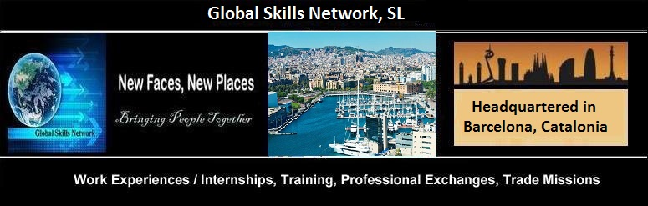
PARTNER SEARCH FOR KA-2 ERASMUS+ STRATEGIC PARTNERSHIPS
EDUCATION * TRAINING * YOUTH
FRAMEWORKS: 21ST CENTURY LEARNING AND TEACHING THROUGH PHENOMENON LEARNING
Reimaging Education in Primary and Secondary Schools Around Topics through Knowledge Building
Inquiries: Sandra Lund, M.Ed., Email: info@ErasmusActions.com

Partner Institution
PIC Number
Full legal name (National Language):
Full legal name (English):
Acronym:
National ID (if applicable):
Department (if applicable):
Address:
Post Code :
City:
Region: | Partner Search Application: FRAMEWORKS: 21ST CENTURY LEARNING AND TEACHING - 1
Country:
P.O. Box :
Website:
Email:
Telephone 1:
Telephone 2:
Fax:

Profile
Type of Organisation
Is the partner organisation a public body? | YES / NO
Is the partner organisation a No- Profit Organisation? | FOR PROFIT / NOT FOR PROFIT

Please briefly present your organisation (e.g. its type, size, scope of work, areas of specific expertise, specific social context etc.).

What age group of students do you teach? What is the primary subject you teach? (Please describe.)
Partner Search Application: FRAMEWORKS: 21ST CENTURY LEARNING AND TEACHING - 2

What educational methodologies are currently most utilized? (Please describe.)
Has your school participated in Erasmus+ Programmes or other European Projects?

Participation in EC projects in the three last years
EU Programme | Year | Project title and Number | Coordinator
 |  | Partner Search Application: FRAMEWORKS: 21ST CENTURY LEARNING AND TEACHING - 3

Legal representative
Title
Gender
First Name
Family name
Department
Position
Email
Telephone 1:

Contact person:
Title
Gender
First Name
Family name
Department
Position
Email
Telephone 1:

Comments:
Partner Search Application: FRAMEWORKS: 21ST CENTURY LEARNING AND TEACHING - 4

.-.-.-.-.-.-.-.-.-.
Global Skills Network
PIC 936464385 * CIF/TAX ID J66359399
Mailing address: Apartado Correos 19029 08027 Barcelona Spain
Email: info@erasmusactions.com
Visit us online at www.ErasmusActions.com
We’re blogging at www.ErasmusActions.net
Partner Search Application: FRAMEWORKS: 21ST CENTURY LEARNING AND TEACHING - 5
VETPRO and Hybrid Coursework Learning Portal: www.ErasmusActions.org

European Career Connections: www.europeancareerconnections.com

Europe Work Experience Portal: www.europeworkexperience.com

