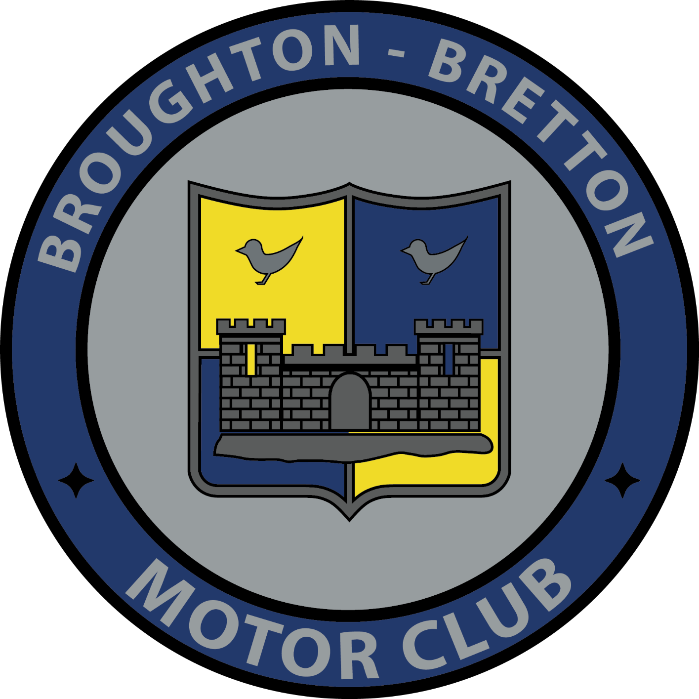
Broughton-Bretton Motor Club Ltd
Membership Application/Renewal Form
Registered Address: 8 Lawnt-Y-Pentre, Flint Mountian, Flint, Flintshire, CH6 5U
Membership runs from 1st January to 31st December and is £10.
Family membership is £15 (2 adults and 2 under 17) Junior Membership is £5 (under 17). Please fill in the details below and hand or email (b-bmc@hotmail.com) to a club official with payment for membership fee.
Name (s): ………………………………………………………………………………………….
Address: …………………………………………………………………………………………………………………..
………………………………………………………………………………………………………………………………….
Contact Number/Mobile: ……………………………………………………………….
Do you wish to be added to the Broughton-Bretton WhatsApp Group (Mobile Only and WhatsApp needs to be on downloaded to your phone): Yes / No
Email: ……………………………………………………………………..
Date of Birth(s): ……………………………….
Please tick:
Standard Membership (£10) |  | Family Membership (£15) |  | Junior Membership (£5)

New Application |  | Renewal
Which motorsport disciplines are you interested in:
Stage Rally |  | Road Rally |  | Targa Rally |  | Marshalling
Auto testing |  | Historic Rally |  | Racing/Go Karting |  | Other:

Cash |  | Cheque
Please make all cheques payable to Broughton-Bretton Motor Club
By signing below to join the club, you are also agreeing to abide by the rules and bylaws of Broughton – Bretton Motor Club and Motorsport UK. If you break or disagree with these rules or bring the sport into disrepute then you agree to forfeit your membership immediately. You are also agreeing to allow us use your detail as described in the clubs privacy notice, if you do not wish for us to contact you using any of you details please tick the box below“
Applicant Signature ……………………………………………..Parent/Guardian (if under 18 years old) : ………………………………………….
Proposed by Signature: ……………………………………….. Seconded by: ……………………………………………………….
GDPR/Data Protection: The information supplied on this form is used to administer your club membership in accordance with the Privacy policy on our website. PLEASE TICK THIS BOX TO CONFIRM YOU AGREE. You can change your mind at any time by just letting us know
You details will be kept for club use only and will not be shared to any 3rd parties.
For Office use only:
Form Complete: ………………. Paid:………………….. Cash/Cheque/BACS:……………………..
Membership card given or sent:………………. Membership Car Number: ……………………..
BROUGHTON-BRETTON MOTOR CLUB PRIVACY NOTICE
Broughton-Bretton Motor Club respects your privacy and we will only use your information in the way we describe in this notice. When using your information, we aim to be fair and transparent, and to follow our obligations under UK data protection laws. Your information is used for administering club membership, activities and competitions.
Broughton-Bretton Motor Club is the data controller for the purpose of GDPR and the Data Protection Act 2018. Our address is 8 Lawnt-Y-Pentre, Flint Mountain, Flint, Flintshire, CH6 5UN Our club contact for privacy and data is Mike Mckeown and the contact details are b-bmc@hotmail.com Tel. 07810 056782
Collecting your information: We collect your information when you fill in membership application or renewal forms, and competition event entry forms. You can give us your information using paper forms or online forms. The information you give us may include your contact details (name, address, telephone number, email address), personal information and identifiers (date of birth, membership number, competition licence number), and other information (vehicle details). When you give us information about another person, such as a child, parent, guardian, or emergency contact you should let that person know that you have given us the information.
If you are under 18 years old, we will also ask for information from your parent or guardian.
Using your information: We use your information when you first apply to become a member of Broughton-Bretton Motor Club and then to administer and renew your club membership, and provide you with member benefits. We also use your information when you enter club events. For competitions, we will publish some of your information in the programme and the results, which will be in the public domain. Your information is used in these ways to fulfil our contract with you.
We may ask you for emergency contact and next of kin details which we will only use in an emergency, and which is use for a legitimate interest. You should let the contact and next of kin know that you have given this information to us.
We might use your information to send you marketing messages by email, but only if you have agreed that we can do this by giving us your clear consent – and you can change your mind at any time just by letting us know. We will not sell your information to another organisation.
To support your lifetime relationship with motor sport and Broughton-Bretton Motor Club we may keep your information indefinitely, unless you ask us to delete it.
Sharing your information: We may share your information with the Motorsport UK as required by its General Regulations for governing motor sport, with other Motorsport UK Registered Clubs, with medical personnel, or any other person if we have to comply with a legal obligation. We may also share your information with service providers, for example to print programmes.
Our website/Social Media Pages: The club website and social media pages (ie Facebook) might contain links to other websites such as online entry and payment sites, partners, and advertisers. If you follow links to other websites please review the privacy policy for each site because we are not responsible for information you share on those sites.
Security for your information: Your information is held securely by us. We have taken all reasonable steps, and have in place appropriate security measures, to protect your information. Your information is not transferred outside the European Economic Area.
Your rights: You may ask us not to process your information for marketing purposes. You are entitled to a copy of the information we hold about you, and to ask us to correct any inaccuracies. You may ask us to stop using your information, and to delete it, although we maintain a skeleton set of your information. If you ask us to do this we will not be able to continue our contract with you. You may make a complaint to the Information Commissioner (www.ico.org.uk). This privacy notice was last updated on 17th October 2019, and we will communicate any changes to you.

