QUAD CITIES MISSING PERSONS NETWORK
MEMBERSHIP/PATRON FORM

You can support the Quad Cities Missing Persons Network as a Friend only, active Member, Patron, or Benefactor
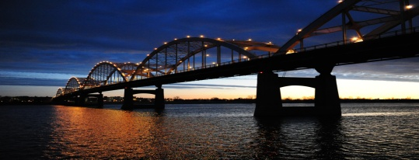

Name: _______________________________________________________________
Address: _____________________________________________________________
City: _____________________________ State:________________ Zip: _______
Phone: _____________________ E-mail: ________________________________
Cardholder: ________________________________ Visa: _____ MC: ______
Card # _________________________________ Exp Date: ____________/____
Signature: ___________________________________________________________
Put a checkmark beside your level of Membership or Patronage and, if necessary, fill in the amount of your gift
MEMBERSHIP
____ Friend of QCMPN (Will receive only
Facebook communications) No Charge
____ Student or Senior (over 65)Membership $10.00
Will receive newsletter
____ Individual Membership $20.00
Newsletter, T shirt (specify size and color Size:____
Safety green: ___ Orange: ___ White: ___
___ Supporting Patron $50.00-100.00 $_______
Newsletter, 2 T shirts or 1 sweatshirt (specify size and color
Size:____ Safety green: ___ Orange: ___ White: ___
Recognition in Annual Report
___ Benefactor $150.00 and up $_______
Newsletter, 2 T shirts or 1 sweatshirt (specify size and color
Size:____ Safety green: ___ Orange: ___ White: ___
Free attendance at am event of your choice:
Annual Banquet ___ Trivia Night Table (for 8)____
Recognition in Annual Report

