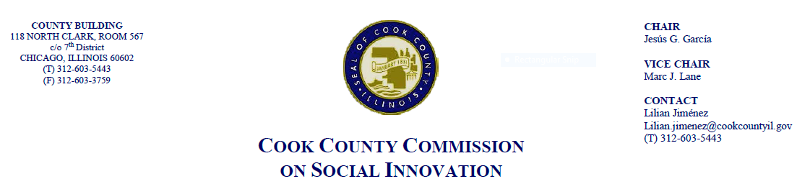September 25th, 2018, 4 P.M.
Cook County Board Room
118 N. Clark, Room 569
Chicago, IL 60602

MINUTES

- Call to Order

The Cook County Commission on Social Innovation convened via an in-person meeting to discuss committee updates and hear from a guest speaker. The meeting was chaired by Chairman Garcia. The meeting was open to the public and took place from 4:16 p.m. to 5:37 p.m.

Commission Members Present:
- Chairman García
- Vice Chair Marc Lane
- Harold Rice
- Xochitl Espinosa
- Wendy Raymer
- Victor Dickson
- Morgan Malone
- Howard Males
- Jay Stewart
- Ald. Susan Sadlowski-Garza (proxy)
- John Yonan (proxy)
- Marc Loveless

Commission Staff Present:
- Victoria Moreno
- Alma Anaya

Public Speakers:
- George Blakemore
- Renee Hatcher

- Approval of the Minutes
- Commissioner motioned the approval of the minutes from August 16th. Commissioner Males seconded the motion and it was approved by a voice vote.

- Committee Updates

Social Capital Committee
- Commissioner Dickson described the Social Capital Committee’s recommendation for an Office of Returning Citizen Affairs in Cook County, but a member of the Board of Commissioners has expressed interest in taking this on separately, outside of the Commission on Social Innovation
- Commissioner Dickson is working on a draft resolution for the Office on Equity and Inclusion

Financial Capital Committee
- Comm. Garcia called for consideration of the Worker Cooperative Proposed Resolution.
- Comm. Raymer commented that they have great hopes for it is be passed and implemented. The worker cooperative community is looking to this as a sign of legitimacy for their goals in upcoming years.
- The Commission voted to approve the Resolution and will be introduced to the Board of Commissioners at the Sept. 26, 2018.

- Guest Speaker: “Independent Film-making”
- Mark Armstrong and Rujanee Mahakanjana of the Chicago Film Action Board
  - Presentation with a focus on how to strengthen the field of filmmaking in Cook County
  - There is an epidemic of invisibility in this field with women, minorities, LGBTQ, and people with disabilities
  - CFAB works to assist teens with development and opportunities in this area and is exploring how to expand these partnerships
  - Especially in the digital age, people are looking at film for education – sexual harassment, job safety, etc. This seems to be a need in Cook County, especially in social engagement.

Post-Presentation Discussion
  - Comm. Loveless is on board of Reelings Film Festival and committed to working with this group to expand opportunities for film-making with a social justice lens
  - Comm. Malone stated it’s important to also consider building funding and other sustainable resources
  - Ismael Cuevas (on behalf of Comm. Garza) – suggested thinking about opportunities for students to access film school. More people are using social media for film. How to integrate this?
  - County currently doesn’t receive tax credits for the film-making that does take place in Chicago. There is a need to look for ways to keep the revenue here.

- Adjourn
  - Commissioner Males moved to adjourn, seconded by Commissioner Rice. Meeting was adjourned at 5:37pm.

