Rock City Church Unoffendables
Curriculum

Contents

Introduction………………………………………………………………………..........Page 4

Table of Contents

Lesson 1: “A Clean Heart”……………………………………..………………….....Page
Lesson 2: “It’s Not Fair”...........…………………………………………………….. Page
Lesson 3: “Mad at Dad: When Fathers upset us.…………………………..Page
Lesson 4: “Don’t Quit, Stay and Obey”………...…………………………….....Page
Lesson 5: “Stronger than the Giants”…………………………………………..Page
Lesson 6: “A Precious Stone”…………..…………….………………………........Page
Lesson 7: “Building others up”..………………………………..…………..........Page
Lesson 8: “Forgiving others” ………………………...........................................Page
Lesson 9: “He is My Defender”………….………………………………………...Page
Lesson 10: “Don’t Judge Others”……………………………………………........Page
Lesson 11: “Getting It Right”.........………………………………………………..Page
Lesson 12: “Will you Forgive Me?”……………………….................................Page
Lesson 13: “Walking in Forgiveness”…………………………………………...Page

Don’t Quit, Stay and Obey
Daniel 3:4-6, 16-18, 24-25, 30

GODS GENERALS FALL LESSON 4
AGE: ELEMENTARY 9-11 YEAR OLDS
Adopted From Bait of Satan by John Bevere

Lesson Topic:
Key: Offense blocks spiritual growth, but suffering and obedience take us to a deeper relationship with the Lord and others.
LESSON | WHAT CHILDREN DO | SUPPLIES | PREPARATION
1  Getting Started | Introduction/Ice Breaker:  Mixed Up Messages– In the style of Simon says, teacher gives instructions to class, and they are supposed to do the opposite. The class discusses what it was like to obey the leader, even when the instructions are difficult to follow. | List of “mixed up” instructions for the children to follow. | Teacher makes list of 5-10 mixed up instructions for the children to follow. Ex: Stand Up, sit down, stand still, open your eyes, etc.
2  Bible Exploration.  Key Verse Activity | Key Verse: Philippians Daniel 3: 4-6, 16-18, 24-25, 30  Bible Story:  When we obey God, even when it is difficult, we grow in God.
 | Bible Activity: Write it Out.  Children answer discussion questions following the lesson, regarding obedience. | Paper  Pencils/pen
 | Act it out.  Children break into groups, then create scenes based on their answers to Discussion question # 4 -  Can you think of a time when you had to choose not to quit, but to obey a leader, even though it was hard? | N/A
LESSON | WHAT CHILDREN DO | SUPPLIES  NEEDED | PREPARATION OVERVIEW
3  Weaving Faith  Into Life | Craft/Make and Take:  Firey Furnace Bible Craft (Adapted from https://www.123homeschool4me.com/2014/12/fiery-furnace-bible-craft-for-kids_18.html)  Children create firey furnace craft, with Shadrach, Meshack and Abed-Nego figures. | For each student:  - brown paper bag  - a sheet each of red, yellow and orange construction paper  - White paper to create Bible characters puppets  - Scissors  - Tape  - 3 straws. | Create completed sample for the class to see (optional)
Object Lesson/Activity:
See “Additional Activity”.

 | Additional Activity:  The Firey Furnace Game  http://catholicblogger1.blogspot.com/2010/01/fiery-furnace-game.html | - board game  - game pieces  - game questions  - directions | - Teacher pre-prints directions and glues to front of a file folder  - Teacher prints game board and glues to the inside of the file folder  - Teacher pre-prints sample questions (See below), or creates their own questions  - Teacher pre-prints “flame tokens”
Daily Challenges:
Children are challenged to make daily decisions to obey God, even when it is difficult.
4  Lasting Impressions | Prayer Points:  Children pray to God for help to obey, in the midst of suffering, because it brings us closer to God.
 | Faith at Home:  Talk about how to share what they learned with their families. Children are encouraged to keep a journal of how they practice obedience, even when it involves suffering. |  | What parents can do at home: Encourage children to study Daniel 3: 4-30, and to keep a journal.
Lesson Topic: Don’t Quit, Stay and Obey.

Lesson Background/Foundation for Teachers: When considering our leaders, and their work, we must remind ourselves that their instruction is God-ordained, and spirit-led, and God expects our obedience to their instruction to be immediate and without constraint.

Jesus provides the best example to us of this radical obedience, obtained through the “classroom of suffering”.

Philippians 2:5-9
In your relationships with one another, have the same mindset as Christ Jesus:
6 Who, being in very nature[a] God,
did not consider equality with God something to be used to his own advantage;
7 rather, he made himself nothing
by taking the very nature[b] of a servant,
being made in human likeness.
8 And being found in appearance as a man,
he humbled himself
by becoming obedient to death—
even death on a cross!
9 Therefore God exalted him to the highest place
and gave him the name that is above every name,
It cannot be argued that Jesus innocently suffered and died the most torturous death, in obedience to the Father. Jesus had the power to rescue himself from His crucifixion, yet He chose not to quit, but to endure it, because He had a purpose.

In Daniel 3:1-30, we read about Shadrach, Meshach and Abednego, who lived in Babylon, at a time when and King Nebuchadnezzar ruled over the land. The king expected everyone to bow down to worship a statue, and made it illegal for anyone who refused. The penalty for disobeying the law was to be thrown into a fiery furnace.

Shadrach, Meshach and Abednego refused to worship the statue, and instead, chose to obey God’s rule regarding idols.

Deuteronomy 5:8-9
“You shall not bow down to them or worship them”

Faced with the threat of death, Shadrach, Meshach and Abednego still chose to obey God rather than the king. God rewarded their obedience by protecting them when they were thrown into the fire. When the king saw that God protected them, Shadrach, Meshach and Abednego were rewarded with a promotion. The king also told everyone to honor the God of Shadrach, Meshach and Abednego.

When we remember that our pain has a “purpose”, in our case, to draw us closer to our Lord and Savior, Jesus. In the case of Shadrach, Meshack, and Abednego, they also received greater favor. We can be assured that when we obey with endurance as the characters in our lessons, we grow in God.

Introduction Activity “Mixed Up Messages”
Supplies Needed: List of teacher-created “mixed up” instructions for the children to follow.
Directions:
In the style of Simon says, teacher gives instructions to class, and they are supposed to do the opposite. The class discusses what it was like to obey the leader, even when the instructions are difficult to follow.

Praise & Worship:
- Song 1: Trust and Obey – Hillsongs Kids
- Song 2: Super Strong God – Hillsongs Kids

Key Verse: Daniel 3: 4-6, 16-18, 24-25, 30

Bible Story:
- Scripture Reference: Daniel 3:4-6, 16-18, 24-25, 30
- Narrative of Story:

Do you know what the word “obey” really means? The Biblical word for “obey” comes from the Greek “hupakou” which means to listen attentively; by implication to heed or conform to a command or authority. This word conveys the idea of actively following a command. There is no choice in the matter, it is to be done whether one agrees with it or not. Obedience is involuntary.

In the culture we live in, the word “obedience” is portrayed as negative, but this should not be so amongst God’s people. Obedience to God’s Word, and God’s appointed (I.e. choice, selected, approved) leaders helps us to grow in God. When we obey those who lead us, and they talk to God about us, they can “do it with joy”.

“What if that leader is wrong?” This is a good time to look at the example of Jesus. We can all agree that Jesus was falsely accused, suffered and died. At any point, He could have used His power as God to free Himself from His captors, avoid the cross, and His eventual death. But Jesus’ pain has a “purpose” - to rescue us all from the sting of sin, and to secure eternal life for all those who chose to follow Him. Our obedience does not have to be to death, because Jesus already accomplished that victory, once and for all. For us, the purpose is to grow in our relationship with Him.

In our story, King Nebudkenezzar made a law that everyone in his kingdom had to worship a golden statue, and those that did not, would be thrown in a firey furnace.

Daniel 3:4-6 New Revised Standard Version (NRSV)

4 the herald proclaimed aloud, “You are commanded, O peoples, nations, and languages, 5 that when you hear the sound of the horn, pipe, lyre, trigon, harp, drum, and entire musical ensemble, you are to fall down and worship the golden statue that King Nebuchadnezzar has set up. 6 Whoever does not fall down and worship shall immediately be thrown into a furnace of blazing fire.”

When the king discovered that three Jews, Shadrack, Meshack, and Abednego would now bow down to the statue, he was outraged, and ordered that they be thrown into the furnace. But Shadrack, Meshack and Abed-nego were of a “different spirit”. They were not afraid, because they knew that they had to obey God, and refuse to worship the golden image, even if the consequences could lead to death.

Daniel 3:16-18
¹⁶ Shadrach, Meshach, and Abed-Nego answered and said to the king, “O Nebuchadnezzar, we have no need to answer you in this matter. ¹⁷ If that is the case, our God whom we serve is able to deliver us from the burning fiery furnace, and He will deliver us from your hand, O king. ¹⁸ But if not, let it be known to you, O king, that we do not serve your gods, nor will we worship the gold image which you have set up.”

Because of their obedience, and much to the King’s surprise, God delivered the three men from certain death, and the King was forced to acknowledge God.

Daniel 3: 24-25
²⁴ Then King Nebuchadnezzar was astonished; and he rose in haste and spoke, saying to his ^{[d]}counselors, “Did we not cast three men bound into the midst of the fire?”
They answered and said to the king, “True, O king.”
²⁵ “Look!” he answered, “I see four men loose, walking in the midst of the fire; and they are not hurt, and the form of the fourth is like the^{[e]} Son of God.”

²⁸ Nebuchadnezzar spoke, saying, “Blessed be the God of Shadrach, Meshach, and Abed-Nego, who sent His Angel^{[g]} and delivered His servants who trusted in Him, and they have frustrated the king’s word, and yielded their bodies, that they should not serve nor worship any god except their own God! ²⁹ Therefore I make a decree that any people, nation, or language which speaks anything amiss against the God of Shadrach, Meshach, and Abed-Nego shall be cut in pieces, and their houses shall be made an ash heap; because there is no other God who can deliver like this.”

The obedience of Shadrach, Meshach and Abed-Nego impacted the kings so greatly, that the entire kingdom was affected, and the three men received a promotion.

Daniel 3:30
³⁰ Then the king ^{[h]}promoted Shadrach, Meshach, and Abed-Nego in the province of Babylon.

You may be thinking, “Obedience is too hard. And I don’t want to endure any suffering for it, that’s for sure. Isn’t there another way?” It is natural to try to avoid the unpleasant nature of suffering.

But obedience is God’s “vehicle” of choice along the road of discipleship. If we don’t obey God, we cannot be in His Kingdom. In John 14: 15-16, God promises to send us a “Helper”, the “Holy Spirit”, to give us the strength we need to “stay and obey”. God, our Father, is watching to see if, even when the choice to obey is difficult, we will trust Him to “work out” everything for our eventual good.

Philippians 2:5-9, and then have the children break into groups to discuss the lesson further, having one person in each group designated to record the answers to the following discussion questions.

Discussion Questions:
- Was it right for Shadrach, Meshach and Abed-Nego to disobey the king’s law?
- How did God protect them?
- How did God reward them?
- Can you think of a time when you had to choose not to quit, but to obey a leader, even though it was hard?

Bible Activity: Act it Out

Children break into groups, then create scenes based on their answers to Discussion question # 4 (see above.)
Game/Object Lesson:

Craft/Make & Take: Firey Furnace Craft (adapted from https://www.123homeschool4me.com/2014/12/fiery-furnace-bible-craft-for-kids_18.html)

Supplies Needed:

- brown paper bag
- sheet each of red, yellow and orange construction paper
- White paper to create bible characters puppets
- Scissors
- Tape
- 3 straws

Directions:
- Draw and color 3 Bible characters (Shadrach, Meshach, and Abednego).
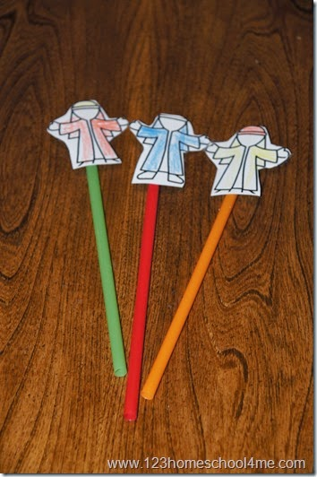
- Cut out the figures and tape each one to a straw.
- Cut 4 strips of the sheets of paper, vertically.
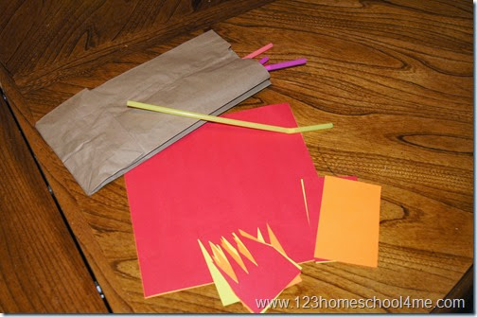
- Now cut paper in squares, then make jagged fire in the middle of the squares.
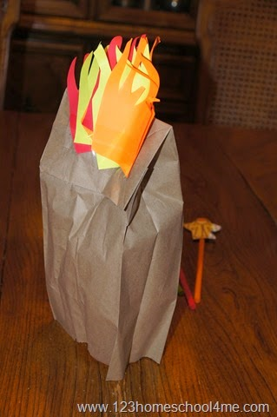
- Tape several colored squares to the back of your brown paper sack to the “bottom” part of the bag.

- Cut a circular hole in the front of your bag. Insert several sheets of “fire” construction paper through the bottom of your window and staple or tape in place.
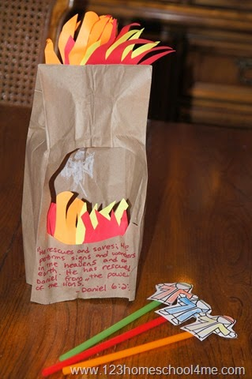
- Insert the blue Shadrach, Meshach, and Abednego puppets through the bottom of the bag to put them in the “fire”.
- Use white crayon to draw an angel on the inside (back) of the window opening.

Additional Activity:
  - Title: The Firey Furnace Game (excerpted from http://catholicblogger1.blogspot.com/2010/01/fiery-furnace-game.html
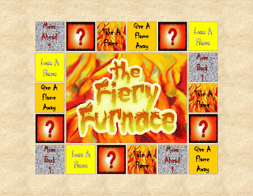

- Directions: Children form teams to answer board game questions on today's lesson. If the team answer questions correctly about the Bible story, they receive a flame token.
- Land on a “Take A Flame”, you can take a flame token from any player.
- If you land on “Lose A Flame”, you must return a flame token.
- If you land on “Give A Flame Away”, you must give one of your flame tokens to another team.
- Teams work their way around the board and try to collect flame tokens.
- The first team to collect 7 flame tokens (to represent the seven times King Nebuchadnezzar ordered the furnace to be heated more than usual) wins.

Sample Questions:

Where did King Nebuchadnezzar put the statue?
(On the plain of Dura in the providence of Babylon.)

Fill in the Blank:
King Nebuchadnezzar had the people make a huge golden ________.
(statue)

True or False:
King Nebuchadnezzar made a statue out of stone.
(False)

When the people heard the sound of musical instruments, what were they ordered to do? (Fall down and worship the golden statue which King Nebuchadnezzar had set up.)

Fill in the Blank:
Whoever does not fall down and worship shall be instantly cast into a white-hot _____. (furnace)

Who would not worship the statue?
(Shadrach, Meshach, and Abednego)

How many would not worship the statue?
(3)

What did the king do when he found out that they would not worship the statue?
(The king flew into a rage and sent for Shadrach, Meshach, and Abednego.)

True or False:
When the king questioned them he said, “Is it true that you will not serve my god, or worship the golden statue that I set up?” (True)

True or False:
These three men burned up in the white-hot furnace.
(False)

What wouldn’t Shadrach, Meshach, and Abednego do for any other god?
(Worship them.)

True or False:
When they came out of the furnace they were unharmed.
(True)

When the music started to play, what were the people ordered to do?
(Fall down and worship the golden statue which the king had set up.)

When were the people supposed to bow down to the statue?
(When the music played.)

What did Shadrach, Meshach, and Abednego do when the music started playing?
(They did not fall down and worship the king’s god.)

Why did Shadrach, Meshach, and Abednego have the courage to refuse to bow down to the statue? (They had faith that God could save them.)

What would happen to someone who was caught not worshiping the image?
(They were thrown into the furnace.)

Who did the king praise after they came out on the furnace completely unharmed?
(God)

What happened to the men who threw Shadrach, Meshach, and Abednego into the furnace? (The flames burned them up.)

What book in the Bible did this story come from?
(Daniel)

What did the three men do when they were thrown into the furnace?
(The walked about in the flames, singing to God and blessing the Lord.)

Who went down into the furnace and drove the fiery flames out?
(An angel.)

What did the king hear when the men were in the furnace?
(He heard them singing.)

When the king looked into the fiery furnace how many men did he see inside?
(4)

Who was the other man in the furnace that the king saw?
(An angel.)

Why did the 3 men say to the king that there was no need for them to defend themselves? (Because they had faith that God could save them.)

The king became so mad that they would not worship the golden statue so he ordered the furnace to be heated up how many more times than usual? (7)

True or False:
The men were not bound when they were thrown into the furnace.
(False)

Fill in the Blank:
The three men were Shadrach, Meshach, and ____.
(Abednego)

Fill in the Blank:
The three young men worshiped ___.
(God)

How many men were thrown into the fire?
(3)

How did it feel inside the furnace when the fire was driven out?
(Like a dew-laden breeze was blowing through it.)

Why didn’t Shadrach, Meshach, and Abednego bow down to the statue?
(God does not want us to worship anything or anyone other than Him.)

True or False:
King Nebuchadnezzar gave orders throughout the country over which he ruled that no one should say anything against the God of these three Hebrews. (True)

True or False:
The king gave the young men better positions than they had before.
(True)

True or False:
When the king looked into the furnace, he thought one of the men was Daniel.
(False)

Closing Activity & Prayer:
- Call to Action: We must obey God, and those in authority over us, as Jesus did.
- Prayer: We would all like to believe that if were in Shadrach, Meshach, and Abed-Nego's “shoes”, we would have trusted God, without fear. They had to surrender their fear, for faith, fully trusting God, when faced with what could have ended in death. Pray - “Lord, help us to surrender all in obedience to You, and to offer ourselves as vessels willing to suffer for Christ. “

Faith At Home:
- Description: Children are encouraged to study, practice obedience and reject the spirit of offence, and to keep a journal.
- Challenge: Read Daniel 3. 4-30. Keep a journal of each time God helped them to be obedient, even when it was hard, just like Shadrach, Meshach, and Abed-Nego.

