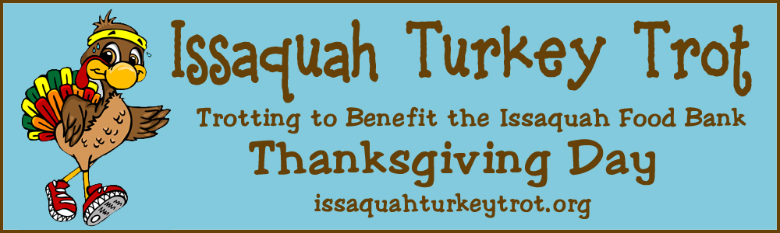
Issaquah Turkey Trot Sponsorship Proposal
New ROUTE – Through downtown Issaquah!
The Issaquah Turkey Trot is a fun & casual 5K on Thanksgiving morning. There are no prizes, timing chips or numbers. The purpose is to come together during the Thanksgiving holiday and help those in need in our community. All proceeds from the Turkey Trot go to the Issaquah Food and Clothing Bank. This year we are expecting 4,000 participants. Please join us as a sponsor of this great family event and help provide for those in need.
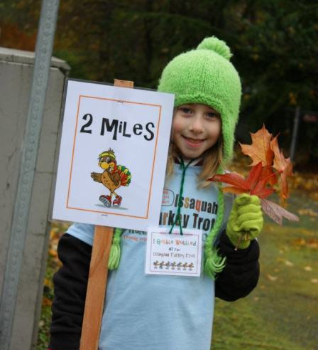
WWW.ISSAQUAHTURKEYTROT.ORG
Turkey Trot Sponsorship Levels
 | Big Tom Turkey Sponsor  $5,000 | Mashed Potato Sponsor  $2,500 | Stuffin  Sponsors  $1,000 | Pumpkin Pie Sponsors  $500
Announcer at  Race Start | X
Website Main Page | Logo
Race T-shirt | Large  Logo | Medium  Logo | Small  Logo | Company Name
Website Sponsor Page | Logo | Logo | Logo | Logo
Social Media Recognition | X | X |  | Issaquah Food Bank  - Serves individuals and families living in the Issaquah School District boundaries  - Serves over 50,000 individuals and 15,000 families a year; 60% of those are children and seniors.  - Other Special Programs Include – Summer Lunch Program, School Supply Drive, Holiday Gift Program, and many more!  Visit The Issaquah Food Bank’s website to learn more:  www.issaquahfoodbank.org
Sponsor Listing and Link on Emails to Trotters | X | X | X
Sponsor a Gobble Wobble Station along the route on Thanksgiving morning. | X | X | X
Booth and/or Banner at the Start/Finish Line | X | X | X | X
Complimentary Entries | 50 | 20 | 10 | 5
For More Information on Sponsorship, Please Contact:
Cori Walters,425-392-4123 ext. 12
Cori@issaquahfoodbank.org
Tom Matthews, 425-985-1231
tom.matthews@issaquahturkeytrot.org

