New Target On The Pistol Range

There are now 4 steel plates for use on the pistol range
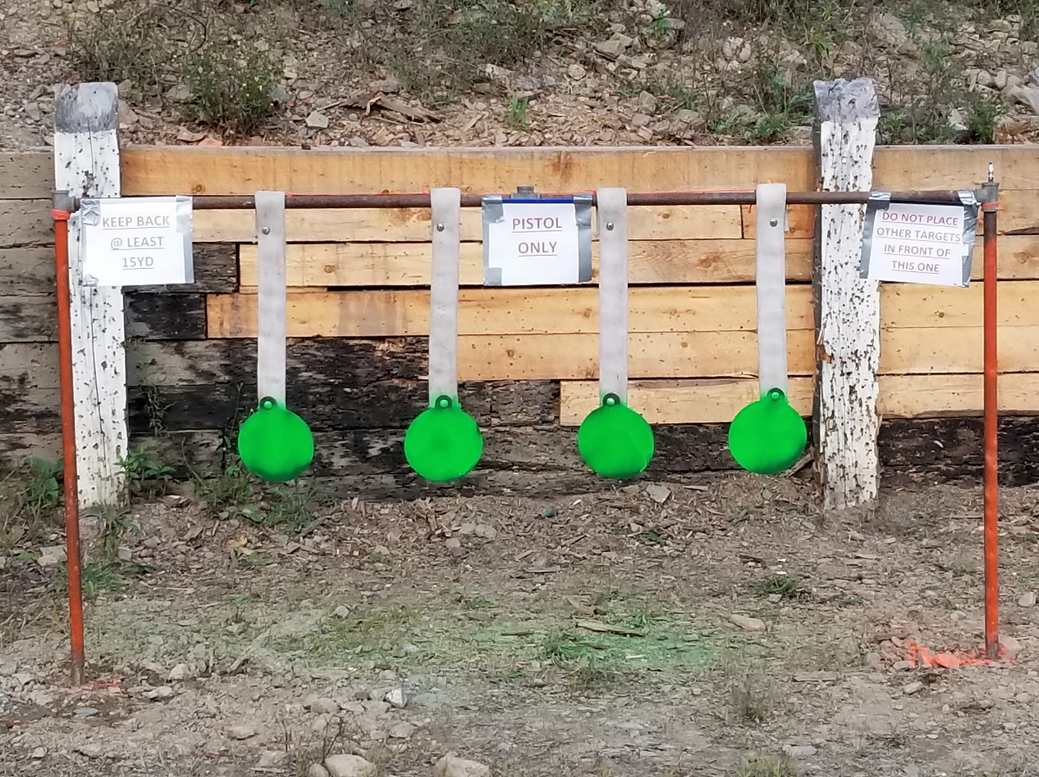
Please follow the basic safety rules when shooting these steel targets

- PISTOL ONLY – no magnum or +P loads please
- Stay back at least 15 yards
- Ear and eye protection is required as always
- Do not place other targets in front of this target, someone already has, and dented the heck out of the one post

