THIRTY-SECOND SUNDAY IN ORDINARY TIME
NOVEMBER 10-11, 2018
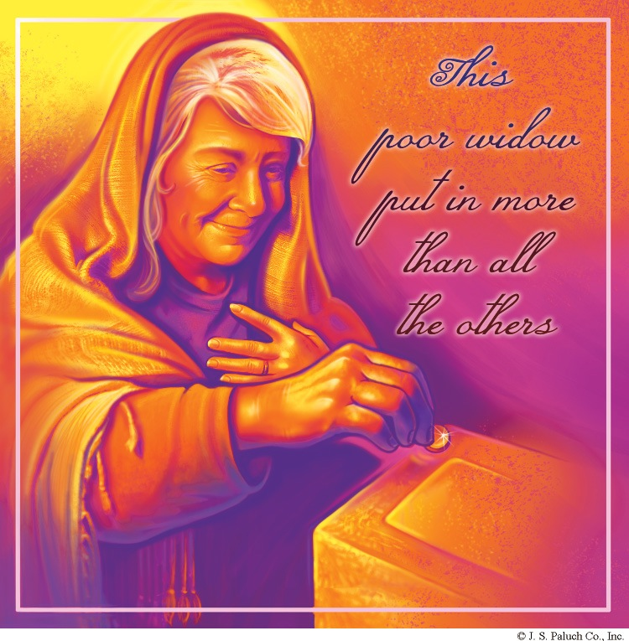
THE CALL TO DISCIPLESHIP
The core vocation in Gospel of Mark is the vocation, or call, to discipleship. Today’s Gospel passage provides us with one last example of what it doesn’t mean. A destitute widow shows us that discipleship means following Jesus’ way of service, even if it requires giving one’s livelihood (or life). The scribes show us by their bad example that discipleship should entail a vocation to extend God’s care to those who are most in need.
In our reading from the Book of Kings, another widow and her son are close to death. They too give what little they have, but Elijah rewards them with food enough for a year. And the reading from the Letter to the Hebrews reminds us that Jesus sacrificed his life “to bring salvation to those who eagerly await him” (Hebrews 9:28).

CATHOLIC CHURCH HIERARCHY
By: Dennis Tavares

All the Church’s popes, bishops, priests, and deacons of the last 2,000 years flowed from the first Holy Orders from Jesus to His apostles. These Orders were to take the Good News of salvation to the ends of the Earth, and to spiritually feed and care for His sheep-flock of believers through time. The authority that flowed from Jesus to the Apostles through the Holy Spirit, and then to their successor bishops has kept the Catholic Church on her mission for 2,000 long years, through good times and bad times, through heresies and schisms, through political upheavals and wars, and through many personal failures of the shepherds and the flock. The deep faith of the Catholic laity, in union with bishops and their helpers, the many priests, deacons, and religious orders of men and women, is proof that love conquers all things in all times.

PASTORAL RUMINATIONS
By Fr. Andre Querijero

The recently brutal massacre in Pittsburg’s Tree of Life Jewish synagogue leaving 11 dead and 6 innocent congregants injured, shocked and stunned us. In solidarity with our peace-loving Jewish brethren of the Mendocino Coast Jewish Community in Caspar, CA, I reached out to Rabbi Margaret Holub emailing her the following message.

Dear Rabbi Margaret:

From my Catholic faith community at Our Lady of Good Counsel in Fort Bragg to our Jewish brothers and sisters, we send you our prayerful condolences and love.May God’s “Hesed” suffuse our hearts and subdue the evil of hatred and bigotry in our midst.

One with you in prayer,

Fr Andre Querijero

Here is the Rabbi’s reply.

Dear Reverend Querijero,

Thank you so much for your words of hesed to our Jewish community. They bring tears to my eyes as I read them. I know they will when I share your note with our Jewish community.
I am deeply grateful for all the friendship that has been shown to me and to our community this past week. May you and your congregation also be well.

With love,

Margaret

As of this writing, another mass shooting has occurred at Thousand Oaks Bar in Southern California killing at least 12 people. Although the motive for this cold-blooded destruction of lives is not known yet, our parish community join the entire nation in denouncing any form of violence emanating from lies and divisiveness, fanatical racism and irrational rage.

WEEKLY COLLECTION
NOVEMBER 3 & 4, 2018… $2,102.00
LIABILITY INSURANCE.. $783.00

THIS WEEKEND’S SECOND COLLECTION: MAINTENANCE FUND
NEXT WEEKEND’S SECOND COLLECTION: COMMUNICATION & CATHOLIC UNIVERSITY OF AMERICA COLLECTION
THANK YOU
FOR YOUR SUPPORT & CHRISTIAN GENEROSITY
THE LIFE OF SAINTS:

SAINT JOHN BOSCO
JANUARY 31
PATRON OF EDITORS

God of mercy, you called St. John Bosco to be a father and teacher of the young. Grant that, inspired by his ardent charity, we may serve You alone and never tire of bringing others to Your Kingdom.

When he was a boy, John learned many tricks by watching circus men. He gathered boys around him and put on little shows. Then he repeated the sermon he had heard in church.
At thirteen John left home and went to work with a farmer, then a tailor, a baker, a shoemaker, and a carpenter. In this way, he worked himself through college and seminary, and became a priest.
Boys loved Father John. He found places for them to meet, to play and pray. When neighbors complained about the noise, Father John rented an old barn in a field. He called it “The Oratory.” He started many of his oratories. He believed that prayer and the sacraments are the best ways of making boys good.
John Bosco also founded the Religious Order of Salesians, a group of priests who would help him in his work for boys. They went also to other countries to educate boys. Father John set up shops of all kinds to teach boys different trades. He wrote many booklets and the boys printed them and sent them out for people to read.
Father John died at the age of seventy-three in 1888.

READINGS FOR THE WEEK:
Monday: Ti 1: 1-9; Ps 24: 1 b-4ab, 5-6; Lk 17:
1-6
Tuesday: Ti 2: 1-8, 11-14; Ps 37:3-4, 18, 23,27,29; Lk 17:7-10
Wednesday: Ti 3: 1-7; Ps 23: 1b-6; Lk 17:11-19
Thursday: Phlm 7-20; Ps 146:7-10; Lk 17:20-25
Friday: 2 Jn 4-9; Ps 119:1-2, 10-11, 17-18; Lk 17:26-37
Saturday: 3 Jn 5-8; Ps 112:1-6; Lk 18:1-8
Sunday: Dn 12: 1-3; Ps 16:5, 8-11: Heb 10:11- 14, 18; Mk 13:24-32

PRAY FOR OUR FAMILY AND FRIENDS THAT ARE IN THE MILITARY SERVICE
José Araiza Jr., Edgar Toscano, Marina González, Alondra Jara, Sonia Jara, Jason Lorenz, Matt Mill y Jared Schroeder

MASS INTENTIONS
NOVEMBER 14-18, 2018
Wednesday (14)  Thursday (15)  Friday (16)  Saturday (17)  Sunday (18) | 12:05pm  12:05pm  12:05pm  5:00pm  6:30pm  8:00am  10:00am | Ruth Cimolino †  John & Esther Domenici †  Bruno & Mayme Donati †  Fred & Clara White †  Lupe Becerra †  Jesús Becerra †  Arturo Martinez †  Allison Leigh Downing †  Brian Serpa †  Prachak & Siriwon Sripramong  (Anniversary)  John & Edith Cimolino †

PLEASE PRAY FOR OUR SICK PARISHIONERS
Betty Cox, Lisa Wright, Ricardo Contreras, Florencia Chávez, Refugio Yáñez, Tarcicio Garía, Sofía García, María de Jesús Mendoza, Ana García, Antonio Cazares, Evelyn Costa, Ryan Moore, Eileen Seeman, Marianne Brannan, Lilia Parrish, Nancy Smith, Julián Palomar, Luisa Martínez, Jennifer Vera, John Braet, Kim Koskinen, Margaret Valencia, Matthew Marcoulier, Dennis Tavares, Jose Freitas, Alfredo Sousa, Juana Arreguín, Aron Yasskin, Victoria Walzer, Fidela Yáñez Jara, Erika Ramos, Bill Gibson, Carla Tomas, Erasmo Yáñez, Memo Soria, Patricia Vargas, Fidela Yáñez, Elvia Flores, Camila Blanco-Cherrez, Yonel Ruíz, Angie Freitas, Russel Bryant, Derrick Heater, Luis Angel, Juan Barrera-Terán, Gabriel Hurtado, Gerald Butler, Helen Reynolds, Toni Clark, Ann Gallagher, Brianna Lopez, Margaret Milliken, Gina Pivirotto, Nick Quin, Mary Servis, Denis Sousa, Victor Venegas, Matty Walker, Charles Lorenz, Rebecca Lorenz, Ofelia Ibarra, Leonardo Naal, Gina Leal.

MEMORIAL TREE
IN THE VESTIBULE OF OUR CHURCH, ON THE SOUTHERN WALL, IS A BEAUTIFUL MEMORIAL TREE. ITS BRIGHT LEAVES REPRESENT PERMANENT MEMORIALS TO THE DEPARTED OF OUR PARISH.
FOR THE SUM OF A ONETIME PAYMENT OF $200.00, YOU CAN GIVE TO THE PARISH SECRETARY THE CORRECT SPELLING AND DATES OF THE DEPARTED AND IN DUE TIME, THE LEAF IS PRINTED AND ATTACHED TO THE TREE: A PERMANENT REMINDER OF A LOVED ONE WHO IS GONE.
FOR MORE INFORMATION, CALL THE PARISH OFFICE AT 964-0229

Rachel’s Vineyard
Healing Retreat
Abortion left you with a broken heart? If you or someone you love is hurting after abortion, discover God’s healing love through a Rachel’s Vineyard retreat. Peace, hope & joy await! Upcoming retreat: December 7 – 9, 2018. Email rachelsvineyard@gmail.com or call (707) 799-6950 for confidential info and registration. International web site: rachelsvineyard.org

