Features

|  |  |
| --- | --- |
| Type of Home: 1 story Rambler  Year Built: 1958  # Bathrooms: 2  # Bedrooms: 2  MAIN FLOOR  Kitchen: 12x17x10  Dining: 10x13.8  Living Room: 29.5x11.5  Bedroom #1: 23x11  Bedroom #2: 10x12.5  Bath: 10x5  Laundry/utility: 13.8x7  BASEMENT  Family Room: 19.7x11  Bonus Room: 16.7x13.1  Bath –sink, toilet, shower  Workshop/ storage room also | Heat: Hot Water  A/C: built in & window  Garage: Double Attached    Beautiful one story home. A lot of storage. Move in ready! The view from your kitchen is a field and view from your living/dining room is the lake. So much privacy! Well built brick patio area to enjoy the outdoors! |

|  |  |
| --- | --- |
| 1012 Nickel Street  Mountain Lake, MN  Owners: Hilda Stoesz Trust B  Parcel #: 22.555.0400  Real Estate Taxes: $1782 | |
|  |  | |
|  |  | |

#### Property Information

#### Property Features

#### Hanson Agency

235 10thStreet North

Mountain Lake, MN 56159

507-427-3500

Brad Hanson, Agent

Dana Kass, Agent

Sharron Hanson, Agent

Mark Hanson, Broker

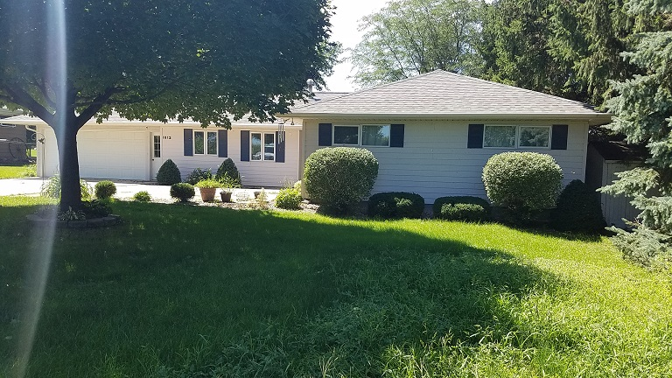

# Priced to Sell at $98,900

# 1012 Nickel Street, Mt. Lake

©2016Hanson Agency